
ESPON BSR-TeMo
Territorial Monitoring for the Baltic Sea Region
Scientific Platform and Tools Project 2013/3/9
Inception Report | Version 06/06/2012

This report presents a more detailed overview of the analytical approach to be applied by the project. This “Scientific Platform and Tools” Project is conducted within the framework of the ESPON 2013 Programme, partly financed by the European Regional Development Fund.

The partnership behind the ESPON Programme consists of the EU Commission and the Member States of the EU27, plus Iceland, Liechtenstein, Norway and Switzerland. Each partner is represented in the ESPON Monitoring Committee.

This report does not necessarily reflect the opinion of the members of the Monitoring Committee.

Information on the ESPON Programme and projects can be found on www.espon.eu

The web site provides the possibility to download and examine the most recent documents produced by finalised and ongoing ESPON projects.

This basic report exists only in an electronic version.

© ESPON & Nordregio, 2012.

Printing, reproduction or quotation is authorised provided the source is acknowledged and a copy is forwarded to the ESPON Coordination Unit in Luxembourg.

List of authors

Nordregio
Ole Damsgaard
Lisbeth Greve Harbo
Gunnar Lindberg

University of Gdańsk
Jacek Zaucha

Aalto University
Tomas Hanell

RRG Spatial Planning and Geoinformation
Carsten Schürmann

Stanislaw Leszczycki Institute of Geography and Spatial Organization Polish Academy of Sciences
Piotr Rosik
Rafał Wiśniewski
Tomasz Komornicki

BGI Consulting Ltd.
Jonas Jatkauskas

Geomedia LLC
Rivo Noorkõiv

1. Developing the conceptual framework – interaction between policy discourse and monitoring system

Performing a desk-based review of theories, trends and policies related to territorial development, territorial cohesion and territorial monitoring is a key prerequisite for proposing and enhancing a successful territorial monitoring system for the BSR. Failure to do so would result in a business-as-usual outcome, i.e. a collection of variables hardly interpretable in spatial terms instead of meaningful policy indicators able to guide policies with territorial impacts.
For those engaged in spatial research and policy advice it has become evident that the theory lost pace to the policy debate and interventions with regard to use of territories and shape of territorial structures at macro scale. The new economic geography, evolutionary economics or institutional spatial economics have been developed at least in parallel to such important spatial documents as ESDP or VASAB vision and strategies. Therefore, the TeMo project should launch the analyses with a screening of key policy documents prepared by the EU, EU member states and VASAB, followed by a related policy discourse.

Key notions
Territorial monitoring system of a macro-region might be rooted in such notions as territorial development, territorial cohesion and territorial integration. They have a lot in common; however, they illustrate slightly different processes. A deeper interpretive analysis of their meaning and use in the key VASAB documents such as the Tallinn report (VASAB1994), VASAB 2010 Plus (VASAB 2001), Gdańsk Declaration (VASAB 2005) and the VASAB Long-Term Perspective for the Territorial Development of the BSR (VASAB 2009) reveals that all those notions, expected to guide spatial development of the BSR, are context-dependent. The objectives and goals put forward by the different VASAB documents (researched also in the context of the EU Territorial Agenda) have evolved in line with the changes in spatial structure of Europe, its political and economic geography, quality of life of European citizens, and consciousness of an average citizen. Such an evolution has not been of a catastrophic character. In contrary, new concepts rather complemented and extended the existing ones, reinforcing one another. Therefore, for designing a long-term oriented monitoring system of the territorial development, instead of focusing on a single concept, an attempt would be recommendable to capture all important “building blocks” of the European and BSR debate on the rationale of territorial development – in order to identify the main components that should be monitored in a long run.

Policy documents at the European level
While the “Europe 2000” and Europe 2000+” reports presented a rather dominant descriptive and analytical part, it was the “European Spatial Development Perspective” that paved the way for macro-scale territorial approach in policy making. The ESDP provided three integrated policy guidelines for spatial development of the EU territory:
- Polycentric Spatial Development and a New Urban-Rural Relationship,
- Parity of Access to Infrastructure and Knowledge,
- Wise Management of the Natural and Cultural Heritage.
On top of that, the ESDP promoted an integrative approach to the development through networking and cooperation - so called vertical and horizontal coordination (ESDP 1999, 35-36).
One year later the Council of Europe, a Committee of Planning Ministers (CEMAT) prepared Guiding principles for Sustainable Spatial Development of the European Continent. The document states principles of a regionally more balanced development of the entire European continent.
The aspects (goals) of territorial development are very similar to the ones featured in the ESDP with an exception of the added components of tourism and natural disasters. To the traditional three pillars of sustainability (social, economic and environmental), the Guiding Principles added a fourth dimension: cultural sustainability.
In 2007 the Ministers responsible for urban development and territorial cohesion in EU countries adopted the Territorial Agenda of the EU. The document reinforces the ESDP approach by operationalising its three guiding principles (named aims in the text of the Agenda) with six priorities for territorial development of EU:
- Strengthening polycentric development and innovation through networking of city regions and cities
- Strengthening new forms of partnership and territorial governance between urban and rural areas
- Promoting regional clusters of competition and innovation in Europe
- Strengthening and extension of trans-European networks (TENs)
- Promoting trans-European risk management including the impacts of climate change
- Strengthening ecological structures and cultural resources as an added value to development.
Very similar, although slightly modified priorities were proposed in the 2011 update of the Territorial Agenda (Territorial Agenda of the EU 2020). The updated Agenda pays more attention to an integrative development and functional linkages, which in the previous draft were mainly restricted to urban and urban-rural cooperation. It attributes more importance to the territorial developmental assets as those that cannot be easily moved in a global economy. In general, the update contains more a local, regional and national perspective in comparison to the previous document. It recognises the significance of local and regional actions for development of the entire EU.
In the meantime, the aforementioned intergovernmental process on spatial planning and development was upgraded through an added Community perspective. Territorial cohesion has become the legitimate component and dimension of the European cohesion policy. There is no uniform understanding of this concept (Medeiros 2011; Faludi 2005; Szlachta and Zaucha 2010; Dühr et al 2010), however its main components may be specified as follows (after Szlachta and Zaucha 2010):
- Territorial cohesion as a measure for enforcing territorial aspects in general; and in economy, social planning and decision-making in particular,
- Territorial cohesion as a method of planning and development, which considers the territorial capital (potential) of places, settlements and regions, and their interrelations,
- Territorial cohesion as an addition to economic and social cohesion, to consider also areas with geographic disadvantages (like mountain areas, islands, areas with severe climate, geographically remote areas or border areas).
Important contribution to the understanding of the first component i.e. the role of territorial cohesion in policy making (as an instrument pursuing integrative territorial approach to policies) has been provided by the report of Barca (2009) and his place-based developmental paradigm.
The recently adopted EU “Europe 2020” strategy pays little attention to the territorial issues. However, the territorial development remains one of the key preconditions for its successful implementation. Therefore, the Polish Presidency of the EU Council made an attempt to identify linking issues between this document and the Territorial Agenda of EU 2020. In effect, five territorial keys were identified that require attention in the implementation process of the “Europe 2020” (Böhme et al 2011):
- Accessibility
- Service of general economic interest
- Territorial capacities/ endowments/ assets
- City networking
- Functional regions
In the Commission Staff Working Document Elements for a Common Strategic Framework 2014 to 2020 an emphasis was put also on integrated territorial development. The adjective “territorial” implies the development, which pays attention to specific features and endowments of different EU territories and regions. For the sake of promoting integrated approaches to territorial development, the proposal for a Common Provisions Regulation provides for two mechanisms to facilitate the development of local and sub-regional approaches: Community Led Local Development and Integrated Territorial Investments for the ERDF, ESF and Cohesion Fund.
For simplicity reasons all the aforementioned notions and paradigms will be hereinafter referred to as the ‘territorial development’, understood as an umbrella concept encompassing: territorial integration, territorial cohesion, integrated territorial development etc.

Baltic raster
In order to identify the main components of the BSR territorial monitoring system the European debate should be translated to the Baltic Sea Region specificity and priorities. The results are presented below and features specific components of the European territorial discourse that were given a prominent place in such VASAB strategic documents as:
- the strategy of 1994 (VASAB 1994),
- the key themes of 2001 (VASAB 2001),
- the key challenges of 2005 (VASAB 2005),
- the action agenda of 2009 (VASAB 2009).
- Balancing territorial development, diminishing territorial divides or alleviating their consequences (paying attention among others to the integration of Russia into the BSR);
- Maintaining at least the existing polycentricity level of the settlement structure and – consequently - ensuring access to services of general economic interest for the entire BSR population;
- Ensuring high quality of urban nodes (dynamic competitive and sustainable large and small cities), and their networking (cooperation of cities and city regions) with focus on diffusion of innovation and enhancement of knowledge-based development;
- Emergence and development of regional clusters of competition and innovation;
- Integrated development of functional areas with focus on:
- urban rural cooperation,
- coastal zones,
- islands,
- integration of border areas
- Development of territorial assets/territorial capital;
- Wise use of the sea space;
- Eco-resilience: i.e. green networks, ecological corridors and preservation of areas of high ecological value;
- Ensuring accessibility, connectivity and parity of access to transport and ICT infrastructure, development of TEN-T;
- Enhancement of intermodality of transport and greening of transport including motorways for the sea, short sea shipping;
- Development of renewable energy resources (also on the sea) and the BSR transmission grid (integration of energy infrastructure in the BSR);
- Territorially-oriented governance (incl. vertical and horizontal integration of policies).

Also the EU Strategy for the Baltic Sea region should be taken into consideration in order to fine-tune the monitoring system in line with the Baltic specificity. First of all the recent Communication on the Strategy EC(2012) underlines importance of installing "a system of realistic and feasible targets and indicators" for the Strategy. Therefore monitoring system to be elaborated by TeMo should become one of the measures for fulfilling this ambition. Secondly some spatial aspects such as marine spatial planning, connectivity, interconnections between energy markets or joint cross-border management and infrastructure planning have received more prominent role in a new strategy set up enhanced in EC (2012). Thirdly some of the proposed by the Commission targets and indicators for measuring progress are of spatial character and directly related to the already listed VASAB priorities which create a chance for TeMo to serve both Strategy and the CSPD needs.

The analysis of ongoing debate might help promote the main components of the territorial development as presented above and embed them into a framework for the BSR territorial monitoring system. However, the final list can only be agreed after discussion with the BSR stakeholders.

Monitoring experience
There are few spectacular examples of successful worldwide monitoring systems, e.g. HDI (laid down in Human Development Reports and computed under United Nations Development Programme) or GCI (published in Global Competitiveness Reports by the World Economic Forum). Also, GDP per capita in PPP, despite massive criticism, is still used worldwide for monitoring changes in the level of well-being. However, other efforts to develop functional monitoring systems turned out less successful. For instance, the original list of 36 “Lisbon” indicators for the EU15 of 2001 has been expanded to 79 indicators and now a short list has been produced of 14 structural indicators. The main reason of those changes was a trade-off between comprehensiveness and coherence of measurement. This illustrates the difficulties of monitoring systems where to many indicators are often included and resulting in eventual short lists to operationalise the systems.
Even more challenging were attempts to establish systems for routine monitoring of territorial development aspects at the supranational level. One of the main problems is the complexity of territorial processes. This has led to e.g. misfortune of the first VASAB monitoring trial in 1996 and the failure to elaborate a system for measuring results of transnational programmes supporting the European territorial cooperation. In the latter case the only feasible solution was the use of proxy measures related to the number of projects or financial allocations. Another reason for difficulties is that statistical systems of EU Member states are not harmonised, i.e. for many indicators no common data for a sufficient time span are available. Difficulties in measuring the territorial development are illustrated by the story of the Cohesion Reports. The territorial information presented there usually refers to the state of territory but hardly to its changes, while the findings (with few exceptions related to typical indexes as GDP etc.) are not intertwined between the series of reports.
Monitoring of territorial issues also witnesses the challenge of trade-off between the scope of measurement and simplicity. The monitoring (territorial) systems proposed for a wide implementation have been either too general or too complex to be commonly used by decision-makers as a guidance for their policies (ICZM indicators, indicators discussed in 2011 by High Level Group reflecting on Future Cohesion Policy), or, vice versa - they were too narrow and thereby might turn attention of decision-makers to non-measurable development components, thus biasing the efforts towards the measurable issues (targets of Europe 2020).
Examination of findings and the experience of the ESPON INTERCO (2011) project, dealing exclusively with the territorial monitoring, and the NTCCP discussions on the territorial keys proposed by the Polish Presidency of the EU Council lead to the following conclusions:
- A monitoring system requires prioritisation and focus. This can be achieved by examining goals and priorities of spatial visions and strategies at different geographical scales. The EU initiatives and regulations (e.g. INSPIRE, GISCO) will not ensure such a focus automatically as many believe, since by definition these general initiatives do not entail any policy objectives.
- A monitoring system, if useful, should guide not only spatial policies but all policies with territorial impacts. It should monitor to what extend such policies contribute to the territorial development.
- Single composite indicators (similar to GDP) depicting territorial development (territorial cohesion) in Europe are unfeasible. This is due to e.g. varied understanding of the territorial cohesion or the overall goal of the territorial development (in fact, spatial policy is about arbitration between different developmental goals, thus there is no single goal that can be used for measurement of the progress in spatial development).
- Therefore, the most promising approach is to disaggregate complex territorial processes into more simple components and to measure the progress in each policy relevant domain separately. Selection (or trade-off) of components (priorities or goals of spatial development) depends on policy decisions in each country and might change with time. Thus, there is no uniform weighting pattern that can be applied in Europe or in the macro region with such a high level of heterogeneity as in the BSR. However, a standardisation of indicators at national or EU average is always feasible to make results of different individual indicators better comparable across countries or macro regions.
- Data gathering should come at the lowest possible geographical level in order to satisfy the plea of monitoring the development of functional regions. However, this would raise the costs of the monitoring system. Thus, there is a need for defining a proper balance between flexibility of the monitoring system and resources necessary for its execution and maintenance.
- Territorial cohesion is always connected with a process or with developments over time. Thus, the monitoring system should enable for time-series analysis. Consequently, the indicators to analyse should be available for different points in time, the longer time series the better.
- The composite indicators pose the threat of being unfriendly, difficult for interpretation for the decision-makers, and, from a pragmatically point of view, often also difficult to compute. There are, however, a few examples of very successful territorial indicators of that kind (e.g. multimodal accessibility). Thus, resigning from such indicators would be premature, as they should be used in a conscious way (if possible demonstrating the impact of each single index on the overall value of such an indicator).
All the above described preconditions and related decisions form important milestones for designing a territorial monitoring system. They require an intensive dialogue between stakeholders (decision-makers) and the researchers. They cannot be taken alone by the experts without involvement of practitioners.
Also, the data availability should be paid due attention. Several monitoring systems failed because they restricted themselves to measure processes, for which they could find available data. This would lead to the business-as-usual case. On the contrary, for instance, the success of Urban Audit can be attributed to the clear measurement framework filled in the course of far-sighted measurement efforts. The lesson learned is therefore that a monitoring system should be developed in a gradual way but with a clear perspective what is desirable and what indicators are necessary in a long run.

2. More detailed overview of the analytical approach to be applied

Having in mind monitoring experience synthesised in the previous section we propose a three level domain-based logic of the monitoring system so as to enable it to depict relevant phenomena at differing policy levels and sectors, while at the same time maintaining maximum operating efficiency and redundancy aversion. This domain-based approach is similar to that in e.g. monitoring of the EU Sustainable Development Strategy or the EU 2020 ditto, as is also the division of the indicators into headline, sub target and auxiliary indicators.
This proposed basic setup is illustrated in Figure 1 below. The red encircling dotted line refers to a number of (unspecified) measurement techniques that may be applied on the variables or indicators contained in the system, so as to enable description or analysis of complex processes or phenomena. We have chosen to include this component on measurement techniques as a “horizontal” issue rather than as a separate thematic layer. Such complex indicators (e.g. GCR – Gini Concentration Rate, or dispersion rate) are the result of certain measurement techniques that to a varying degree are applicable across the entire content of the system.
At this point the TPG wishes to stress the fact that the domains as well as their content at all levels have yet to be decided upon as presented in chapter 1. Based on the literature review as well as on consultation with the stakeholders (workshop), a final proposal for the domains will be made. As an example, Figure 2 below illustrates how a hypothetical domain could look like.
As is the case with similar monitoring systems in use within EU policy (e.g. the SD strategy), the number of headline indicators is recommended to be kept to an absolute minimum in order to enable economical updating of the system (typically one per domain only).

Figure 1: Contextual framework of the monitoring system

Figure 2: Illustrative example of a hypothetical domain

3. Methodology and hypothesis for further investigation
In this section we will further develop some of the topics which are central to the project, namely: i) development of monitoring modules; ii) applications and testing; iii) presentation and visualization; iv) spatial coverage and geographical scale; and v) integration of adjacent areas and other ESPON regions

Development of monitoring modules
The development of the monitoring modules, which constitutes the first work package after the literature and policy review, is made up of a few aspects or steps.

1. Integration of “policy – theory” framework into possible domains of the monitoring system. That is, an integration of chapter 1 and 2 of this report into operationalized domains to be used for developing indicators. This work is initially made up of a workshop with VASAB and ESPON CU to analyse the need for specific domains and indicators within the monitoring system. This will be the so called “policy validation” of first of all the domains but also visualisation concepts and testing.

2. Transformation of domains into possible indicators and scoping of available indicators and data and different geographical scales and across the BSR region. The INTERCO short-list will be considered in this process as well as indicators suggested by other thematic ESPON projects and within the ESPON Database project.

3. Definition of a final coverage of domains and indicators within each domain (data known to exist in the BSR region and at satisfactory geographical scale). This is a desk based exercise which will determine the frame for the entire data collection to follow.

4. Collection of data by each partner and collected centrally at the LP for harmonization and organization.

At this stage the data will be stored in a simple Microsoft Excel database structure, following the metadata organisation within the ESPON Database project. Primarily, besides storing data for future use, the data is structured and stored for use within the visualisation and testing phase of the project. The data is not meant to be searchable at this step of the project (not an Access or GIS database).

Within the scope of the data collection the TPG has established links to the ESPON M4D project to facilitate the gathering and use of ESPON Database information.

5. Production of descriptive statics, simple indicators and complex indicators (can be both composite indicators and new interpretations of simple indicators) in order to feed into the visualisation and testing work packages. Different measurement techniques will be tested.

At the time of this Inception Report we have proceeded along the lines of point 1 in the list above and produced a framework for what should be discussed at the stakeholder workshop together with VASAB and ESPON. This framework constitutes the result of a first process where the dimensions mentioned in Chapters 1 and 2 are taken into consideration. In this framework the columns should be considered fixed, but rows are preliminary for the workshop. Level 1 is of primary importance but will be embedded within level 2 and 3. The framework is presented in table 1.

Table 1. (Following 2 pages) Framework for workshop.

Applications and testing
The activities of applications and testing are separated into three distinct subtasks, each building on the former. The first subtask refers to the identification of 3-5 test case themes for assessment of the ability and capacity of the monitoring system. The suggestions listed below – both at the heading as well as at the subheading level –should be considered indicative only and need to be developed further. We propose that the test cases are conducted in four particular investigative areas and that each serve differing policy needs at differing territorial scales and administrative levels. The proposed areas are as follows:
- testing the overall benchmarking ability (for example the BSR vs. other INTERREG transnational areas);
- testing with a thematic scope (for example territorial cohesion; interregional trade; economic development / labour market; functional or economic specialisation; polycentricism; demography, territorial resilience or urban-rural aspects, etc.);
- testing with a geographic scope (for example certain types of territories such as borders, islands, metropolises, secondary cities, etc.; or particular geographic locations such as cross-border areas, peripheral areas, urban or rural areas, etc); and
- testing of cross-cutting issues (for example mono-polycentricism and territorial cohesion or cohesion and competitiveness).
This would allow for the comprehensive testing of the entire capacity of the developed monitoring system and framework across a wide array of policy settings.

Decision note
In order to meet required project deadlines, the final decision on which topics will be chosen for the testing of the capacity of the monitoring system needs to be made at the stakeholder workshop in Potsdam on 21 June 2012. The TPG asks participants to this meeting to consider which aspects may be of particular relevance or interest (and specifically such not necessarily listed above). The ToR of the project states altogether between 3 and 5 test case themes.

Annex III to the contract raised an important point regarding point nr 1 above, i.e. the overall benchmarking activities to be conducted. In the tender we proposed benchmarking of the BSR against other macro regions such as the Danube. This may prove to be difficult among others due to lack of information, and other benchmarking options would tentatively add more value to the overall knowledge of the European space from a macroregional point of view.
It may therefore be more feasible to benchmark the BSR against other INTERREG transnational areas, namely: 1) Atlantic Coast; 2) North West Europe; 3) South West Europe; 4) Mediterranean; 5) Alpine Space; 6) South East Europe; 7) Central Europe; and 8) Northern Periphery. Additionally, we propose in this case also to include as nr 9) the North Sea INTERREG transnational area.
The TPG deems this benchmarking approach both fully feasible as well as conceptually sound and would suggest executing such a benchmarking within this WP. For practical reasons (data availability), such benchmarking would need to be conducted on the EU parts of these areas alone.
It is worth to note that for a sound implementation of this benchmarking the selected indicators must be available not only for the BSR territory but also for the entire ESPON space.
The second subtask involves the implementation and consequent testing of the information contained in the monitoring system within those investigative fields decided upon jointly by the stakeholders and the TPG. Generic goals for this task include policy relevance and the ability to depict and respond to European and BSR territorial cohesion aims and objectives. The overarching EU policy framework(s) as well as the particular challenges of the BSR itself will constitute the principal analytical foci of this subtask. It is important to consider that the test cases conducted herein will not be all inclusive and in-depth scientific analyses within their respective themes. Rather, they should be seen as instant snapshots taken within the competence of the developed monitoring system.
Finally, the third subtask involves a critical evaluation of the system where the outcome of the test cases will be analysed in a structured manner. Strengths and weaknesses emerging from the testing process will be identified and tentative suggestions for readjusting the monitoring framework will be forwarded.
The key analytical factor here is the degree to which the capacity of the monitoring system is able to accurately capture principal issues in relation to territorial cohesion within the given policy framework(s). This evaluation will also provide a preliminary assessment of whether the way in which the results are visualised corresponds to the user needs, or whether the visualisation approach needs further refinement.

Presentation and Visualization
The way indicator results and input data are visualized is crucial for the success of the BSR monitoring system. The concept for the visualization and presentation of the monitoring output will therefore not only include traditional maps, but will also include diagrams, charts and tables, and may in addition also include some interactive means, subject to stakeholder consultations at the first stakeholder workshop in Potsdam.The visualization framework should be a flexible framework where the user can select between different indicators, can choose between different geographical scales and select the appropriate mean (i.e. map, diagram, table, time series).
The presentation framework will, beyond that, also develop guidelines on how to analyse the indicators, such as ways to standardize indicators, applying thresholds, or time intervals for analyzing trends. Here the TPG will build upon previous works done by ESPON INTERCO project on the analytical framework for analyzing territorial cohesion (see Chapter B.2.3 of Final Report of ESPON INTERCO; Dao et al., 2012)
The development of the presentation and visualization concept follows a seven step approach:

- Assessment: Assessment of the latest map kits provided by the ESPON Database Project through desk review and direct contact with the authors. Requirements for the amendment of the standard map kits, following the BSR specificities, will be identified (see Annex 1).
- Potsdam workshop: Identification of monitoring needs of policy makers and stakeholders in the BSR. The monitoring needs in this sense are not only a question of indicator selection, but also of how to present and analyse the indicators. A workshop will be conducted where such needs will be discussed. The workshop will, inter alias, discuss questions like how to present the indicators, how to benchmark them, how to standardize them and how to compare them, which and how to use thresholds or target values, and how to deal with time series data.
- Concept: Development of the visualization concept, including new / updated map templates and templates for diagrams and charts. Whether a dedicated smart application (either web-based or local application) will ease indicator handling will also be investigated as part of the stakeholder workshop.
- Implementation: Implementation of the visualization concept. Map templates will be implemented as new template files in ArcGIS, diagram and chart templates will be implemented in Excel or other suitable software, and, if found useful in the previous step, a smart application for the indicator presentation may be developed at this stage.
- Testing: The concept for the visualization will be tested on the basis of the 3 to 5 test cases. These tests will reveal whether the developed concept fulfills all of the monitoring needs of the stakeholders, and whether the way the results are presented is appreciated.
- Revision: The final stage of this process is the revision of the visualization concept, subject to the results of the testing phase. If necessary, amendments to the map templates, diagram and chart layouts or to the application will be undertaken.
- Approval: the final visualization concept will be approved by the stakeholders.

The presentation and visualization concept will generally address different forms of output, different analysis methods, and different implementation means (Figure 3).

Output | Analysis | Implementation

Maps
Diagrams
Tables
Time series
Smart app
Dispari-ties
Trends
Sigma/beta convergence
Thresholds
Standar-dization
Benchmarking
ArcGIS templates
Excel
Tabular forms
Color schemes

Figure 3. Presentation and visualization framework.

Different forms of output may include, but is not limited to, maps, diagrams, tables, time series and a smart application. Analyses may cover the analysis of disparities and trends, and of sigma/beta convergence, but the framework will also include recommendations for selecting and applying thresholds, and ways of standardization and benchmarking. Implementation elements include the development of ArcGIS templates, Excel files, tabular forms, and color schemes.

It should be noted that for all these framework elements the TPG is not necessarily striving for latest state-of-the-art technical implementations, but to develop robust and sound policy-relevant solutions from the stakeholder´s point of view. The presentation and visualization concept will be laid down in three main deliverables:
- A list of detailed monitoring needs for a BSR monitoring system and a detailed concept for visualization. This will be integrated in the interim report and delivered for the second Steering Committee meeting.
- Implementation of the visualization concepts. This also includes the testing of the visualization concept for the selected test cases.
- User manual (as part of the handbook) for the visualization concept and its implementation, including instructions on how to use the various template files and applications.

Spatial coverage and geographical scale
The monitoring system to be developed should geographically cover the entire Baltic Sea Region (BSR) area, including Denmark, Northern Germany, Estonia, Latvia, Lithuania, Poland, North-West Russia, Finland, Sweden, Belarus and Norway (Annex 2). Since ESPON BSR TeMo is expected to focus on this area, a new map template has been developed based upon the ESPON map template standards (Annex 1).

While the delimitation of the study area is rather straightforward, the identification of the appropriate geographical scale to use is more difficult, as a certain area of tension is observed (Figure 4). While usually the explanatory power of an indicator and generally statistical requirements of spatial observatories call for high spatial disaggregation (for instance, NUTS-3 level), in particular when attempting to measure territorial cohesion trends, data availability and data gaps often prevent such disaggregated approaches. Sometimes also specific requirements from a policy point of view (for instance, if regional typologies are set up at a certain spatial level) need to be considered, as well as the complexity / tangibility of understanding any indicator. Last but not least, the different national NUTS systems need to be taken into account (for instance, very small NUTS-3 regions in Germany compared to great corresponding regions in the Nordic countries). Considering all these issues, experiences from previous ESPON projects show that a pragmatic approach to the geographical scale is needed.

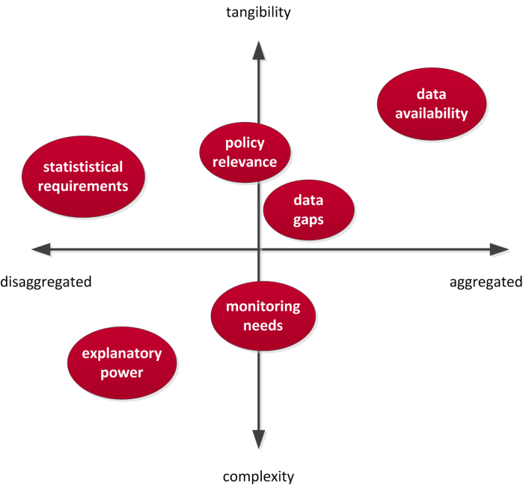
Figure 4. Geographical scale – area of tension.

In consequence of these challenges, the BSR TeMo project team will apply a multiscalar approach. The team considers NUTS-3 level as the basic geographical scale for monitoring territorial cohesion. Many indicators and input data should be available at this level; however, based upon practical experiences, the team is fully aware that for some indicators more aggregate spatial levels like NUTS-2 level can only be used due to restrictions in data availability. On the other hand, for some countries in the study area certain indicators may already be available or may be calculated even at more disaggregated levels like LAU-2 or even raster level. In these cases, data at LAU-2 or raster level will also be collected and analysed. Contrasting results at LAU-2 with, for instance, NUTS-3 level will reveal additional explanatory powers in detecting spatial patterns and trends, which in turn will help the project team in drafting recommendations for the set up and maintenance of the monitoring system. Finally, in order to benchmark or to analyse certain indicators, it is needed to calculate country averages or BSR averages, or to produce summary statistics at national or EU level to compare BSR countries against each other.

As a rule of thumb, data for each country will be collected at the finest spatial level possible. Aggregation of data from finer to coarser spatial levels will be preferred over disaggregating data from higher to lower levels. For instance, raster data may be aggregated to NUTS/LAU levels in order to set the regions in their general context. Raster or LAU levels will be applied to develop innovative, state-of-the-art indicators. If implementation of such local approaches is not possible for the entire BSR area, case study regions will be selected to demonstrate the feasibility and additional explanatory power of such new approaches over the traditional ones.

While for all EU and EFTA countries the NUTS classification is clearly defined, for Belarus and Russia corresponding administrative units need to be identified, which are so-called oblasts and rayons. Oblasts correspond to NUTS2 regions, and rayons to NUTS4 regions.

In brief, the following approach as to the geographical scale will be applied:

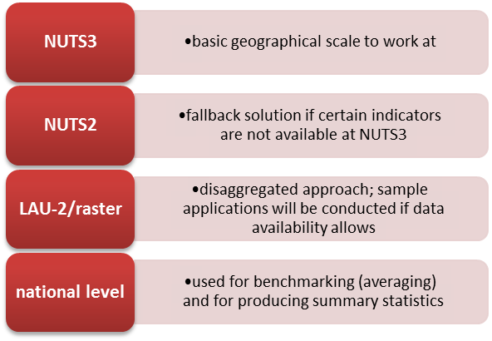
Figure 5. Geographical scales applied in ESPON TeMo.

Annex 2 provides detailed information on the regional subdivisions of the study area in terms of overview maps and overview tables. Apart from such region-based or area-based indicators, the project will also explore possibilities in respect of other types of indicators, such as point data, flow data (i.e. trade or traffic flows) or other forms of interactions and networks between regions. Subject to the selected indicators, some of these approaches may be implemented as demonstration examples. Even though ESPON TeMo strives to establish a harmonized monitoring system, also with respect to the geographical scale, it is not ruled out that eventually different spatial scales will be applied for different indicators. That means that the monitoring system needs to be designed in a way to work with different spatial levels.

Finally, as the geographical size of the various NUTS and LAU units in the Baltic Sea Region varies between countries, and significant differences exist in terms of settlement structure between and within the BSR countries, a more dynamic approach is needed when working and comparing particular areas with territorial specificities such as urban and metropolitan regions, rural regions, agglomerations as well as sparsely populated areas, border areas and islands. The monitoring system shall thus be designed to address these territorial specificities. This calls for the incorporation of a select number of regional typologies as categorical variables in the monitoring system.

Integration of adjacent areas and other ESPON regions
Even though focus of the monitoring system is given to the BSR territory, adjacent regions and regions in the remaining ESPON space will not be neglected.

Adjacent regions are defined as those regions neighboring the BSR territory shown in the extent of the new BSR map template (see Annex 1). Adjacent regions comprise regions in Russia, Ukraine, Slovakia, Czech Republic, Germany, the Netherlands, Belgium, France and the UK. Data for adjacent regions may be collected so that the maps show seamless data for the entire map extent. The extent to which this is implemented depends on data availability; the technical aspect of including such adjacent areas will not be a limitation. Possibly data for some indicators can be more easily collected which may still allow for comparison and benchmarking. The collection of data for adjacent regions will strive for collection data at the same geographical scale as for the BSR territory.

Beyond that, the monitoring system will also compare results for the BSR territory with other macro regions in Europe or with other INTERREG transnational areas, as well as at national levels. Enabling such comparisons means collecting data for the entire ESPON space. It will need to be defined whether such comparisons will be made for all selected indicators, or only for a subset of them as demonstration examples. Data for these areas will, again, be collected at the same geographical scale as for the BSR (NUTS3, NUTS2), allowing for sound benchmarking. Even if collected for the BSR, data at LAU-2 or raster level will not be collected for adjacent regions or other ESPON regions due to the large amount of work involved.

If data gaps are found for adjacent areas or other ESPON regions used for benchmarking, the TPG will only fill these gaps if this can be done with reasonable effort. Focus will always be given to fill data gaps in the BSR.

4. Overview of deliveries and outputs envisaged by the project

As specified by the ToR the main output of ESPON BSR TeMo is a “two level” monitoring system. A basic monitoring system/module will provide fundamental and basic information that can be easily communicated and understood, this will include thematic and sector-oriented information. This is a collection of indicators and indexes for each region and across time which draws upon a database of material.
The advanced monitoring system/module will be based on more sophisticated and complex / combined indicators (and indices) on socio-economic and territorial development. This module should be served by the information in the basic module and be closely related to the political options and objectives set for the Baltic Sea Region in relevant policy documents.
The ESPON BSR-TeMo project will provide a monitoring system which needs to be both readily understandable and easy to use; this includes a well-functioning visualisation concept as explained above. This also includes a test of the monitoring capacity in the case studies also explained above.
In order to extract the most relevant indicators from the monitoring system, present them in a suitable way and make them easily available for consultation to different sets of stakeholders, policymakers and practitioners, the project aims to produce a ‘Handbook of BSR Territorial Monitoring”. The handbook will be in the form of text document and will also be translated into Russian. This will be the main dissemination activity of the TPG.
After the Handbook of BSR Territorial Monitoring is finalised the LP will organise a seminar to ‘launch’ the lessons of the Handbook to EU policy makers interested in territorial aspects and particularly those involved in Cohesion Policy, as well as representatives of national, regional and local authorities and transnational institutions.

Envisaged deliverables of BSR-TeMo

- Inception report.
- Report on the results of the Stakeholder and ESPON network workshop(s) to determine the scope of the monitoring modules and the need for specific indicators and analytical information.
- Interim report.
- Monitoring modules [databases and protocols for the presentation of results].
- Visualisation concept.
- Manual for the continuous management of the modules.
- Draft-final and final report.

5. Indication of barriers that the project implementation might face

The TPG already identified a number of barriers, risk or problems that might occur and hence hamper a proper project implementation. We mention these briefly below and offer some ideas for how to deal with such challenges.

Data gaps:
Data may not be available for a given geographical scale for all countries concerned in the same manner. For instance, data may be available for one country at NUTS3 level, for another country at NUTS2 level, or data may not be available for some reasons for individual regions. Depending on the indicator, different solutions can be applied:
  - Data will remain at different geographical scales, and will be illustrated as available (no further actions)
  - Data from finer spatial levels will be aggregated to higher spatial level to adjust the scales (for instance, NUTS3 level data will be aggregated to NUTS2 level)
  - Data gaps for individual regions will be filled by using reasonable assumptions, for instance by looking at national trends or trends from aggregated spatial levels, or by reviewing alternative data sources.
  - Alternative data sources will be reviewed which can provide the missing information.

Differing indicator definitions:
In some cases the definition of an indicator is differing between the countries (for instance, the number of employees may be measured at the place or residence or the place of work). This may particularly happen when different data sources are used, or when indicator definitions change over time (in case of time series data). Often there is no work around to solve this problem. Sometimes data from another source or for another year may help to overcome the situation.

Different temporal scope:
ESPON TeMo strives to gather all data for the most recent year available. Usually the temporal data availability differs between countries, such as that for one country the most recent year is 2011, for another 2010 and for a third country 2009. When mapping the indicator, ESPON TeMo will apply a pragmatic approach by either using the most recent year for each country or by using that year with the best overall data availability, whatever is more suitable. Beyond that, ESPON TeMo will also gather time series data over the last decade allowing the monitoring system to analyse trends and developments, which also helps overcoming this problem.

Data coverage:
Data may not be available for all ESPON countries. Even though ESPON TeMo is aiming at comparing the BSR territory with regions adjacent to it, or with other regions, focus will be given to close data gaps for the BSR territory; for pragmatic reasons, data gaps for other ESPON regions may not be closed if this would entail too much extra work.

Access to Russian and Belarusian data:
This is a possible barrier for the project but already at the TPG kick off meeting this issue was discussed and the availability of access to national databases and statistical offices seems to be promising and at this stage we believe that this data collection can be performed within the project TPG.

6. Orientation of the project previewed towards the Interim report

During spring the TPG have developed both the concepts for domains, indicators, testing and visualisation. The project is hence progressing well in line with the work towards the Interim report. At a workshop in Potsdam all these concepts (together with dissemination) will be discussed and worked upon with VASAB and ESPON CU. After this workshop the final selection of indicators will be made and the task of collecting the data will start and continue up until the time of the Interim Report. The work on visualisation will start more formally during August and testing will be more thoroughly designed in November once data and visualisation concepts begin to take shape. Also, final decisions on dissemination activities will be taken at the Steering Committee meeting in October 2012. An updated timeline (decided on the first TPG meeting in Stockholm) is introduced below.

Updated timeline BSR-TeMo
References
BÖHME, K., DOUCET, P., KOMORNICKI, T., ZAUCHA J. and ŚWIĄTEK, D. (2011) How to strengthen the territorial dimension of ‘Europe 2020’ and EU Cohesion Policy. Warsaw: Ministry of Regional Development
DAO, H.; PLAGNAT, P.; ROUSSEAUX, V.; ANGELIDIS, M.; BATZIKOU, S.; BAZOULA, V.; TSIGKAS, E.; VAN WELL, L.; STERLING, J.; SCHURMANN, C.; BÖHME, K.; GLÖRSEN, E.; BROCKETT, S. (2012): INTERCO – Indicators of Territorial Cohesion. Scientific Platform and Tools Project. Final Report. Luxembourg, Geneva: ESPON CU, University of Geneva
DÜHR, S. , COLOMB, C. and NADIN, F. (2010) European Spatial Planning and Territorial Cooperation. Routledge, London, New York.
EC (2012) communication from the Commission to the European Parliament, the Council, the European Economic And Social Committee and the Committee of the Regions concerning the European Union Strategy for the Baltic Sea Region, COM(2012) 128 final, available at http://ec.europa.eu/regional_policy/sources/docoffic/official/communic/baltic/com_baltic_2012_en.pdf (access 27 May 2912)
EUROSTAT (2007): Regions in the European Union. Nomenclature of territorial units for statistics. NUTS 2006/EU-27. 2007 edition. Eurostat methodologies and working papers. ISSN 1977-0375. Luxembourg: Eurostat.
FALUDI, A. (2005) Territorial cohesion: an unidentified political objective. Introduction to the special issue. Town Planning review, 76 (1), pp 1-13
ESPON INTERCO (2011) Indicators of territorial cohesion Scientific Platform and Tools Project 2013/3/2 (Draft) Final Report. ESPON & University of Geneva, 2011.
MEDEIROS, E. (2011) Territorial Cohesion: a conceptual analysis. Institute of Geography and Spatial Planning (IGOT) Alameda da Universidade, retrieved on 4th of February 2012 from http://ww3.fl.ul.pt/pessoais/Eduardo_Medeiros/docs/PUB_PAP_EM_Territorial_Cohesion.pdf
SCHURMANN, C.; SPIEKERMANN, K. (2006): Accessibility analysis of the Baltic Sea Region. Final Report. Study for the BSR INTERREG IIIB Joint Secretariat within the framework of the preparatory process for the BSR Transnational Programme 2007-2013. Oldenburg/Dortmund: RRG, S&W.
SZLACHTA, J. and ZAUCHA, J. (2010) A New paradigm of the EU region al development in the context of the Poland’s National Spatial Development Concepts, in: Churski P. and Ratajczak W. (Eds.) Regional Development and Regional Policy In Poland: First Experiences and New Challenges of the European Union Membership, Part 1, Polish Academy of Science, Committee for Spatial Economy and Regional Planning, Warsaw, pp.153-171.
VASAB (1994) Towards a Framework for Spatial Development In the Baltic Sea Region, Vision and Strategies around the Baltic Sea 2010, Denmark
VASAB (2001) VASAB 2010 Plus Spatial Development Action Programme, Vision and Strategies around the Baltic Sea, Gdańsk
VASAB (2005) Gdańsk Declaration and Policy Document Connecting Potentials, Vision and strategies around the Baltic Sea 2010, 6th Conference of Minister for Spatial Planning and Development, Gdańsk
VASAB (2009) VASAB Long-Term Perspective for the Territorial Development of the Baltic Sea Region. Towards better territorial integration of the Baltic Sea Region and its integration with other areas of Europe. Vision and Strategies around the Baltic Sea, Riga

Annex 1. New Map Template for Baltic Sea Region

Since the monitoring system to be developed should focus on the Baltic Sea Region, it was decided to develop a new map template (BSR mapkit) in ArcGIS for this territory based upon the general ESPON map templates.

The justification for this new template is that all maps produced for this monitoring system should highlight the specificities, trends and spatial patterns within the Baltic Sea Region as best as possible, i.e. the map scale and map extent should be adjusted to this area.

Of course the new map template needs to follow the general ESPON map guidelines to ensure harmonized map layouts. Figure A.1 illustrates the new map template for ESPON TeMo, highlighting the study area and its adjacent regions.

The main map is fitted to the outline of the BSR region. Adjacent areas are shown as well, from Russia in the East to the UK in the West, plus neighboring regions to the south. The additional overview map highlights the BSR territory in the overall ESPON space.

One of the advantages of this focused map template is that, as the spatial extent is adjusted to the outline of the BSR, higher spatial details can be shown. For instance, indicators at LAU-2 or raster level can be illustrated much clearer compared to Europe-wide map extents.

Apart from this new map template, the ESPON TeMo project will also need to work on the GIS input layers in different aspects:

- Generalization level: The standard ESPON shapefiles provided by the ESPON Database project are highly generalized. This generalization was introduced with the view to produce clear and easy-to-read maps. What works well for the cartography, entails certain drawbacks when attempting to use these layers for spatial analysis. Through the generalization overlay procedures in the GIS will return unreasonable results, for instance when spatial objects plunge ‘into the sea’ or when spatial objects ‘move’ over country boundaries. Therefore, for GIS analyses, the project team seeks for alternative input layers of administrative boundaries with higher resolution.
- Seamless layers: so far the standard ESPON shapefiles provided by the ESPON Database project do not include regional boundaries for Belarus and Russia. Also, regions of the candidate countries and of Turkey are only provided as separate shapefiles. Again, this is not useful for GIS analyses, and causes extra work in the cartography. Thus the task for ESPON TeMo is to generate seamless layers of administrative boundaries (NUTS3, NUTS2 and NUTS0) for the study area.

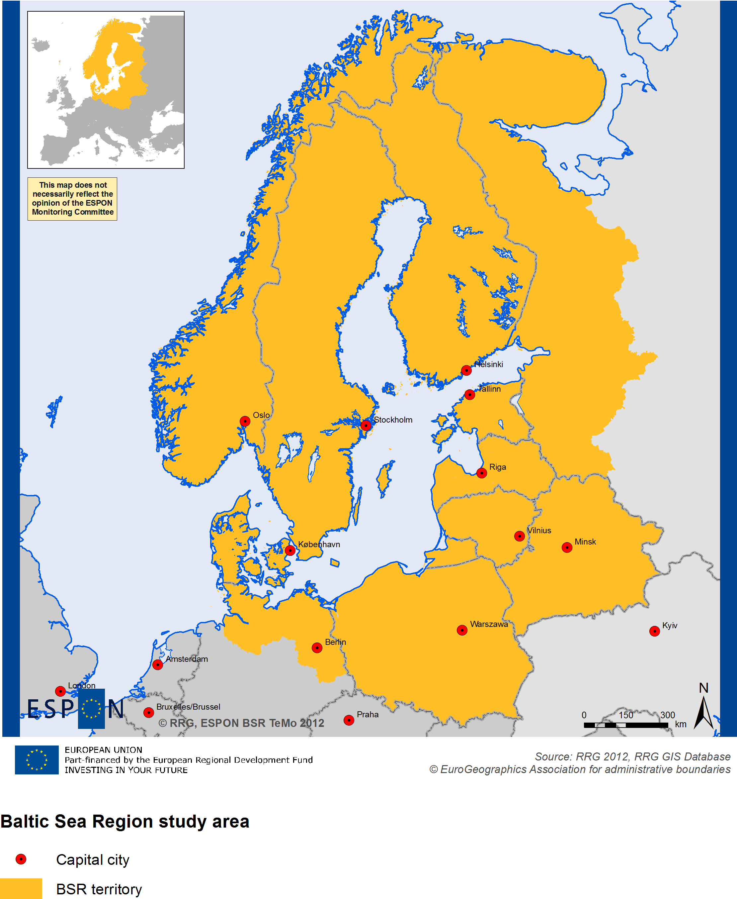

Figure A.1 Baltic Sea Region study area.

Annex 2. Regional Subdivision of the Study Area

NUTS-3 and NUTS-2 levels are identified as the main geographical scales to work at in ESPON TeMo. Following is a comparison of these NUTS levels for the countries concerned (Table A1), as well as an illustration of the regional boundaries (Figure A2).

Even though there is already a newer NUTS classification, the NUTS 2006 system will still be used (Eurostat, 2007) since all the data provided by Eurostat, representing one of the main data sources, still refers to this classification.

Table A1. NUTS3 and NUTS2 levels in the Baltic Sea Region.
Country | NUTS2 |  | NUTS3
Belarus | Oblasts | 7 | Rayons (sNUTS4) | 118 (130**)
Denmark | Regioner | 5 | Landsdeler | 11
Estonia | Country | 1 | Groups of Maakond | 5
Finland | Suuralueet / Storomraden | 5 | Maakunnat / Landskap | 20
Germany * | Regierungsbezirke | 8 | Kreise / kreisfreie Städte | 66
Latvia | Country | 1 | Regioni | 6
Lithuania | Country | 1 | Apskritys | 10
Norway | Regions | 7 | Fylker | 19
Poland | Województwa | 16 | Podregiony | 66
Russia * | Oblasts | 7 | Rayons (sNUTS4) | 123***
Sweden | Riksomraden | 8 | Län | 21
* Only those entities located in the BSR.
** Including towns of oblast subordinance (urban locality with the population of not less than 50,000 people; it has its own body of self-government). Belarus officially has 118 rayons, but there are separate statistics for towns of oblast subordinance.
*** On the level sNUTS4 Russian statistic includes rayons and municipality districts.

Apparently there are huge differences in the number of regions between the BSR countries, both at NUTS-2 and NUTS-3 level. While at NUTS-2 level the three Baltic States are not further subdivided, Germany, Sweden and Poland have 8, 8 and 16 NUTS-2 regions, just to mention the extremes. At NUTS-3 level, the number of entities is even more significant, ranging from 5 regions for Estonia up to 66 for Germany and Poland. By way of consequence, the average size of the regions is differing accordingly.

This basic drawback of the current NUTS classification cannot be amended by ESPON TeMo, since many datasets are provided based upon this classification. Therefore, the project will attempt to find additional data at LAU-2 or raster level; if not for all BSR countries, LAU-2 or raster data may be exemplified for a subset of them. One of the main advantages of using regular raster systems, for instance, would be to get rid of the distortions caused by the different sizes and different numbers of NUTS entities.

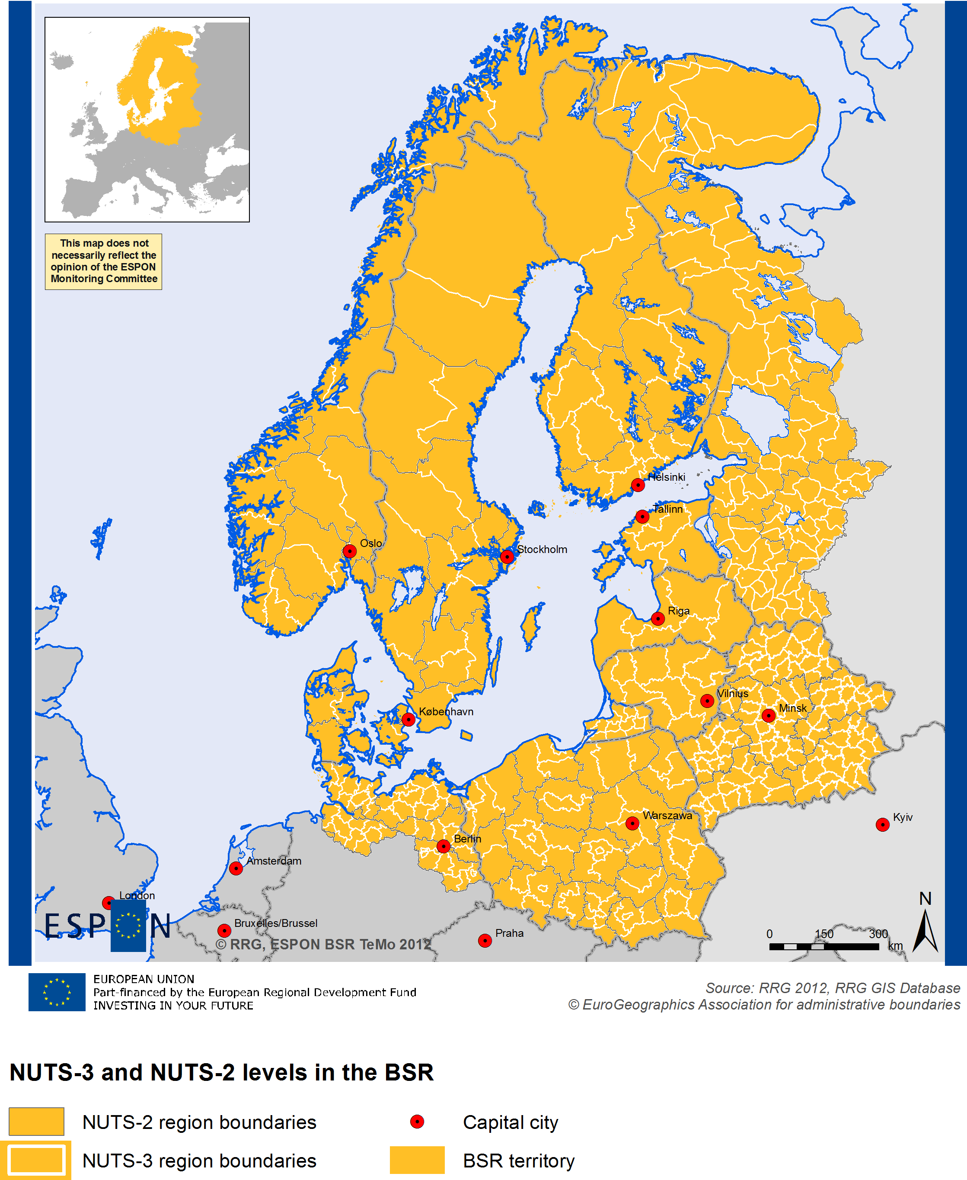

Figure A2. NUTS-3 and NUTS-2 levels in the Baltic Sea Region.


The ESPON 2013 Programme is part-financed by the European Regional Development Fund, the EU Member States and the Partner States Iceland, Liechtenstein, Norway and Switzerland. It shall support policy development in relation to the aim of territorial cohesion and a harmonious development of the European territory.
ISBN

We distinguish between three separate types of components of the system: a) variables; b) indicators; and c) measurement techniques. For instance, for a certain year and for a certain level of territories, the nunmber of inhabitants and the amount of GDP would be variables. They bear little relevance in themselves, but need nonetheless to be collected so as to enable further analysis. When these two are combined into e.g. GDP/inhabitant, we have an indicator. If such (variables or) indicators are analysed via certain measurement techniques, for instance with the aid of a dispersion rate, we are able to create complex indicators that enable the measurement of complex processes or phenomena such as e.g. territorial cohesion, or spatial integration. In order to ease communication, the terms “variable” and “indicator” are henceforth in this text used synonymously.
European level (ESPON Space, EU), national level, BSR level, regional level (NUTS2, NUTS3), local level (LAU, raster)
Beta convergence is the correlation between states and trends to analyse whether badly performing regions catch up faster than good performers. Sigma convergence indicates how regional disparities evolve over time, calculated by using the standard deviation divided by the average of them.
Including the following German Länder: Berlin, Brandenburg, Bremen, Hamburg, Mecklenburg-Vorpommern and Schleswig-Holstein. In addition, also a number of NUTS-3 regions in Lower Saxony are covered, which are Celle, Cuxhaven, Lüchow-Dannenberg, Lüneburg, Osterholz, Rotenburg (Wümme), Soltau-Fallingbostel, Stade, Uelzen, Verden and Winsen.
Covering St Petersburg, Leningrad Oblast, Republic of Karelia, Kaliningrad Oblast, Murmansk Oblast, Novgorod Oblast, and Pskov Oblast.
This aspect is all the more important for ESPON TeMo since different countries are involved including regions in three non-EU countries. In case of Russia and Belarus the oblasts correspond to sNUTS-2 and the rayons correspond to sNUTS-4.
Available data at raster level may include population figures, environmental data or accessibility indicators calculated at raster level (Schürmann and Spiekermann, 2006).
Implementing such approaches constitutes rather new approaches to ESPON, as so far ESPON concentrated on collecting regional data.
In case Eurostat manages to fully update its Regio database to the NUTS2010 classification, we will use NUTS2010 if corresponding NUTS region GIS layers for NUTS2010 system are also available through ESPON database project.
I.e. raster systems where each raster cell is of same size.

