
GROSEE
Growth Poles in South-East Europe
Emergence of GROwth poles NETwork in South-East of Europe
Targeted Analysis 2012/2/19
Revised Interim Report | Version 30/04/2013

This report presents the interim results of a Targeted Analysis conducted within the framework of the ESPON 2013 Programme, partly financed by the European Regional Development Fund.

The partnership behind the ESPON Programme consists of the EU Commission and the Member States of the EU27, plus Iceland, Liechtenstein, Norway and Switzerland. Each partner is represented in the ESPON Monitoring Committee.

This report does not necessarily reflect the opinion of the members of the Monitoring Committee.

Information on the ESPON Programme and GROSEE projects can be found on www.espon.eu

The web site provides the possibility to download and examine the most recent documents produced by finalised and ongoing ESPON projects.

This basic report exists only in an electronic version.

© ESPON & University of Bucharest, 2013.

Printing, reproduction or quotation is authorised provided the source is acknowledged and a copy is forwarded to the ESPON Coordination Unit in Luxembourg.

List of authors


University of Bucharest, Bucharest, Romania
The Interdisciplinary Centre of Advanced Researches in Territorial Dynamics
Ioan IANOȘ, Daniela STOIAN, Natașa VĂIDIANU, Andrei SCHVAB, Cristina MERCIU, Irina SAGHIN, Loreta CERCLEUX, Radu PINTILII, Gabriel PASCARIU, Cristian IOJĂ, Daniel PEPTENATU, Cristian DRĂGHICI, Cristian TĂLÂNGĂ, Crisitan BRAGHINĂ, Daniela ZAMFIR, Valentina STOICA


National Technical University of Athens, Athens, Greece
Minas ANGELIDIS, Epameinontas TSIGKAS, Andreas POTOURIDIS, Maria KOTRONAKI


Union of Architects in Bulgaria, Sofia, Bulgaria
Atanas KOVACHEV

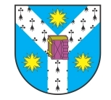
University ”Al. I. Cuza” of Iași, Iași, Romania
Cornel IAȚU, Roxana CERNESCU, Mihai BULAI
Table of Contents

1. Executive Summary iv

2 Introduction 2

3 General methodological approach 3

4. Data collection and case study area 4
4.1 Data collection, database, indicators, maps, typologies 4
4.2 The research area of the three capital cities 5

5. Inside the three metropolitan areas 7
5.1 Competitiveness and innovation 7
5.2 Demographic and social structure, well-being 12
5.3 Internal connectivity 16
5.4 Environment 19
5.5 Territorial and urban structures and policies 23

6. Drivers of competitiveness 26

7. Accessibility and connectivity 35

8 Existing planning and cooperation of the three capitals (preliminary findings) 40

9 Synthesis: from the local capacities of the three capitals to their global role (preliminary findings) 44
The three capitals in the respective national urban systems 44
The SEE in the World and Europe 45
The integration of SEE in the world 45
The integration of SEE in the European space 45

10 Policy recommendations and measures and possible projects (preliminary findings) 48

11. Further proceedings towards the Draft Final Report 51

ANNEX I – REFERENCES
ANNEX II – GENERAL METHODOLOGICAL SCHEME OF THE PROJECT
ANNEX III – LIST OF INDICATORS
ANNEX IV – MAPS, TABLES AND FIGURES
ANNEX V – OUTLINE OF THE BROUCHURE

Figures
Figure 1: Complex interractions of Bucharest, Sofia and Athens to transform SEE into an emergent growth area
Figure 2: The general methodological chain
Figure 3: Metropolitan Region and Metropolitan Area in GROSEE
Figure 4: GVA per economic sector in 2009 in the three countries and capitals
Figure 5: Employment rate % (20 to 64 years) in EU-27 and the three countries and capitals 2000-2011.
Figure 6: Unemployment rate in the three countries and capitals 2000-2011
Figure 7: Demographic indicators for the Balkans
Figure 8: Per capita GDP PPS in % of the EU27 average (=100) in 2009 per capital and country of the EU27
Figure 9: INTERREG IVC: Number of contracted projects by regions
Figure 10: Per capita GDP in PPS (Purchasing Power Standard) in % of the EU27 average (=100) in 2008, per country, in EU27, Norway and Switzerland –divided in North, South and East- and Western Balkans and Turkey
Figure 11: Per capita GDP in PPS in % of the EU27 average (=100) during the crisis period 2008-2011, in Euro-zone, SEE countries, Italy, Portugal and Spain
Figure 12: South-East European polycentric network in regional context

Maps
Map 1: Approximations of the CC (Core Cities), FMA (Functional Metropolitan Areas) and MR (Metropolitan Regions) for the three capitals with NUTS2 and NUTS3 units
Map 2: Intensity of the links between the subsidiaries of firms included in the ORBIS database in 2008 inside SEE

Tables
Table 1: Consumption of water (cubic metres per annum) per inhabitant
Table 2: Collected solid waste in Urban Audit cities - tonnes per inhabitant and year
Table 3: CO2 emissions in tonnes
Table 4: Travel cost gains between the main city pairs that the TEN-T no 7 Project

1. Executive Summary

GROSEE (Growth Poles in South-East of Europe) is an ESPON targeted analysis based on user demand. As the second report on the project, this Interim Report has developed some results and inserted new ideas compared to the Inception Report, advancing different fields from those that will be presented in the Draft Final Report, which will be delivered mid-September. The Interim Report has focused the research on the comparative analysis of the aspects concerning the structure and dynamics of the three main components of territorial metropolitan areas (Bucharest, Sofia and Athens) and the assessment of their competitive potential in the context of the EU 2020 Strategy and the 2020 Territorial Agenda implementation. In this report, some methodological elements have been developed, a statistical database was completed and synthetic and comparative maps for the three metropolitan areas were compiled.

1.1. The aims of the project

GROSEE project has the following goals:
- to analyze the role of the Capital regions in South-Eastern Europe in the European urban network;
- to identify the necessary types of actions in order to improve the relationships between the Capital Regions and the European core economic development area;
- to make policy recommendations regarding the economic and territorial development of the three case study areas (Bucharest – Romania, Sofia – Bulgaria and Athens – Greece).

Romania, Bulgaria and Greece, they form the Balkan axis of the European Union, representing its most peripheral space of large size. According to the ESPON project 3.2. Territorial Scenarios, this area might become an “Emerging peripheral integrated zone”, if transnational cooperation policies are promoted, by identifying in the first place, the strengths of the three national capitals focused on metropolitan areas.

To create a synergistic territorial development in this area, a more intense cooperation between the three analyzed countries is required, between their capitals and other major development centres, such as Thessaloniki, Timişoara, Constanţa and Varna. Unfortunately, a great handicap of this space is represented by a set of complex factors: poor accessibility by road and rail, geographical barriers, low economic competitiveness and the state of the interethnic conflict in the Western Balkans. All these, plus the differentiated start in terms of connection with the EU core (Romania and Bulgaria joined the EU in 2007), are the main challenges to cope with in order to strengthen the cohesion of South-Eastern Europe.

South-East Europe is an individual peripheral EU macro- region and the less developed overall. For its transformation into an emerging growth area in the context of the EU 2020 Strategy, several types of relations with synergistic effect on accelerated development of SEE were identified (Figure 1).
- the relations between each capital and its surrounding areas, which through an increased orientation to the regional potential valorisation provide increased cooperation potential with the others;
- the relationships between the three capitals that may become the key elements to transforming this area into one of cooperation, with an increased interaction capacity in the European urban and regional network;
- the cooperation with the European core and the emerging area of Central Europe, which speeds on the one hand, the integration of the three capitals and the other centres of growth in the European urban system, and on the other hand, it makes possible the diversification of the cooperation potential between the capitals and the three states.

Figure 1: Complex interactions of Bucharest, Sofia and Athens to transform SEE into an emergent growth area
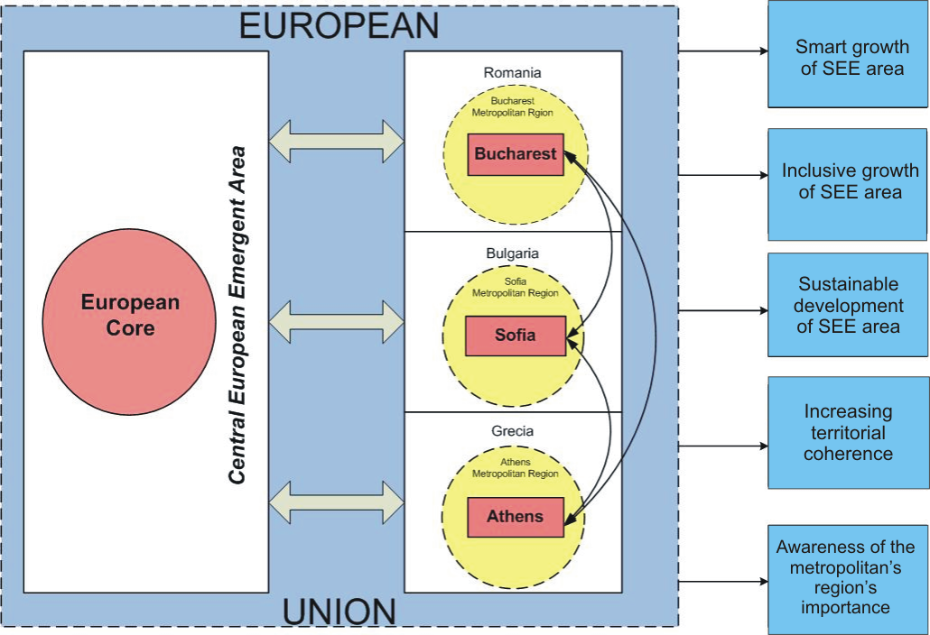

The individualisation of South East Europe as an emerging macro-region comes from the integration of the spatial interaction effects from different levels. This will result in the definition of some new joint projects, in creating awareness for economic growth in the neighbouring countries, in influencing the creation of institutional cooperation culture among decision makers at various levels, , all bringing more development to this European periphery.

1.2. Research approach

The undertaken research has gone from the observation that due to the historical past, ideological and linguistic barriers, the lack of adequate infrastructure and so on, the cooperation between states belonging to the European Union in the SEE is poor, and often accidental. The main working hypothesis is that the three capitals (Bucharest, Sofia and Athens) might be the main drivers of the development of a systematic cooperation between the three countries (Romania, Bulgaria and Greece), and between them and the rest of the EU, including through other national growth poles.

To test this hypothesis, a first important aspect was to focus on the structure and dynamics of the relationships between each capital city and its metropolitan area, the second one was to detect the main similarities and differences between them and the third one referred to the position of assessing the possible effects of an intense cooperation of the respective states and SEE as a whole. The main methodological steps are part of an integrated chain approach, expressing the logics of the project (detailed in the chapter concerning the general methodology).

The main methods used to achieve the project objectives and to test the hypothesis referred to:
- desk research, encompassing the study of literature in the field and various projects developed through EU programs;
- statistical analysis and cartographic representation, using GIS methods;
- comparative analysis of the three metropolitan areas;
- applying questionnaires and conducting interviews with different categories of experts and decision makers (these methods will be used to develop the Draft Final Report);
- SWOT analysis applied to individualize drivers of competitiveness for the three capitals in the South-Eastern space.

1.3. Main findings

The main results obtained in the conducted research focus on: a) the delimitation and the analysis of the three metropolitan areas, assessing the competitive and innovation degree, the demographic and social structures, the degree of connectivity of metropolitan region centre, the environmental issues and the urban and regional structures b) the individualization of the drivers of competitiveness as elements of growth, c) the degree of accessibility and the connectivity analysis of the three metropolitan areas at national and continental level. By this research, inputs have been created in order to assess the level of planning and cooperation between the three capitals and the estimation of how this may increase their importance at global level. The new research will integrate the results of the interviews with various decision makers including the definition of the appropriate policies to enhance cooperation between Bucharest, Sofia and Athens.

From the undertaken research, the following preliminary results have been reached:
- Customizing a huge human potential in research and development, and a very low level of expenditure dedicated to this sector, especially in the case of Romania and Bulgaria. The share of this expenditure is far below the EU average and far away from the target set at the national level through the 2020 Strategy;
- The three capitals represent true nationwide "islands of high technology and innovation". Significant cooperation between them is missing; the comparative analysis shows an advanced position of Athens in relation to Bucharest and Sofia;
- Demographic dynamics is differentiated through the relationship between the three cities and their metropolitan areas. An intense suburbanization process for metropolitan Bucharest and Sofia resulted in a decrease in their population in favour of the surrounding communities. For the metropolitan area of Athens, a decrease of population in the central area (Core City and close surroundings) has been registered, and an increase in the north-east and south-west of it;
- The dramatic decrease in the fertility rate since 1990, all three cities being below the European average (1.59 children / women). Lowest values ​​(1.25) were registered in Bucharest;
- The continuous increase of life expectancy, although values for Bucharest and Sofia remain far below the European average. Only Athens exceeds this average, registering 80.4 years (compared to the European average of 79.7 );
- The working age population is higher than the European average for Bucharest and Sofia, but below it for Athens; for Bucharest this value is the result of a pro-life policy promoted by the former communist regime;
- Demographic ageing is an important feature of the three metropolitan areas, with values ​​increasing between 2000 and 2011. The ratio of people over 65 years and people under 15 years is below the European average in Bucharest (1.12) , above average for Attiki (1.23)and well above average for Sofia (1.54);
- Bucharest and Sofia metropolitan areas are still areas of emigration (even if the values ​​are lower compared to other regions of those countries) while Athens metropolitan area has turned into an area of ​​immigration;
- The transformation of the three capital cities in national and regional hubs for transport networks at European level, with a detachment of Athens in terms of air transport;
- Internal connectivity is poor in terms of public transport system concerning the relations between the metropolis and the metropolitan areas, especially in Bucharest and Sofia;
- The internal connectivity and the accessibility to external nodes are important factors of competitiveness through the connections to the most developed regions of Europe;
- An increasing demand for efficient and comfortable transport was registered in recent years, putting pressure on public transport networks in all three capitals, especially for Bucharest and Sofia. The three capitals have no access to the major European transport networks, except for the air transport means;
- Concerns appear in the context of protection and preservation of the environment.
- Each capital has a master plan, but there is no integrative master plans of cities and metropolitan regions for Bucharest and Sofia, hence a chaotic suburbanization process! In this context, short-term results might be positive in terms of increasing the revenues for the towns in the metropolitan area. On the other hand, long term negative effects such as the bottle necks for the infrastructure unitary projects, the loss of local identity, the high costs for restructuring settlements have to be foreseen.
- The analysis at a national and metropolitan regions level shows that the three capitals, as drivers of competitiveness, do not redistribute enough innovation and technological progress; better interactions at these levels could generate smart growth and the achievement of the national targets set by the 2020 Strategy;
- Despite the financial crisis, the three capitals and especially Athens continue to be drivers of competitiveness in SEE and in the Balkans. Cooperation and interdependence, mainly in the major cities and in the capitals of the neighbouring countries, show a particular interest in the development based on innovation and economic competitiveness.
- Multi-level interdependencies in innovation and high technology are meant to increase the accessibility of the three capitals to the European Core and to the emerging area of ​​Central Europe, especially through the transport corridors;
- The three capitals are isolated from the European core, and this is due to lack of strategies and policies to implement projects focused on the connection to the European motorways and high-speed rail networks;
- The analysis of the projects within the INTERREG programs shows a relatively small number of them between the three capital cities and their metropolitan areas, but also their reduced impact;
- The poor awareness of the importance of an intense cooperation with the neighbouring areas is reflected in the reduced rooting both in the SEE economy and in the global one;
- In order to convert SEE in a similar emerging area as Central Europe is, there are several ways to define customized policies to generate the required synergy for the development of cooperation having as drivers of competitiveness, the three capitals and their metropolitan regions.

1.4. Further research

The next period will focus on continuing the research that will converge with already carried out studies to verify the main working hypothesis. In this respect, the research will include:
- conducting interviews with key decision makers at different levels;
- organizing workshops with the participation of local, regional and central decision makers in each capital;
- received inputs will allow to carry on further detailed analysis:
  - to have a detailed measurement of cooperation between the three capitals
  - to reveal their ability to get more involved in the EU and the global economy;
  - to formulate policy recommendations in order that this space becomes a true emerging area for the European Union.

2 Introduction

The undertaken study starts from the importance that the three metropolitan regions (Bucharest, Sofia and Athens) might have in achieving the project goals: to analyze the role of the Capital Regions in South-Eastern Europe in the European urban network, to identify what type of actions are needed in order to improve the relations between these Capital Regions and the European core economic development area, and to make policy recommendations regarding the economic and territorial development of these metropolitan areas.
Bucharest, Sofia and Athens are the biggest urban communities in Romania, Bulgaria and Greece, and their recorded progresses in a very complicated socio-economic context show their capacity to continue the upgrade at the infrastructure and institutional level. The new economic tendencies had an important role in diminishing the management role of the State through deregulations and privatizations (Mulaert et al., 2001), by sustaining entrepreneurial initiatives, by attracting domestic and foreign capital, and by sustaining public-private partnerships. In this framework, Bucharest and Sofia have to deal with the lack of institutions capable to amplify these processes of strengthening their urban national systems in the SEE. The construction of their metropolitan institutions becomes the key element to promote interconnectivity (by inter-locality cooperation) for Bucharest and Sofia. (Brenner, 2003).

The research project responds to the indicative questions formulated in the project’s proposal, providing support elements that converge with the attainment of the main goal. To that effect, the answer to the question regarding the main drivers of competitiveness in the three capitals is the comparative analysis of the three metropolitan regions. It reveals that the three countries and capitals have a considerable human potential in R&D. Their share in the total employment is growing and does not differ so much from the EU average. The low expenditure in R&D despite its increase (a slow one) remains much lower than the actual EU average as well as the Europe 2020 target. Athens performs better than the two other capitals. They function as a type of “island of high technology and innovation” in their countries or, in other words, they do not redistribute enough innovation and technological readiness to their countries. However, they also have a good position in comparison with other EU metropolises and the potential to compete satisfactorily at EU level if they succeed in increasing their expenditure in R&D.

In response to the question regarding the accessibility of these cities and the improvement methods, including the efficiency of the European transport corridors, the project offers a detailed analysis on the connectivity and accessibility both within metropolitan regions, as well as at regional and European level. The accessibility at intra-metropolitan level shows that for Athens the challenge is to develop the public transport, while Bucharest and Sofia should answer to the growing demand for urban transportation (this would suppose combining the improvement of public transport with that of the road network). The accessibility at a European and regional level has been analyzed by taking into account the traffic and the existent transport infrastructure. The importance of the three capitals in the air transport was also pointed out, in particular the connections between these and other cities in the region. TEN-T Networks have been drawn to insure the north-south or northwest-southeast connectivity (from central Europe - Vienna and Budapest towards Athens and Istanbul). They reinforce, once more, the centralist position of the capital cities (Bucharest, Sofia, Budapest, Vienna, Zagreb, Ljubljana) and insure the most important internal needs – Sofia to Black Sea, Bucharest to Black Sea and to west, Athens-Thessaloniki or Via Egnatia (east-west). The achievement of an efficient Trans-European Network plays a crucial role in the attainment of the Europe 2020 strategy in terms of building missing links and removing bottlenecks along the European infrastructure.

To reveal the role of Bucharest, Sofia and Athens in the European polycentric network, the project presents some elements, such as those related to the place occupied in various European and world hierarchies, the three metropolises connectivity with relevant regional cities (Thessaloniki, Istanbul, Belgrade, Sofia, Varna) as well as the cities of Central Europe (Vienna and Budapest). In order to assess the insertion potential of these metropolises in the European polycentric network, the analysis undertaken on competitiveness shows both their strengths and weaknesses. In the next phase (according to the activity plan), such search will be refined, offering extensive analysis.

The results of these analyses, as well as those that will be done for the Draft Final Report, including the findings of the interviews with the decision-makers and those regarding the workshops, will allow the improvement of the proposals that have been already included in the last chapter of this report. The list of these policy recommendations, including the measures that would allow the definition of some projects that would improve the competitiveness and the growth of cooperation between the three capitals and between the latter and the European Core.

Besides the direct results, convergent with the project goals, GROSEE provides an interesting input for other European projects, such as FP8-Horizon 2020, with its domain Better Society, especially the axes "Health, demographic change and wellbeing" and "Inclusive, innovative and secure societies".

3 General methodological approach

Despite the location in the same geographic space, the physical, ideological, linguistic and historical barriers determined a poor cooperation between Romania, Bulgaria and Greece until 1990 which has been improved but has not reached yet a sufficient level. The main hypothesis on which this research was focused is as follows: the three capitals might become the engine of a systematic cooperation between the three countries and between them and the European core, through a better integration in the European urban system.
To test this hypothesis, a first set of analysis aimed at the relationship between the structure and dynamics of each capital and its metropolitan area, a second one aimed at identifying the key competitiveness elements that would facilitate cooperation between them and the third one assed the possible intense cooperation between the European core and the SEE through the network of regional urban poles (see Annex II, Figure I).
Due to the diversity in the structuring, evolution and management of the three metropolitan regions, the present administrative frame of NUTS II and NUTS III was used in order to facilitate a viable comparative analysis. Our attempt to analyse Bucharest’s flow and accessibility at LAU level proved to be hard to put through due to unreliable statistical data, but also to the lack of comparative data in the case of the other two case studies. Such analysis might produce results comparable at a European level, results that assure in the same time a better integration of the new information in the ESPON data base.
One of the important sources to obtain indicators’ values was that represented by the Statistical Yearbooks of the three countries, in some cases regional statistics or data at the capital level. To obtain comparable analysis in many cases, we used data provided by EUROSTAT, by other ESPON projects or by other European documents. The interpretation of these data took into account the demographic, economic and connectivity potential, the environmental conditions in order to achieve a comparative analysis and to establish the regional role of each metropolis.
The general methodology for the report followed the steps for the entire project (Figure 2): establishing the relevant indicators, confronting the list with the statistical evidences, exchanging indicators to complete them after consulting the partners, completion with other indicators (where it was the case), checking if the indicators respect the SMART (Doran, 1981, Meyer,2003) criteria, developing each chapter, making comparative analysis by the activity and sub-activity responsible, finalising the material, consulting partners concerning the final form of the report.
In accordance with the general methodological scheme of the project, the indicators have been analyzed at different territorial levels. The main methods to achieve the project’s objectives and to test the working hypothesis are represented by: the desk-research, including the study of literature in the field and various projects developed through the EU programmes, the analysis of statistical data and their cartographic representation through the use of software such as ARCGIS 9.3, SPSS, specific cartographic data basis for the ESPON programme, SWOT analyses, comparative analyses of the three metropolitan areas. In the elaboration of the Draft Final Report questionnaires and interviews with various categories of experts and decision-makers will be applied.
The methodological elements are found at the level of the main chapters of the study.

Figure 2: The general methodological chain
Verification
SMART
criteria

Final
version
Setting the relevant indicators
Cross-reference with statistical evidence

Partners’ consultation

List completing

Chapter elaboration

Comparative analysis
Homogenization and integration of chapters

Partners’ consultation

Methodology
(Main steps)

Data collection and case study area

4.1 Data collection, database, indicators, maps, typologies

The TPG has reviewed the existing indicators, data sources and data provision and has also taken into account the proposals of the ESPON CU and the Steering Committee in order to conclude to a list of appropriate indicators which have been used for the Interim report (see in Annex III).
The entire list is quite large as it was necessary to take into account a great number of aspects of the different issues studied in the project. The TPG has also produced a list of headline indicators which is mainly composed by indicators included in the respective list of Europe 2020 (EC 2010), EC 5th Cohesion Report (2010) and ESPON INTERCO (2012). Thus, our list of headline indicators includes indicators corresponding to the more important policy orientations of EU policy documents. Specifically, all the Europe 2020 indicators associated with quantitative “2020 targets” are included in the GROSEE list of headline indicators.
We should note that it is not possible to include all the indicators proposed by the SC because we should keep a balance on the use of indicators per issue i.e. we should keep only the indicators directly linked to the main questions arisen for the analysis and policy proposals of GROSEE; in case we keep the indicators corresponding to issues of secondary importance for GROSEE, we risk wasting our budget resources and limiting the readability of the project’s reports.
We have used indicators in the Interim Report for which there is Eurostat data or at least data for Large Urban Zone (LUZ) of Urban Audit. Data at LAU level have also been used at a limited extent. The main objective of the TPG for the Interim Report was the data collection for different levels / zones of the three Metropolitan Regions. Specifically on the basis of the approximations of the CC, FMA and MR for the three capitals with NUTS2 and NUTS3 units (see Annex IV, Table I) the TPG has collected data for the latter units for all indicators that were used. Evidently, data for other territorial levels has also been collected.

4.2 The research area of the three capital cities

In the Inception Report, the TPG has analysed in depth the division of the three capitals on different levels: the Core City (CC), the Functional Metropolitan Area (FMA) and the Metropolitan Region (MR) (see Figure 3) and in more detail in the Annex II of the Inception Report.

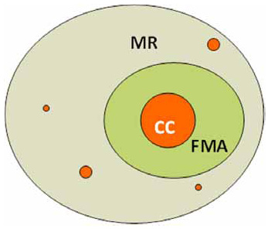
Figure 3: Metropolitan Region and Metropolitan Area in
GROSEE
MR (Metropolitan Region)
= FMA (Functional Metropolitan Area)
+ Outer Metropolitan Ring / OMR,
FMA = Core City (CC) + Outer FMA
Source: ESPON POLYCE (2012)
It has also defined necessary approximations of the CC, FMA and MR for the three capitals with NUTS2 and NUTS3 units. Map 1 below visualises the breakdown of the three case study areas into the different units of analysis. There are methods of delimitation of these three zones (CC, FMA, OMR) of the MRs at a very low territorial level, close to the “real” metropolitan territories: land plot using CLC or Urban Atlas 2007 sources for comparable land use.
In the following, we refer to data on the Functional Metropolitan Areas (FMA) of the three capitals. Where we do not follow this general approach, we make reference to specific statistical units.

Map 1: Approximations of the CC (Core Cities), FMA (Functional Metropolitan Areas) and MR (Metropolitan Regions) for the three capitals with NUTS2 and NUTS3 units
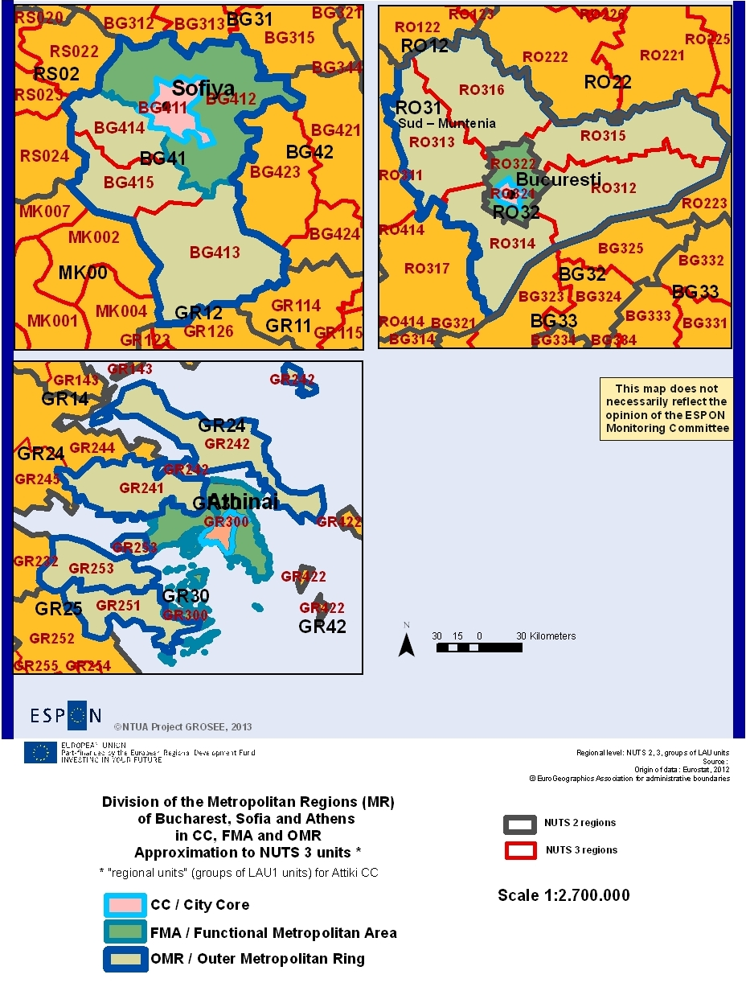
Own elaboration, based on Eurostat data

Inside the three metropolitan areas

5.1 Competitiveness and innovation

The competitiveness of the territorial units and, particularly of the cities, is a very complex concept. Therefore, it is difficult to understand its underlying factors as well as to measure it. A first aspect of the concept refers to the cities’ competitiveness as single entities. A second aspect is the integration of cities into economic and urban networks.
A large part of the relevant recent literature is covered by ESPON projects, because the latter have examined many features of all EU cities. Researches and publications outside ESPON usually refer only to a few countries or a few characteristics of all cities across the EU. Specifically, the project ESPON 3.4.2 “Economy” (2006) defined as key drivers of territorial competitiveness, the economic structure / specialization, the technology and innovation and the human resources, as well as the accessibility and the institutional /governance factors. The ESPON projects on cities in relation to polycentricity ESPON 1.1.1 (2005), 1.1.3 (2006) and ESPON 1.4.3 (2007) as well as other relevant ESPON projects as, indicatively, FOCI (2010) and ATTREG (2011) have adopted more or less, the same line of analysis. According to several relevant studies, the various economic branches are not of the same significance regarding the cities‘ competitiveness. Some, such as Advanced Producer Services (APS) and HT (High Technology) activities are of strategic importance, thus they should be specifically analysed (Goebel, Thierstein and Lüthi, 2007, Thierstein and Droß, 2008, Angelidis et al., 2011). Also, some EC reports are of particular interest, which discuss inter alia the changes in the factors that impact territorial competitiveness in the current globalisation frame. See indicatively the EC 5th Cohesion Report (2010) that brings evidence on the fast growing influence of innovation and “Europe 2020” (EC 2010) that underlines the importance of “smart development”.
Appropriate indicators have been chosen through wider lists drafted in the frame of the ESPON projects FOCI (2010), INTERCO (2012), SIESTA (2011), POLYCE (2011) and METROBORDER (2010) or have been used in the EC 5th Cohesion Report (2010) or in “Europe 2020” (2010) and “Lisbon strategy” (2000). We have used both appropriate simple indicators and some already commonly used composite indicators of competitiveness, such as labour productivity. We aimed at using the indicators not in a static and fragmentary manner, but as evaluation criteria of the competitiveness of global patterns (types) of spatial development in the three capitals and countries and the identification of the drivers of change for these patterns. This approach, which has been adopted by several ESPON projects (see indicatively in ESPON FOCI (2010) and ESPON Spatial Scenarios (2006) allows us to proceed in more reliable analyses of the future perspectives and, therefore, in more appropriate policy recommendations for cities and regions.
Given the fact that the recent crisis created a new context for territorial development, we considered as being very important to examine in depth the impact of the crisis in the cases of the three capitals compared to the respective changes in the rest EU cities and regions (see, among others: EU 2010 / URBACT and ESPON ECR2, 2012). Finally, we have focused on the changes ‘trends in the competiveness of the three capitals in order to better define their future perspectives, on the basis of which appropriate planning proposals might be drawn.
The whole analysis was structured around the following hypothesis: the reinforcement (emergence) of the development axis Athens - Sofia - Bucharest can act as a catalyst for increasing competitiveness through the spatial integration of the entire SEE.

Specific characteristics of the three Capitals
Apart from general factors impacting on the competitiveness of the three metropolitan regions (see paragraphs below), specific geographic features of each one have also a considerable impact. The population potential of Athens / Attiki (3,8 millions of inh. at FMA level in 2011) is considerably bigger than that of Bucharest and Sofia (1,9 and 2,3 million, respectively). In addition, Athens das a considerably more extended area densely populated and occupied by premises of economic activities compared to the other two capitals. Also, the existence of the Athens basin, which is surrounded by mountains, hampered the expansion of economic activities in the rest of the Attiki region, which neither applies for Bucharest that is situated in a lowland area, nor for Sofia.

The factors of competitiveness of the three capitals

Economic factors of competitiveness and indicators of economic performance
Regional competitiveness analyses give often an excessive importance to the purely economic aspects of competitiveness as GDP, income, economic activities, productivity. However, in the line of more global competitiveness approaches, we will also examine in detail the role of other factors such as the labour market, the human capital and the technological readiness. While we emphasise the analysis of the three capitals, we will also discuss their role in the context of their countries’ economy, SEE and Europe that was analysed in previous projects in more detail. Also, we clearly discern the trends observed before the recent crisis period from that observed during the crisis (from 2008 until today) because, as we will see, the crisis has changed significantly the development patterns of the three capitals and their countries.

Regarding economic performance, we start with the GDP analysis which is the most usual measure for the regional economy competitiveness. However, we should also examine other measures defining the performance profile as well as the wider economic profile of the three capitals such as the Gross Fixed Capital formation (GFCF), the Gross Value Added (GVA), the Foreign Direct investments (FDI) and the population income.
During the pre-crisis years 2000-2008 GDP in PPS per capita in Attiki approached the EU27 average, but thereafter, it recorded a significant decrease. Bucharest and Sofia showed a remarkable increase in GDP per capita before crisis, while the decrease in the crisis period was lower than in Attiki. FDI (Foreign Direct Investments) were clearly focused on the three capitals compared to their countries. The real growth rate of regional GVA during 2001-2008 was, in general terms higher than the EU27 average.
The turnover for enterprises during the period 2003-2007 was more dynamic in Romania and Bulgaria compared to Greece (data available only at country level).
Gross Fixed Capital Formation (GFCF) in Euros amounted in 2005 in Greece to 40 billion and rose up to 53 billion in 2007. In Romania the increase was more important: from 18 to 38 billion (there are no comparable data for Bulgaria). During the first year of the crisis (2008), while GFCF in Greece decreased slightly, it continued to increase in Romania. In both countries there was a sharp decrease during the second year of the crisis (2009).
The disposable household income during 2000-2008 presented a significant increase in Bucharest and Sofia, while the respective change was less intense in Attiki. Hence, the growth rates of the previous economic indicators in the three capitals had an almost similar response in household incomes.

Economic structure per sectors of activities
The economic structure of cities and regions per activity sectors is a crucial aspect of their competitiveness.
As it results from the analysis of Gross Value Added (GVA) per activity sectors in 2009 (Figure 4) the economies of all three capitals present higher shares in a broader sector including trade, transport, hotels and restaurants. However, Bucharest and Sofia record also high shares in industry and construction, while in Attiki there is an increased participation of the wider sector of public administration, defence, education and health, as well as real estate activities. Regarding financial activities (banks) and insurance, as well as information and communication branches, which are of strategic importance for competitiveness, Attiki presents a more important volume of GVA in comparison with the two other capitals (the latter present bigger shares % than Attiki.

The division of GFCF by activity (there are not comparable data for Sofia) is similar in general terms to that of GVA. The same division pattern is more or less reflected also in the sectoral structure of employment in 2011 (except for Real Estate activities in Attiki which had a lower share in employment than in GFCF).
Specific attention should be paid to tourism because it is a sector in which all three capitals have an important comparative advantage (in comparison with other EU MRs), not enough exploited so far. In the economic analysis of tourism, demand and supply (accommodation infrastructure) are of crucial importance. From the demand side (arrivals) Attiki presents in 2010 a clearly higher tourism intensity index (nights spent in collective tourist accommodation per 1000 inh.) than Sofia and Bucharest. Arrivals in the three capitals increased before the crisis and decreased slightly in Athens and Sofia during the crisis. Supply, as for the number of bed places offered, has been rising continuously during 2002-2011 in all three cases, with the exception of a small decrease in Attiki after 2009.

Figure 4: GVA per economic sector in 2009 in the three countries and capitals
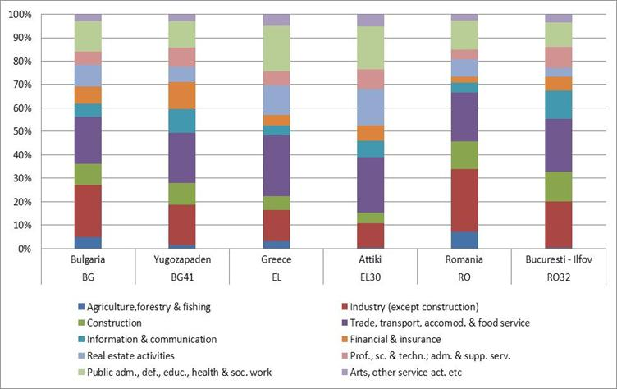
Own elaboration, based on Eurostat data

Employment and unemployment, labour productivity
At first, Attiki presented before the crisis both a lower employment rate (Figure 5) and a higher unemployment rate (Figure 6) in comparison with Bucharest and Sofia.

During the crisis years 2008 to 2011, the employment rate of all three countries and the FMAs of the three capitals decreased, except for Bucharest. Sofia had in 2011, within the crisis, a higher rate (71%) than the EU27 average (68%) while the Bucharest rate was similar to the EU27 one. Inversely, the rates of Attiki (60%) as well as of the three countries were much lower than the actual EU27 average; this means that they should make greater efforts to reach the Europe 2020 target regarding the employment rate (75%).
This rate has risen impressively during the crisis period in Attiki, reaching 28% in October 2012. It is the first time that Attiki records the highest unemployment rate among the Greek regions. Unemployment rates in Sofia and Bucharest also increased, but with clearly lower rates than in EU27 and Attiki. It should be stressed for Bucharest that during 2000-2009, the raise in the number of employees in FMA (Bucuresti-Ilfov) replaced only a part of the jobs lost in the OMR (Sud-Muntenia).

Figure 5: Employment rate % (20 to 64 years) in EU-27 and the three countries and capitals 2000-2011.
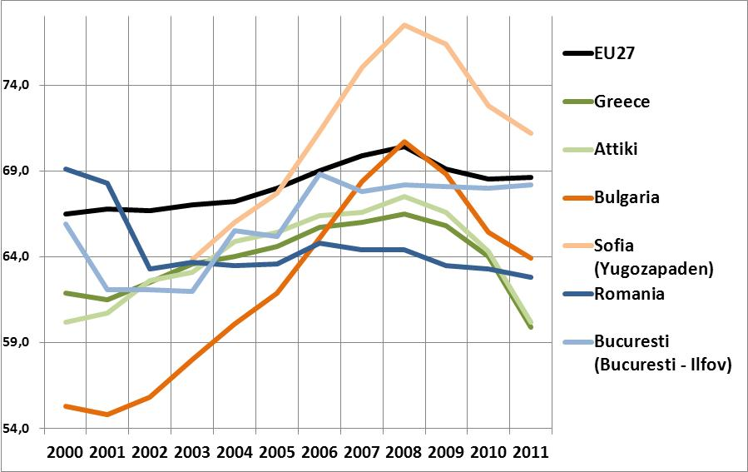
Own elaboration, based on Eurostat data

Figure 6: Unemployment rate in the three countries and capitals 2000-2011
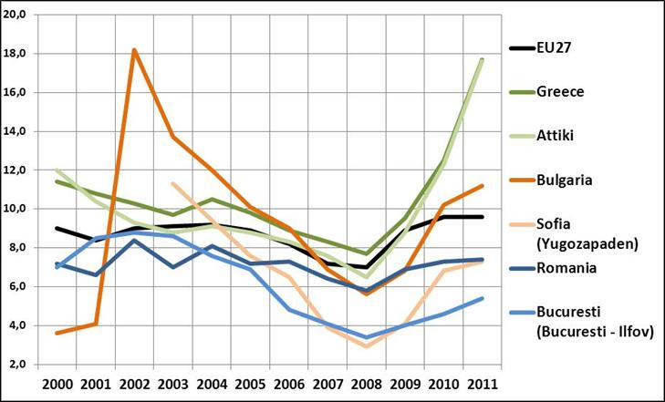
Own elaboration, based on Eurostat data

During the crisis period 2008-2011, the decrease in the employment rates was more significant in specific sectors; primarily, in the construction sector, this is mainly linked to domestic demand; EU-27 experienced a high percentage of employment decrease in construction (13%), but the decrease in Attiki and Sofia was considerably higher (37% and 32% respectively), while in Bucharest it was significantly lower (11%). High percentages of employment decrease for the three capitals were also recorded in the industry sector.
Labour productivity is a very important factor of competitiveness. There are different measures of labour productivity which correspond to different simple indicators (for example: GDP, GVA etc.) or combinations of indicators and therefore to different competitiveness aspects.
The labour productivity index of Eurostat corresponding to GDP as PPP per person employed as for the EU27 average (=100) is of particular interest to our subject. The value of this index was very high for Greece in 2001 of 98, while it was much lower in Bulgaria 32 and Romania 26. During 2001-2008 it remained stable in Greece and increased very considerably in Bulgaria and Romania. During the crisis period 2008-2011, the value of the index decreased in Greece (90 in 2011) and increased slightly in Bulgaria and Romania (44 and 51 respectively).
As the above indicator corresponds only to national and not regional level, we elaborated data from Eurostat on GDP and employment in order to calculate the values in regional level of another commonly used index: labour productivity as GDP (in millions of PPS) / employment (in thousands, people 15 years or over). The index values analysis for 2010 indicates that only the FMA of Attiki (with 71) surpassed the EU-27 average (57) while the index value for Bucharest (58) was roughly equal to the EU average and Sofia scores much lower (39).

The index of European Commission’s Directorate General for Regional and Urban Policy (DG REGIO) regarding the productivity growth through employment shifts between economic sectors (Eurostat data) is also interesting. During the period 2000-2007, while the productivity growth due to the above factor, amounted to 0,40 for the entire EU-27, it was much higher in Sofia (0,82) and much lower in Attiki (0,23), while in Bucharest there was a small decrease (-0,02).
In summary, the improvement in employment and unemployment rates before the crisis in all three countries and capitals was followed by an extreme deterioration, particularly in Athens and Sofia, with emphasis on the construction sector, but also in industry and specific branches of services. Labour productivity was relatively high in Greece and Athens, but decreased in the period of crisis, while it was quite lower in the other two countries and capitals. Therefore, this aspect of the competitiveness pattern of the three capitals showed improvement before the crisis, but registered a decline in the crisis period.

Technological and innovation readiness and specific branches dynamics
Technological and innovation readiness is generally lower in the three countries than in the more competitive EU countries. However, this weakness regards more the expenditure and investment in R&D and much less the readiness of the Research and Development (R&D) human potential. More specifically, regarding the total expenditure in R&D as % share of regional GDP in 2007, the three capitals were more distant from both the EU average and the Europe 2020 target, with Bucharest performing higher than Attiki and Sofia.
However, all three capitals record high percentages concerning Human Resources in Science and Technology (% of active population) in 2011, with Bucharest surpassing significantly the EU27 percentage. High performance is also observed in employment in Knowledge - intensive sectors for Attiki, and Bucharest in 2011 which exceeded the EU27 average, while Sofia performed lower. However, the share of enterprises with innovation activities in 2006 was in Greece marginally higher than the EU27 average and by far higher than in Bulgaria and Romania. Regarding also the number of patent applications (to the European Patent Office) per million of inhabitants, Greece exceeded significantly in 2010 the respective index of Bulgaria and Romania, although it performed lower than the EU27. Concerning the share of households with broadband access the three capitals perform the same, all lagging behind EU27. The share of households with access to the internet at home is higher in Bucharest in 2011, approaching the EU27 average, while Attiki and Sofia perform significantly lower.
It is particularly important to examine the contribution of the Advanced Producer Services (APS) and High Technology (HT) branches in the competitiveness of the three capitals and countries, as well as whether relevant firms’ clusters are formed among the three capitals. We limit ourselves here to mention the relevant conclusions of ESPON FOCI (2010),(see also in Angelidis et al., 2011). APS and HT are highly developed and spatially integrated in the "pentagon" of the EU, while in Southern and Eastern Europe, these activities, as well as the spatial links among them remain weak. Most of APS and HT activities are integrated in EU level clusters. However, the "strong points" of the latter remain particularly in the "North" EU. Only a few units of these clusters are located in the rest of the EU space; so there, the clustering at national or regional level is weak. This is obvious in the case of SEE and the three capitals. Attiki includes comparatively more of these strategic activities, but they are largely "dependent" on the similar activities of the major cities of the "North". The corresponding integration among Athens - Sofia - Bucharest is growing, but still remains limited. The preliminary update of this analysis in the context of GROSEE, basically ,confirmed these findings.

The quality of the available human potential
The quality of human potential as for the share of tertiary educated people (30–34 years) to the total population in 2011 was higher in Attiki, exceeding the EU27 average and approaching the target of Europe 2020, while Bucharest and Sofia had lower shares. A low share of early school leavers shows that the local education system succeeds to integrate a big share of young people in the high quality human potential for competitiveness. From this scope, Sofia and Attiki performed well in 2011 as their shares were lower than the EU27 average, while Bucharest recorded a much higher share (but this correspond to NUTS1 RO3, a larger area than the capital). Healthy life expectancy, measured by the number of years of healthy life expected, is a good index for the potential labour productivity. This index amounted in 2007 to 62 in EU 27, 66 in Attiki and 62 in Bucharest and Sofia (DG Regio 2010).

In summary, for the two last sections: The three countries and capitals have a considerable human potential in R&D. Their share in the total employment is growing and does not differ so much from the EU average. The low expenditure in R&D despite its increase (a slow one) remains much lower than the actual EU average as well as the Europe 2020 target. Athens performs better than the two other capitals. In all the issue aspects (expenditure, introduction of R&D in enterprises and human potential, the three capitals perform much better than the rest of their countries, raising the distance between them). They function as a type of “island of high technology and innovation” in their countries or, in other words, they do not redistribute enough innovation and technological readiness to their countries. However, they also have a good position in comparison with other EU metropolises and the potential to compete satisfactorily at EU level if they succeed in increasing their expenditure in R&D.

Before going to more general conclusion, it is worth mentioning the differences within the three Metropolitan Regions (MRs). The main finding is that the "Core Cities" / CC of Bucharest and Sofia presented before the crisis higher competitiveness dynamics, thereby acting as cores which spread growth and enhance the competitiveness of the other areas in the corresponding MRs, especially the suburban areas included in the respective Functional Metropolitan Areas (FMAs). Such dynamics have been also developed regarding the Attiki’s FMA (as defined herein), except that it occurred much earlier.

5.2 Demographic and social structure, well-being

If we take a look at the entire space of the European Union, the tendencies show a slow increase of human population despite a low fertility and an accelerated ageing population. The recent development in terms of population movements inside and outside the European Union add up to this (ESDP, 1999; ESPON 1.1.4, 2002; ESPON DEMIFER, 2010, EC, 2011). A perpetuation of these tendencies will determine a decrease in the active population (population able of working) and an increase in the number of older people that would lead to an imbalance of the economic and social system and therefore to an accentuation of the imbalances between regions. (DEMIFER, 2010). The demographic aspects are closely linked to the economic and social ones, so that an integrated approach to labour force dynamics is needed. Especially in the current economic context, the human capital receives a particular attention. For example, one of the European 2020 Strategy aim is ”to make full use of the labour market” (p. 17) by reducing unemployment, facilitate a greater involvement of women, older workers and migrating workforce, vouching for a high skilled population and reducing the rate of poverty. Anyhow, these targets can be more challenging for some regions than for others (ESPON SIESTA, Final Draft Report), requiring individualized approaches from one region to another.
The analysis of the population and of the social aspects specific to the three study cases (Bucharest, Sofia and Athens) is based on the contributions of ESPON projects such as FOCI (the current status and the perspectives of the population growth and the migratory flow, as well as the human effects on the environment and vice versa in the metropolises and the metropolitan areas); DEMIFER (the development of some demographic scenarios that represent the basis for the regional policies); ESPON 1.1.4 (appreciations at a national level and comparisons between the EU member states), but also on national and international documents that focus on population and migration status, and on the causes and effects of the phenomena and processes at a national and supranational level, as well as on possible policies for the long-term improvement of the difficulties and socio-economic challenges determined by the demographic evolution. For determining the current state of the population, the migratory flow and the well-being in the three case studies, a number of specific indicators (see in the Annex III) have been used, and as specific years, there have been taken into account the gathering and the analysis of the most recent year available for each indicator and data series starting with 1990 in five-years intervals or every year if it was relevant. This approach follows on one side to address the changes due to the shifting of Romania and Bulgaria to a new political regime and economic system and their integration in the European Union and on the other side to identify as much as possible the effects of the economic crisis, assessment that will remain largely speculative due to the missing of recent statistical data of the year 2009 for certain indicators. The comparative analysis doesn’t remain only at the level of the three case studies, but takes as a reference point the EU27 average, as well as feedback (subject to the availability of the) statistical data from the Balkan countries.
For a coherent analysis, it is necessary to present the general tendencies of the demographic evolution at a European level. Thus, following the undertaken studies within the framework of the above mentioned ESPON projects and the studies published by the European Commission (the Demographic Report, the Fifth Cohesion Report or the ESDP), the following aspects have been identified:
- Most of the region in West and Central Europe know an augmentation in terms of population due to the positive natural increase, but especially to the positive migration balance.
- Almost all the regions in the Eastern and South-Eastern countries have a low birth rate and in the same time a negative migration balance value, thus establishing the origin regions of the migrations to Western and Central-European countries. Greece is an exception with a series of regions where either the natural increase, or migration, or both values (in the case of Athens) are positive.
- At European level, the fertility rate has experienced a revival in recent years to 1,6 children/woman. However the replacement rate assessed to 2,1 children/woman in 2010 is still a distant goal. In the same time, an increase in the life expectancy is remarkable.
- The demographic ageing and the increase of the life expectancy still remain unavoidable issues.
- The migration might be beneficial when newcomers increase the number of the persons capable of working and in the same time, it is a disadvantage for the regions in which the young and the adult population are migrating.

A comparison of the Balkan countries reveals a mosaic profile of the population growth. Most of the regions in Romania and Bulgaria register a negative population change in the three analysed intervals (1998-2002, 2003-2007 and 2008-2012). This is due to negative values for both, the natural population development and migration. Bosnia-Herzegovina and Serbia register the same tendency at the national level for the period 2008-2011. Unlike them, Greece is characterised by a diversity of demographic differentiation registering at national level a positive population change since 1998 until 2012. Albania, FYROM and Montenegro show the same positive trends at national level for the period 2008-2012, the increase being determined especially by the positive natural growth.
The evolution of the population in the metropolitan areas of Bucharest, Sofia and Athens is closely related to the historical past, the geographical particularities and the differentiated economic and socio-cultural development. A common historical past of Romania and Bulgaria (over 40 years of communism, the change of political regime in 1989, the integration into the European Union in 2007) is reflected in an evident similarity of population dynamics and behaviour of internal and international migration. On the other hand, the geographic and cultural specificity also influence the demographic tendencies.
Another specific characteristic of the east European countries (such as Romania and Hungary) is represented by the increase of population in the areas adjacent to the capitals and a decrease of people in the core city (ESPON, 2008). The phenomenon is a proof of the still active suburbanisation processes in these spaces. The increase in the number of inhabitants in the area immediately adjacent to the capital puts the first considerable pressure on the transport system. In tandem with this process, the gentrification and the segregation of population are emphasized. (For more details see sub-chapter 5.5)

In the case of the three case studies, the fertility rate as a main factor in the population dynamics (with life expectancy and migration) recorded an increase both at a country level and at the macro-region (NUTS2) with values under the EU27 average (1,60 children/women in 2011) and among the regions with the lowest values for this indicator. The demographic Report 2010 suggests that this increase is due to the age of young mothers (above the average age of 30), but also to the increase in the standard of living/ wealth, especially in the case of Romania and Bulgaria. In the rest of the Balkan countries, the fertility rate drops sharply as a result of the migration of the female population of childbearing age. Instead in Turkey, and more precisely in Istanbul, the same indicator records the highest values, not only in the SEE countries, but also in the European Union (Istanbul 1,72 children/woman; Turkey 2,04 children/woman in 2010).
The results of the life expectancy at birth indicator are worrying, where Romania (74.3 years) and Bulgaria (73.9 years) along with other Balkan countries such as Serbia (74.1 years), Montenegro (75.5), FYROM (74.7 years), Bosnia Herzegovina (75.5 years) and Albania (77.04 years) keep a record of values ​​below the EU-27 (79.7 years), the difference being around 6 years even though the general trend in recent years is the improvement of this indicator gap between eastern and western Europe. Greece instead manages to exceed the EU average in 2011 with a difference of 2 units (80) as against the country with the highest life expectancy in Europe (Switzerland 82.2). The trend is preserved in all three case studies and also in the NUTS3 development regions.
The demographic ageing is a matter of concern for the entire EU as a result of four factors: (1) the low fertility rates, (2) the gradual retirement "post war baby-boomers", (3) the increasing life expectancy and (4) the current migration flows. Romania, Bulgaria and Greece, as well as the metropolitan areas of Bucharest, Sofia and Athens are feeling the effects of ageing due to negative natural balance and intense process of emigration. Along with this, also a decrease in the active population in Bucharest, Sofia and Athens from 2008-2009 is observed, except for Sud-Muntenia (a part of the metropolitan area of Bucharest-OMR) where there is an increase in the population of working age probably due to the increase in the number of workers in the region’s new industries. This phenomenon can be attributed to the economic difficulties encountered in this period and to a reversed migration of people aged 15-64 years to the rural areas of origin.

Regarding the migratory movement, two trends might be observed. The first one specific to Romania and Bulgaria is the increase of the migration flow from rural areas to urban ones soon after the change of political regime, followed by a massive labour migration since 2000 to the Mediterranean states and at the same time an improvement in social services of general interest due to increased suburbanization by younger population, called by scientists “rural gentrification” (Nica-Guran, 2009).
A second trend is specific to Greece. Since the ‘90s Greece changed from a country of international emigration into a country of international immigration. A high share of the total of immigrants comes from the Balkan countries –mainly from Albania, and secondly from Bulgaria and Romania. During the last years, the share of immigrants from Asia and Africa has considerably increased. Along with this, an increase in the illegal number of migrants is to be noticed, many of them not being recorded by the official statistics (Angelidis and Karka, 2010). The share of international immigrants in Attiki is higher than their share in Greece.
Nowadays, the three analysed capitals remain attractive and still manage to attract immigrants from other regions.

Figure 7: Demographic indicators for the Balkans
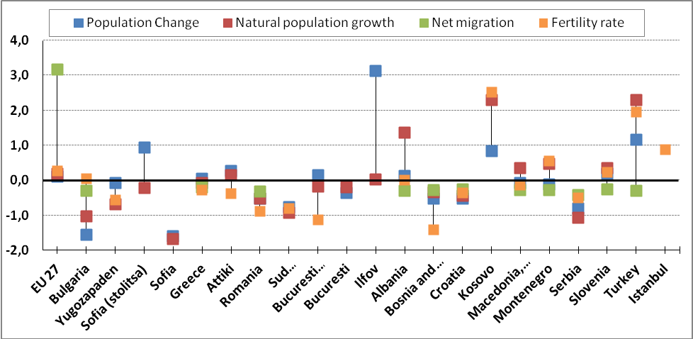
Note: Data has been used for the Population change between 2007-2011, for the population growt -2011, for the net migration- 2011, except for Serbia 2005; for the fertility rate- 2011, except for Montenegro and Istanbul -2010

Although the Greek average rate of people at poverty risk has a medium value, Attiki shows a rate under the 25% threshold because the capital city of Greece manages to maintain a higher income per inhabitant. Starting from 2008-2009 the effects of the economic crisis start to appear reflected by the increase of people at poverty risk and social exclusion. Bulgaria and Romania enter in a totally different category. In 2007, the year of accession to EU, the national average for Bulgaria was 60.7% while for Romania was 45.9% . The region to which the Bulgarian capital belongs has much lower rates than the national average, thus reflecting the strong positive influence of Sofia over the level of poverty in Yugozapaden region. The national trend of people at poverty risk in Romania is declining, but this trend is not clearly evidenced in the FMR and OMR of Bucharest. For Bucharest-Ilfov (FMR) region the poverty rate fluctuates widely reflecting the uncertainty and instability of incomes. Sud-Muntenia region, the Outer Metropolitan Region of Bucharest, is one of the most exposed European regions to poverty. Even in 2011 the regional average of Sud-Muntenia was higher than 40%. These values reflect the high vulnerability of this region; it lacks a developed economical level, it is unable to produce high incomes, but also there is a lack of Bucharest capacity to induce development at this scale.

Conclusions
Compared to Western Europe, and the average of the 27 member states, Romania, Bulgaria and Greece as well as their capitals and metropolitan regions remain at the bottom of the list in terms of demographic and social aspects. However, among the Balkan countries and especially at a national level, the three case studies are important growth poles and it is easily proved by the continuing attraction of migrants either to the capital or to the adjacent area. The fertility rate represents a continuous growth trend, while maintaining a high economic level can benefit a continuation of this trend. Demographic ageing has not yet reached alarming levels for these regions, the attraction of young people and the ones of working age dims the increase of the process, although in recent years there is a decrease in the number of people aged 15-64. In this equation, we must not forget Istanbul with a population of over 13 million inhabitants, with a high potential of employment and a high fertility rate.
Poverty remains a threat, especially for Bucharest and Sofia and it could be also the case of Athens in terms of economic instability. Thus, the initiative "European Platform against Poverty" in the Europe 2020 Strategy advocates for reducing social exclusion, discrimination by identifying groups at risk of poverty and ensuring adequate social support and health. This initiative is being welcomed particularly in the current economic climate, whilst reinforcing the idea of an increase in all society’s sections. (ESPON SIESTA, 2011)

5.3 Internal connectivity

Good Intra-urban connectivity and accessibility is necessary for ensuring high life quality for all the citizens together with high attractiveness for investments. It includes aspects such as: accessibility to services of public interest (health care, education, public transport, etc.), accessibility to work, leisure activities and green areas and connectivity of different areas inside the city. The relevant recent literature as well as the EU policies focus on sustainable urban mobility, improvement of the public transport and access to services and better coordination of urban and transport planning. See indicatively: EC 2007 / Green Paper and EC / 2007 / Sustainable Urban Transport Plans, Wickham and Lohan, 1999, Crampton, 2008, ESPON ATTREG 2010, ESPON TRACC 2011 and for the data and documentation: EU/Transport, 2012, Athens UTO2012, Angelidis et al., 2006, Milakis, 2006.

Analysis of internal connectivity of the three capitals
Internal connectivity of the three capitals is examined at different spatial levels and by different transport modes: road, air, rail / public transport, sea (ports), water.

Road transport
The three capitals have extensive networks of motorways and road lines while Attiki has a more developed network of motorways per inhabitant than Bucharest and Sofia. The Attiki road network has been significantly improved during the period before the Olympic Games of 2004 while the road system of Bucharest has mainly been improved during the recent years. Both road networks of Bucharest and Attiki are mainly based on radial axes. In Attiki since the ‘70s, the road rings were planned and gradually implemented. Specifically, a first inner road ring has been finalised, while two others have partially been implemented and a fourth additional extra outer ring is under implementation. We should also mention that the motorway Attiki Odos connects the two National Roads and the city of Athens with Western and Eastern Attiki in which the International Airport El. Venizelos is located. In Bucharest, the road network has a radial pattern, nine main roads converging to the central part of the city and a circular pattern surrounding the city as a result of the two circular roads. The enlargement of a ring-road has been initiated in 2010. In Sofia the main motorways and roads are connected to the Sofia Ring Road. In addition, the Yugozapaden Region road network is branched to a grid of secondary roads, connecting the small villages and towns in the region.
The motorisation rate-ratio of passenger cars per 1.000 inhabitants- in 2010 was clearly greater in Attiki than in Bucharest and Sofia (672 against 444 and 432), as well as the EU27 average (473). Regarding the road safety, the number of deaths in road accidents per millions of inhabitants (road fatality rate) decreased in general from 2005 to 2011 in all three countries and capitals, while it was lower in the three capitals than in their respective countries in 2008, with Attiki performing better than Bucharest and Sofia, as well as EU27.
All three capitals face important problems of the road network performance which result mainly from the rapid increase of the road traffic during the last 20 years and lead to the saturation of many motorways and to the decrease of the average speed on the entire road network. In Attiki, the population growth together with the increase of the motorisation rate (number of cars per 1.000 inhabitants), until at least 2010, as well as the low use of the public transport have contributed to the rapid increase of the road transport demand. On the other hand, the road transport supply has increased less than the road transport demand. We should note that illegal parking in the roads area reduces the capacity of a great number of city roads.
In addition, poor planning and incomplete infrastructure of the main road network and, even more, the lack of proper management, further reduced the network effectiveness and increased the number and the gravity of road accidents. Bucharest struggles with an overcrowded road system, tending to reach its limits. The development of road traffic intensity after 1990, as a result of the increase in incomes, life quality as well as time and comfort of travelling by private car, caused the overloading of the existent infrastructure. In Sofia, the slow pace of construction of new routes/streets has been typical during the last 10 years, while the poor state of the pavements and the desultory parking in the active lanes of the streets cause additional diminishing of the throughput capacity of the main street network. The lack of synchronization between the institutions involved in planning as well as the absence of high-speed city motorways obstructs the city’s normal functioning.

Air transport – access to the capitals
All three capitals have by far the most important airports of their countries serving national and international trips. The respective airports have been upgraded recently. The new international airport El. Venizelos of Attiki, opened before 2004, is located in East Attiki and is the most important one in SEE as far as it considers its capacity and the traffic volume. The international airport Otopeni in Bucharest is now upgrading and serves an increasing volume of traffic (Baneasa airport is provisionally closed).The international airport in Sofia is situated just 10 km from the city centre and it is the largest airport hub in Bulgaria, operating since the late 1930s. Recently (in 2006) a new runway and a passenger terminal were opened and in 2011 the new airport control tower began operating.
The three capitals are very important nodes of the national air transport networks. Attiki is directly connected with almost all the 38 Greek airports; the airport of Thessaloniki is also an important hub at national (and international) level. The strongest linkages are between Athens and Thessaloniki, Herakleion, Chania, Rhodos and Kyklades. Bucharest airport constitutes the most important hub of the Romanian network counting 17 airports. The strongest linkages are between Bucharest, Timisoara and Iasi. Sofia is also the hub of the 15 Bulgarian airports. The flows from Sofia to other airports of Bulgaria appear limited. In 2012 the number of passengers on internal flights from Sofia airport has increased by +34% in comparison to 2011.The air transport flows among the SEE countries, capitals and cities have been developed considerably from 2000 to 2010, while they have roughly stagnated from 2010 to 2011. The air transport flows between the SEE and the rest of Europe have been also developed during 2000-2010. Specifically, the flows between Athens and London, Rome and Paris as well as between Bucharest and Vienna, Paris, Munich and Amsterdam are more significant.

Ports – access to the capitals
Attiki has four main ports (Piraeus, Lavrio, Rafina, Elefsina). The port of Piraeus, one of the four largest in the Mediterranean, constitutes a commercial, passenger and watercrafts’ repair port and a major hub of international freight. The port of Lavrio has much less traffic, mainly passenger, but also commercial. Rafina serves limited domestic commercial traffic. Even though Bucharest has not a port, it is connected by the European road E85 to the Danube Port in Giurgiu and to the Danube Port in Oltenita, while the opening of the A2 motorway, led to a fast connection of Bucharest with the Black Sea’s main port. Several attempts have been made to finish the project Danube-Bucharest Canal. Sofia has no coastal borders or ports, but there is a link to maritime transport through the Trakia and Hemus motorways (or railways) to the Bulgarian port cities of Burgas and Varna.

The public transport system (PTS)
PTS in Attiki includes an important track based transport network comprising three metro lines, tram lines and suburban railway lines, of which an important part was constructed after 2000, while extensions of the existing metro lines are under finalization and new metro lines and important extensions of the existing lines are previewed. There is also a large bus and trolley lines network.
In Bucharest, PTS has bus, trolley-bus and tramway lines as well as 10 pre-urban lines that connect the capital to the towns in Ilfov County. There are also 4 main metro lines, while extensions of the network have been made between the 90’s and 2011. In addition, there is a fifth metro line under construction. In Sofia, the well-developed bus and trolley routes and the recently constructed metro-lines lessen the load on the road network, while the PTS also includes many tram lines and suburban rail.
The fleet of public transport vehicles increased considerably during the last 10 years both in Attiki and Bucharest. In Attiki and Bucharest, the number of public transport passenger movements recorded an increase from 1999 to 2008 and a slight decrease from 2008 to 2011. According to the people’s index of satisfaction with public transport in 2009 (UA data), Athens performs higher (69) than Bucharest (52) and Sofia (50).The share of passenger trips by public transport in the total of passenger trips is lower in Attiki than in Bucharest and Sofia.

Accessibility to airports, basic urban functions and services
In all three capitals, access to airports has been considerably improved during the last decade. Bucharest Otopeni airport is accessed by two express lines that start from the city centre, namely the North Railway Station. An express trip lasts in general 45 minutes. The highest accessibility is for the inhabitants from the central part of the city. In the case of Attiki, access to the El. Venizelos airport is very satisfactory. The airport is firstly well linked to the metro and to the suburban railway networks. A trip from the city centre to the airport lasts about 30 minutes. Also, there are two express bus lines from the airport to the city centre. Sofia Airport is situated just 10 km away from the city center; it is connected to one of the major motorways of the city, while an extension of the metro line is planned to reach the airport in 2014.

The access to industrial zones is, in general terms satisfactory in all three cases. The Bucharest industrial areas, even those at the city’s periphery are well accessible through public transport. The areas situated on the peripheral zone of the capital are linked through radial axis and also through the metro. In Attiki, the access to the majority of the Basin’s industrial zones through public transport (metro and suburban lines) is generally good while the access to several zones of Eastern Attiki through suburban railway lines and the road system is quite good. Most of the logistic and business centers in Sofia are situated on the Ring road of the city, on main transport corridors (like Tsarigratsko Shose) and on main transport hubs (airport and railway stations). The access to these areas is very good.
The location of commercial centres in all three capitals is continuously changed; new trade centres are built in more peripheral areas. In Bucharest, the most accessible trade centres are those in the city centre due to the convergence of the public means of transport. In the case of Attiki access to commercial centres is quite satisfactory. Big grocery stores were initially developed in the central area. New commercial centres have been developed mainly along the main roads of the Basin as well as in West and East Attiki. The more recently built commercial centres were often installed near metro stations. Sofia has a good access to commercial centres. It has 6 large shopping malls and trading centres and 2 more are under construction as of 2013. In addition, the city incorporates more than 30 hypermarkets and large stores. The central part of the city is a busy commercial zone with hundreds of small shops and offices.

Conclusions
The fast growth of the population and of the activities in the gradually enlarging three Metropolitan regions during the last 20 years increased considerably the transport demand and the respective pressures both on the road and public transport networks. The latter have been considerably upgraded and meet better the actual demand. Motorisation rate is clearly higher in Attiki, resulting, to a comparatively higher share of passenger trips by private car in the total. Inversely, the share of trips by public transport is higher in Bucharest and Sofia. In this respect, the challenge for Attiki is to further develop public transport, while Bucharest and Sofia should answer to the growing demand for urban trips(this would suppose combining the improvement of public transport with that of the road network).
The three Metropolitan Regions constitute the most powerful transport hubs in their countries and at SEE level and the most important SEE nodes of European transport networks. The access from the three urban areas to the major external transport nodes is now improved but needs specific additional works. By evaluating all of the above, the level of both the internal connectivity and the access to external nodes which count as important factors of competitiveness and accessibility of the three capitals is nowadays close to the level of the more developed EU metropolitan regions.

5.4 Environment
Table 1: Consumption of water (cubic metres per annum) per inhabitant
5 top and 5 bottom capital cities | 2007-2009
Lefkosia (CY) | 49,2*
Warsowia (PL) | 49,7
Berlin (DE) | 54,0
Bucharest (RO) | 55,2*
Tallinn (EE) | 56,2*
Athens (EL) | 57,6
Lisbona (PT) | 122,0
Valletta (MT) | 124,3*
Sofia (BG) | 125,4*
Amsterdam (NL) | 125,5*
Stokholm (SE) | 131,8
*most recent data for Valletta is 1989-1993, for Lefkosia 1999-2000, for Bucharest, Tallinn, Athens and Sofia 2003-2006 (Source: EUROSTAT)
The environmental protection and the reduction of climate change risks are key objectives of the EU policy. They underpin the concept of sustainable development - fundamental policy goal on the Europe 2020 Strategy which suggests that economic growth (smart), social cohesion (inclusive) and environmental protection (low carbon economy) should go hand in hand and complement one another. Also, a new Environment Action Programme for the EU, entitled Living well, within the limits of our planet, proposes to enhance Europe`s ecological resilience and transform the EU into an inclusive and sustainable green economy.
Research has shown that Greece, Bulgaria and the South and South Eastern parts of Romania are among the EU regions with a high climate change vulnerability index (see The climate change challenge for European regions, DG Regio, 2009). According to the latest Eurostat data (Energy, transport and environment indicators, 2012) the three countries continue to demonstrate poor results in the field of waste management. Furthermore, the ESPON Climate project shows that the metropolitan regions in Bulgaria, Romania and Greece lag behind most EU capitals in terms of adaptive capacity to climate change.
Some of the environmental problems, faced by Sofia, Bucharest and Athens are an outcome of the natural conditions typical for the three regions. Specific for the metropolitan region of Bucharest is the existence of loess and alluvial deposits that are restricting major infrastructure projects; these deposits have an impact on air and surface waters quality and lead to pollution with particulate matters. Bucharest metropolitan region is also characterised by a small amount of aquatic surfaces (4.9%) and forest land (10.5%), which emphasizes a high level of anthropogenic changes.
Sofia is situated in a large intra-mountainous depression, being a convergence centre of some main communication ways that cross Bulgaria. The relatively large population, the more intense circulation flows and the industrial activities are elements that put their footprint on the environment. The frequency of the thermal inversions determines the persistence of some pollutants in the region (during the atmospheric calm) with serious effects on the environment.
Typical for Athens is the higher population potential than that of Bucharest and Sofia. Thus, Athens has a considerably more densely populated area than Bucharest and Sofia. This leads to higher concentration of gaseous pollutants in the Athens atmosphere in comparison to Bucharest and Sofia. The natural environment in Attiki is very rich and despite the anthropogenic interventions the current state of the natural landscape is still good. On the contrary, the urban green is very limited.
The environmental analysis carried out during the GROSEE project encountered some difficulties due to the scarcity of the statistical data at city level. Such data is largely altered, failing to capture neither the new “developments”, nor the consistent trends. However, an attempt was made to apprehend the environment in the three case studies and to place them in a European and even global context.

Water and waste
According to the most recent Urban Audit data, the consumption of water per inhabitant shows a considerable difference between Sofia on one side and Bucharest and Athens on the other. So if Bucharest is ranked between the first 5 capital cities with a low consumption, and Athens ranks 7th, Sofia is among the last five European capitals in this perspective. It is remarkable that Bucharest recorded a rapid decrease in water consumption per capita in 2003-2006 compared to the increase from 119.3 m³ /year (1999-2002) to 125.4 m³ /year (2003-2006). Since no sets of data
are available for Athens, it is imposable to estimate an evolution.
In the case of the Bucharest metropolitan area, an extension of the water network is pursued while in Sofia, the focus is on a reduction of the water consumption up to 113 cubic meters by the year 2020 (Sofia Master Plan). According to the Strategic Positions and Priorities of Attica Region for the Programming Period 2014-2020 regarding the management of water resources the Master Plan for Implementation of the Directive 2000/60 will be applied in the Region, covering all actions required (the necessary studies on local level, financing infrastructure etc.)

Table : Collected solid waste in Urban Audit cities - tonnes per inhabitant and year
5 top and 5 bottom capital cities | 2007-2009
Praga (CZ) | 0,2*
Sofia (BG) | 0,3*
Athens (EL) | 0,4*
Bratislava (SK) | 0,4*
Oslo (NO) | 0,4
Valletta (MT) | 0,7
Lisabona (PT) | 0,7
Istambul (TR) | 0,7
Luxembourg (LU) | 0,8
Helsinki (FI) | 1,0*
* Most recent data for Bratislava is 1994-1998, for Praga and Helsinki 1999-2000 and for Sofia and Athens 2003-2006 (Source: EUROSTAT)
The percentage of resident population connected to wastewaters collection and treatment systems (UWWTP) (treatment of urban wastewaters %) in 2009 was much higher in Greece - 87%, than in Bulgaria (45%) and Romania (29%). The share of population with access to sewage in Sofia capital is nearly 95%. The Bucharest case is similar. The dwellings that are connected to the public sewage system in Bucharest are 94.9 % (2010). The improvement of infrastructure of wastewater management is included in Objective 3 (Improving quality of life and protection of the environment) in the frame of Regional Operational Programme of Attiki for the programming period 2007-2013. Furthermore, during the period 2014-2020 the construction of sewerage networks and the corresponding wastewater treatment will be promoted in eastern Attica, where the urban wastewater treatment system is insufficient.

From 2003 to 2006 (Eurostat), the total solid waste generated per capita was estimated at 0.3 tons/year, two and a half times less than the quantities registered for 1999-2002 (0.8 tonnes per inhabitants/year).
Sofia and Athens (no data available for Bucharest) find themselves in the top five capital cities
registering lower amounts of waste per capita, but a serious problem is the low share of waste recycling. Less than 5% of the municipal solid waste in Sofia and Bucharest is recycled (2011), the rest is deposited on local landfills. Sofia went through a series of crises due to insufficient landfills capacity and was forced to transport its waste to other nearby cities.
In 2010, Bucharest city was depositing on landfills 42% of the generated waste. For the same reference year, the daily rate of production of household waste is 1.2 kg/inhabitant, which is higher than the value registered for other urban (0.8-0.9 kg/inhabitant) and rural areas (0.3-0.4 kg/inhabitant) in Romania. In Ilfov County, the total waste amount, deposited on landfills is 76800 tons/year, the daily production of household waste being 0.6 kg/inhabitants.
Athens shows 0.4 tonnes of solid waste collected per inhabitant/year in the period 2003-2006. The rate for 1999-2002 was the same. In recent years Athens is facing serious problems in all phases of municipal waste management due to over-concentration of population and lack of appropriate measures for efficient collection, transport and waste disposal.

Land use/environment quality
The FOCI project identifies high homogenisation of the landscape and urban sprawl over lost agricultural land, also due to the increase in terms of population for all the three capitals.
The arable land area in Sofia capital (NUTS 3 level) in 2009 amounted to 36 244 ha – 27% of the total territory of Sofia municipality (134 168 ha). Most of Sofia’s arable land is located in the northern, less urbanized part of the region - the northern areas of Novi Iskar, Kremikovtsi and the southern region of Pancharevo. Over the last decade arable land in Sofia has diminished 51 831 ha in 2000.
The agricultural lands are an important part of the green-yellow belt of Bucharest. In 2010 the agricultural lands in the capital increased to 3481 hectares – a 14.61% share of the total city area. 84% of the total agricultural lands in Bucharest city are used as arable land, compared with the share for Ilfov County with a 96% share (97823 hectares). Over 90% of the arable lands in Bucharest are abandoned because of intensive urbanization, high fragmentation of land and low attractiveness of the agriculture.
The used agricultural area of Attiki amounted to 127.700 ha and covered 33.5% of the total area of the region (Eurostat, 2002). The arable land area of Attiki increased to 127.700 hectares and covered 3.5% of the total area of the region (10.4% of the agricultural area). (See Annex IV, Map III, IV, V)

All analysed metropolitan regions face environmental problems due to the deficit of green spaces in their core areas. According to the Master plan for Sofia (approved in 2009) the total green areas inside the borders of the compact city are 3622 ha or 17% of the built up area. In Bucharest and Athens green areas represent respectively 10% (2275 hectares or 14 m2 per inhabitant for Bucharest) and 10,3% of total city area. The green area per inhabitant amounts for the Athens Core city to 2,5 m2/ inhabitant. In Bucharest and Sofia the green areas registered an important decrease in term of surfaces, especially due to the restitution processes and transfer of the public land into private property in the post-communist period. Outside of the core areas, all metropolitan regions have important forest surfaces. The biggest surfaces are registered in the Sofia metropolitan region, where most forestlands are included in natural protected areas.

Protected areas
The main target of the EU conservation policy is to create a pan-European protected areas network – the ”Natura 2000” network – that will facilitate the protection of species and habitats of European conservation interest (Fontaine et al., 2007). However, ”Natura 2000” sites do not act as wildlife or sanctuaries or strictly protected areas. Anthropogenic activities that do not affect but rather facilitate the protection of species and maintenance of habitat integrity, such as traditional agricultural, gathering of non-timber forest products etc. are supported.
”Natura 2000” sites are in all three metropolitan regions. In the core areas, it is only 3 SCIs (Sites of Community Importance in Sofia and 1 SPA (Special Protection Areas) and 1 SCI in Athens. The highest number of ”Natura 2000” sites is registered in Bucharest metropolitan region (51), which represents only 10% of region surface (especially wetlands, deciduous forests, prairie biological communities). The highest level of protection is in Sofia metropolitan region, where ”Natura 2000” sites represent 31.6% of total surface (the mountainous areas from the Sofia neighborhood). In Attiki metropolitan region only 6.4% is included in the ”Natura 2000” network (Mediterranean forests and shrubs).

Air pollution
Despite the progress achieved in controlling air pollution, the three metropolitan areas show signs of serious environmental stress. In all three cities, the main sources of air pollution are motor vehicles, industry, power stations and open fires. The major air pollutants in Sofia, Bucharest and Athens are carbon monoxide (including carbon dioxide as a main green-house gas), nitrogen oxides (including nitrogen dioxide), ground-level ozone concentration, particulate matter (PM), sulphur dioxide and
methane.
Sofia is the largest industrial centre in Bulgaria with many production facilities and 3 thermal power stations in operation. A lot of them are dumping significant amounts of air pollutants (carbon dioxide, sulphur dioxide, nitrogen oxides). In terms of air quality one of the most significant problems in the Sofia Metropolitan area is the high content of Particulate Matter (PM-10). For the period 2007-2009, Sofia registered 176 days per year with levels of particulate matter above the normal level. Urban Audit data shows that Athens and Bucharest face similar problems. The number of days with high level of PM-10 for Bucharest is 167 (ref. period 2007-2009), the value for Athens is 174 days (ref. period 1999-2002). Only Cyprus capital overpasses the values of the analyzed three capitals and represent together with Valletta, the five European capitals with the highest values of the PM10. The difference between them and the rest of the capitals is sizable.
Table 2: CO2 emissions in tonnes
Level of pollutants for some European and international cities (indicatevely) | 2007
Shanghai  New York  Athens  Beijing  Paris | 11.7  10.5  10.4  10.1  5.2
Source: Hoornweg D., Sugar L., Trejos Gomez C. L. (2011) “Cities and greenhouse gas emissions: moving forward”, Environment and Urbanization, Vol. 23, No 1, April, 211-213
Carbon dioxide is the main greenhouse gas emitted in Bucharest-Ilfov Region. The quantities in 2010 reached 7.263 million tonnes (from which 7.212 million tonnes per year came from Bucharest), the main producers being the energy industry and the road traffic. The CO₂ produced in Sofia was about 1.7 millions of tonnes in 2010 and is decreasing since 2007.
The missing of some statistical data of the CO2 emissions at NUTS3 doesn’t allow us to evaluate the EU2020 target concerning emissions reduction. Only Athens appears to emit exactly a double level of pollutants (10.4 tonnes of carbon dioxide equivalent) compared to the much larger Paris (5.2 tonnes), more than Beijing (10.1 tonnes) and marginally less than New York (10.5 tonnes) and Shanghai (11.2 tonnes), the latter representing some of the most important global metropolises. For Greece, the total greenhouse gas emissions are slightly larger than those of Athens - 11.78 tons of carbon dioxide equivalent (data 2007).

Expenses for environment protection
Environmental protection requires serious investments in all three capitals. Expenditure on environment is a key factor for reducing the negative impact of socio-economic processes on nature. According to Eurostat data for 2009 the annual expenditure on environment per capita in Bulgaria and Romania is respectively 37.8 euros and 38 euros. The value for Greece is higher– 73 euros per inhabitant. Regional data shows that in 2010 Sofia capital spent 154.39 million euro on environment – nearly one quarter of the total expenditure on environment in the country (0.65 million euro)
The Statistics for Sectorial Operational Plan for Environment projects show that Bucharest-Ilfov Region spent 72 million euro (2012) for the development and modernization of water supply and sewage systems, 320 042 euro were spent for the biodiversity conservation. In Sud-Muntenia Region, 611.7 million euros were distributed for the development and modernization of water supply and sewage systems, while 77.1 million were spent for waste and contaminated sites management and 8.82 million euro for biodiversity conservation.
According to the National Strategic Reference Framework (NSRF) for Greece and, specifically, the environmental axis of Regional Operational Programme of Attiki the budget for environmental actions and works until 2009 amounted to 278,3 millions of Euros (legal commitment).
In addition, various environmental projects have been funded by the Operational Programme “Environment and Sustainable Development” for Greece.
Sofia municipality is among the beneficiaries of the Operational Programme Environment (2007-2013). The municipality has already completed two small projects with the total value of 458 000 euros and has registered in 2012 5 new projects, summing up to 51794871 euros. At the moment there is only 1 project in progress – the development of integrated waste treatment system, comprising of two waste treatment facilities and one new landfill. This project (176548047 euros) addresses the need of new measures for solving the waste treatment crisis in the capital. In recent years Sofia had to cope with insufficient landfills capacity and was forced to transport some of the waste to other municipalities.

Risks and hazards
The Bucharest area is characterized by a high seismic risk (the 6 degree Richter quakes frequency is 10 years, 20 years for the 7 degree Richter quakes, 50 years for 8 degree Richter quakes and 200 – 300 years for the 9 degree Richter quakes) (IGAR,2010). Also, some areas of Bucharest metropolitan region are exposed to flooding, to a high level of groundwater level and salinization.
The metropolitan area of Sofia has been mapped for 3 major natural risks – potential landslide processes, increased seismic activities and high levels of ground water. The capital falls into a zone with a possible earthquake level of 9th degree according to Medvedev-Sponheuer-Karnik scale (equivalent to 7 degree in Richter quake) due to the formation of the Sofia Hollow in Neocene (or tectonic ditch) and the relative towering of the surrounding mountain massifs. 7 zones in the city have been identified as potential for landslide processes, 4 city regions are mapped as risky because of shallow ground water.
Regarding natural risks and hazards, the region of Attiki is characterised by the presence of ruptures that are forming a complicated tectonic structure, while the burgeoning of the agglomeration of Athens in the second half of the 20th century has an important impact on the metropolis seismic safety.
Regarding natural risks and hazards, the region of Attiki is characterised by the presence of ruptures that are forming a complicated tectonic structure, while the burgeoning of the agglomeration of Athens in the second half of the 20th century has an important impact on the metropolis seismic risk. The core city of Attiki is characterized by low seismic risk rate while a great part of OMR is characterised by intermediate seismic risk rate (data from the map of seismic risk of Greece). We should also notice that West Attiki records rich flooding (Diakakis, Foumelis, Gouliotis and Lekkas, 2011) in comparison to East Attiki. Finally, natural risks are higher in North-Eastern Attiki where earthquakes (as in Parnitha in 1999), land fires and floods have damaged transport lines and properties (NTUA, School of Rural & Surveying Engineering 2006).

Green energy consumption
Regarding the climate change context, green energy becomes an important target of the environmental policy in the European Union. In 2009, in the European Union 9% of total energy consumption was from renewable sources (68% from biomass). In all member states, this indicator registered a growing trend. Between 1990 and 2009, Romania registers the most important increase of renewable energy consumption of all the states from Eastern and South Eastern Europe (from 2.5% to 14.9%). In the case of Bulgaria and Greece, the dynamics are smaller (1% to 6%). In Greece, renewable energy sources are represented mainly by solar energy, in comparison with Romania, where windmills and biomass produce more renewable energy.
At the European level, 19.8% of the total electricity consumption is from green sources. In Bucharest metropolitan region, 28.9% of total energy consumption is represented by the renewable sources (dominant from wind mills). In Sofia and Athens metropolitan regions, the value is half than the value for Bucharest metropolitan region (12.9% in Sofia and 13.1% in Athens). Considering that the EU target for 2020 is to reach 20% of renewable energy sources, it is clear that while Bucharest overextended this target Sofia and Athens must submit more efforts related to this issue.
In conclusion Sofia, Bucharest and Athens are facing many environmental issues, from poor air quality to inefficient waste management, noise, diminution of green areas surfaces. Although some positive developments have been observed, the three capitals and their metropolitan areas are still lagging behind the average levels in EU on major environmental indicators.

5.5 Territorial and urban structures and policies

In the frame of highlighting the territorial strengths and weaknesses of the three urban structures we have examined: (a) The urban development patterns in the three metropolitan areas and their surroundings: specific urban functions with national and interregional effect, built areas’ expansion inside and outside the metropolitan areas in relation to the real estate market, urban sprawl in relation to the transport and other infrastructures, the land use patterns in relation to urban planning arrangements; (b) The links of the strategic national, sectoral and spatial plans with the metropolitan planning, the metropolitan planning strategies, objectives and measures and the implementation of the latter. Attention will also be paid to the specific negative impacts of the recent crisis on the three city areas (see for the general impact of the crisis in chapter 5.1).These issues are also linked to themes developed in the chapter 5.1, 5.2, 5.3, 5.4 and 8. Specific literature on territorial and urban structures and policies includes various aspects: territorial structures of industrial metropolitan areas (Cepoiu, 2009), environmental consequences of restructured urban areas (Peptenatu, et al., 2010), development of urban structures (Ianos, 2004, Vossen, 2004, Vlastos, Barbopoulos and Milakis, 2005), urban planning arrangements (Angelidis, 2005, Thornley,1993). See for other specific literature, the analysis of urban sprawl. European territorial policy documents have also been taken into account as, indicatively, Territorial Agenda 2020 (2011) and Leipzig Charter (2007). We have used Corine Land Cover (CLC) 2000 and 2006 and Urban Atlas data. Because there are not CLC data for Attiki for 2006 we have compared Urban Atlas data for 2007 with CLC data for 2000 for Attiki. As urban land cover data in Urban Atlas are divided in more classes than in CLC, we have developed a specific method of matching the urban land cover classes of Urban Atlas data to those of CLC in order to achieve an appropriate comparison.

Specific urban functions with national and interregional effect and the urban structures
In chapter 5.1 and 5.3 we have stressed the importance of the three capitals at national level regarding industrial and service activities, universities, hospitals and commercial centres and analysed the accessibility of the city population to these amenities.
Here we will bring additional information on the potential of universities and culture facilities in relation to urban tourism in order to complete the analysis of the activities which have a structural role in the three urban areas. As it results from Urban Audit and national data regarding the number of students in higher education, the shares of the three capitals in the total of their respective countries are very high.
On the other hand, the index of the number of students in higher education (ISCED level 5-6) per 1000 inhabitants is higher in Bucharest Core City (99) and Sofia Core City (87), than in the Athens “kernel” (only 27). The three MRs have considerable cultural resources, which constitute important components of the respective city identities. Specifically, the three city areas include important historical and cultural neighbourhoods and monuments, which constitute an important asset for the urban tourism development.
As we have underlined in chapter 5.1, the comparative advantage of the three capitals in all these urban functions has not been exploited enough so far. This exploitation should be more deeply taken into account in the respective structural urban plans as well as the more detailed plans of urban interventions, including urban regeneration interventions in the capitals.
Urban patterns in the fast expansion and recession phases
Regarding urban development patterns in the three capitals, we should at first mention the impressively intense expansion of the built area outside the City Cores of Attiki and Bucharest: Eastern Attiki in the case of Attiki, Ilfov for Bucharest and the close neighbourhood of the latter. In the case of Sofia intense expansion of the built area occurred mainly in the southern and eastern territories of the City Core (as defined in this project). This intense expansion has taken place during the last twenty years; it was faster during the last decade.

These built up areas have taken the form of linear developments along the main road axes of the respective areas as well as developments at the periphery of the smaller cities and settlements of the MRs. Industrial, commercial and “business” centres as well as storage facilities and, even more, residential housing and holiday homes have been developed throughout these new built up areas. Also, a more diffused development (through illegal built up to some extent for Attiki) outside the settlements is observed in the cases of Bucharest and Attiki. For Eastern Attiki, we should also mention the intense built up areas for holiday homes and tourist installations on the coastal zone. In Sofia, there is still pressure of building new dwellings in the denser part of the Core City while pressure has increased in the surrounding area.
In all three capitals, the demand for housing has considerably increased before the crisis due to the impressive rise of migration. On the other hand, because the banks provided loans for purchasing homes more easily, the total number of homes bought by households has increased considerably. In this frame the housing and land prices have been significantly raised. The decrease of the available population income during the crisis limited the housing demand and the land prices in Attiki and Bucharest while the decrease in Sofia is so far comparatively lower, as it seems that the housing demand remains high. In all three cases, the housing problem becomes more important for the poorest population.
Green space area per capita was during the last decades and remains currently considerably higher in Sofia and Bucharest City Cores than in Attiki City Core. However, the extent of some major green spaces in Sofia (for example at the foot of Vitosa) as well as in Bucharest has been reduced because of the pressure to expand the residential areas.
Impressive urban sprawl, insufficient development of local urban centres in the recently built areas
We should examine if the impressive expansion of the built-up areas outside the three City Cores is a type of urban sprawl as defined by several relatively recent research and publications (Batty, Chin and Besussi, 2002, Bruegman, 2005, European Environmental Agency, 2006, Burton, Jenks and Williams, 2002, Ianos et al., 2012). Urban sprawl and its opposite, “compact city”, are very important concepts for territorial planning, because they are closely related to the degree of conservation of natural resources (especially agricultural land) as well as the degree of energy consumption and pollution of air, soil and water corresponding to different configurations of the transport system.
Urban sprawl has many aspects. It involves the diffusion out of the suburban zone of a city, in areas with low density and (usually) rural development. It is also connected with strict separation of land uses and corresponds to different forms of planning having in common the high rates of dependence on private cars. "Compact city" is associated with relatively high densities of residential and mixed land uses. It relies on an efficient public transport system and corresponds to a spatial distribution that encourages walking and cycling, thus leading to low energy consumption per person and less air pollution. Even more important: a relatively large population (with sufficient density) offers a larger potential of social interaction. Therefore, “compact city” is a more sustainable model of urban development because it involves less dependence on private cars and requires fewer and cheaper per capita infrastructure.

Concerning the basic components of urban sprawl, we can point out some common features among the three capitals. Regarding population density change, the country reports show that a considerable development outside the City Cores (CC) is undergoing in the three capitals. Smaller cities and settlements in the outer FMA (that means except the CC) and OMR are developing (see also Annex IV, Map I) and are gradually integrated in the three FMA and their close neighbouring areas.

However, in all three capitals the dispersion is the main feature of the new built areas; the pre-existing local urban centres have been developed less than needed to cover the demand of the additional population regarding local public as well as private services. In this sense, the respective local urban centres remained weak and the entire urban development model differs by far from the “compact city” model. The fact that urban sprawl is excessive in the three cases leaded to the previously mentioned negative social and environmental impacts.
As we have already pointed out, urban pressures in all three cases resulted in important limitation of the agricultural land and decrease of the agricultural production. Thus, agricultural land, a very important local asset in in all three cases, is not enough exploited. As we have also stressed before, while business and commercial centres, but also smaller commercial and services units as well as the construction sector have been developed rapidly up to 2008, this development has been considerably slowed down during the crisis period. The land and buildings prices have decreased and at least in the case of Attiki a number of stores and services have been closed. This change demonstrates that the development pattern in these areas was not resilient to the crisis. Therefore, this development pattern should be recorded in the disadvantages of the overall territorial pattern in the case of the three capitals.

Rather monocentric patterns at both FMA and MR level of the capitals
Regarding the polycentricity at the FMA level, approached as approximations of NUTS3 (“regional units” for the City Core of Athens), it seems that the three FMA are rather monocentric, as the City Cores have a very high weight in their entire FMA. As we have stressed previously, despite the fact that important commercial and business centres have been installed in the recently built-up areas outside the city cores, the peripheral centres of the FMA are comparatively weak and should be further enhanced.
Regarding the entire MR, the level of polycentricity is higher in the MR of Bucharest and Sofia than in the MR of Attiki; the shares of the urban centres’ population located in the Outer Metropolitan Rings (OMR) in the population of the two first MRs are considerably higher than in the case of the latter.

Drivers of competitiveness

This chapter provides an in depth approach of drivers of competitiveness for the three capitals in relation to their role and the synergies among them at different territorial levels.
Starting from the results of the chapter 5.1 on competitiveness based on the economic structure inside each capital, we enlarge the scope of our analysis to incorporate the networks’ impact as well as other very important factors of competitiveness such as human resources and social structure (5.1 and 5.2), internal connectivity (5.3), environment (5.4) territorial and urban structures (5.5) as well as, in a more qualitative way, the governance structures of the three capitals. We have also taken into account the historical and physical - geographical factors impacting on the competitiveness of the three study areas. Further on, as the drivers of competitiveness of the three single FMAs differ substantially, it was necessary to detect the comparative strong and weak factors of competitiveness in each case, in order to proceed, inter alia, to an evaluation of the possible synergies and complementarities among them.Then we compared the competitiveness of the three capitals with metropolitan regions and other European FUAs. Then, we examined the drivers of competitiveness of the three capitals in the metropolitan context (their impact on the “Outer Metropolitan Ring” / OMR), and the contexts of their countries, the SEE and the wider Balkan area, Europe and the world. We have used a wide range of simple and composite indicators. For the pre-final report, we will use additional composite indicators as well as appropriate territorial analysis models. Emphasis will be given to methods examining the existing and potential competitiveness synergies among the three capitals and finally, the potential role of the “emerging development axis” in the entire SEE. Specific indicators will be created in order to measure existing “competitiveness distance” of the SEE from the “Pentagon area” and other more developed mega-regions of Europe. We have already developed the first ideas of a SWOT analysis regarding the potential complementarities and integration among the three capitals (belonging to an “emerging development axis”) and the decrease of their “competitiveness distance” from the more developed Europe. This analysis will be further developed for the pre-final report. Finally, we should mention that the specific analyses of the firms, research and transport links among the SEE cities implemented in ESPON FOCI (2010) (results included in Angelidis et al., 2011) have been enriched in GROSEE through deeper analyses and comments.
The related literature as well as specific ESPON projects identify primarily the following territorial factors of cities’ competitiveness from regional to international levels in a knowledge-based economy: innovation, sectoral structures, social structure, governance and institutional structures. Further on, in today's globalised knowledge economy, networking and clustering become more and more important for the understanding of the cities‘ position in European and in global markets. The capacity of some cities to be competitive at different territorial levels defines to a great extent their success in capturing the opportunities for economic development. However, while ESPON 2006 projects (see, for instance in ESPON 1.1.1, 1.1.3 and 1.4.3) emphasized the need to implement the approach of networking, they primarily took into account the proximity networking and less the distance networking. The latter had been approached in depth, among others, by the pivotal researches of the GAWC working group on the links among the multinational companies subsidiaries located at European and international importance citiy nodes (Taylor, 2003, PwC Big Cities Network, 2005; see also in Castells, 1996, Castells, 1999, Castells, 2003, Moulaert, Rodriguez and Swyngedouw, 2003, Sassen, 2002). In a similar line, other researches had proposed different typologies of the distance networking (Rozenblat and Pumain, 2004, Rozenblat and Pumain, 2007) or assessed the international competitiveness of cities using indicators on cities networking through cooperation of firms or research centres (ESPON FOCI 2011) or the intensity of transport/ communication flows between European cities (see in Amiel, Mélançon and Rozenblat, 2005 and in more detail in chapter 7).
Specific literature concerning the role of the FMAs in the growth of their surrounding regions (OMR and beyond) indicate that the most important factors are the economic structures (intra-sectoral and inter-sectoral relations), the social structures, the labour market conditions and accessibility (see in FOCI 2011). As the basic orientation of GROSEE is to promote polycentric integration among SEE capitals in the frame of their respective urban networks, research experience in other polycentric integration areas including FMAs is useful (see in Hall – Pain 2006, Otgaar - Van Den Ber - Van Der Meer 2008 and Gabi - Thierstein - Kruse - Glanzmann 2005 and especially for the synergies and complementarities in polycentric urban networks in Meijers 2006 and 2009).

Drivers of competitiveness of the three capitals and SEE

Historical factors impact considerably on different aspects of competitiveness. Looking at the historical past of Romania and Bulgaria, it is clear that the over 40 years of communist regime strongly influenced the economic development of the two countries. The focus is set in this period of planned economy on the industrial speed up, forcing large urban and rural areas to develop an artificial industrialisation which has minimized the abilities of the two countries for competitiveness. A second issue in reaching a high competitiveness at local, regional or national level lies in the slow transition process to the market economy. The economic development of Greece has been closely related since 1981 to the EU economic unification process. This has led both to the agriculture and industry restructuring and to the increase of their competitiveness at European and world level although having been associated with important losses in production and jobs. The entry of the country in 1999 to the Eurozone (which offers monetary stability) has contributed to the competitiveness increase of the financial sector as well as of a number of service branches, but has also accelerated the development of sectors related to consumption patterns, such as construction, health and education activities.

In terms of geographical factors, it is clear that the peripheral position of the three countries and capitals within the EU has a considerable impact on their competitiveness at the EU level. An asset for the Romanian and Bulgarian regional competitiveness is given by the presence of the Danube, facilitating the transition of goods at European and global level. The advantageous position of Greece and Attiki at the crossroads of the Mediterranean, the Middle East and Northern Africa constitutes a considerable potential for the raise of their competitiveness. Bulgaria, with a coastline along the Black Sea, and Sofia has a key location on the Balkan Peninsula.

Economic structures and interdependencies among the three capitals, Europe and the world have been examined as drivers of competitiveness on the basis of the analyses in chapter 5.1.
The competitiveness patterns of the three capitals have several similarities and dissimilarities. Regarding GDP, FDI, GVA, GFC formation and disposable household income as for the EU27 average, Attiki presented higher scores during the last decade in comparison with Bucharest and Sofia, which approached the EU average faster than other EU countries and regions. As for the FDI and GFC formation per capita that constitute an important driver of competitiveness, Sofia (and Bulgaria) at first and Attiki (and Greece) at second present a deficiency compared to other more developed countries and regions. While there is a shortage of investments in all of Romania, Bucharest sees a higher rate of investments per capita.
In the capitals the service sector shows higher shares concerning the overall breakdown of sectors than in the rest of the respective country. Especially, the capitals have an even higher share than the countries regarding financial services, which have strategic importance for competitiveness (Table xxx). The financial sector of Attiki is the most important of the three cities in total capital as well as the most competitive (despite the fact that its share in the overall breakdown of sectors does not differ much from that of the two other capitals). Attiki has a better sectoral structure because it has much more powerful financial and information / communication activities than Bucharest and Sofia.

Table 3 : GVA per economic sector % in the three countries and capitals in 2009
Country/capital (NUTS 2) | Agriculture, forestry & fishing | Industry (except construction) | Construction | Trade, transport, accommodation & food service | Information & communication | Financial & insurance activities | Real estate activities | Professional, scient. & techn., admin. & support services | Public admin., defense, educ., health & soc. work | Arts, other serv., active of hous. & extra-terr.
BG | 4.8 | 22.1 | 9.2 | 20 | 5.7 | 7.1 | 9.4 | 5.5 | 13.2 | 2.9
BG41 | 1.5 | 17.2 | 9.2 | 21.5 | 10.3 | 11.4 | 6.6 | 8.1 | 11.2 | 3
EL | 3.1 | 13.4 | 5.8 | 26 | 4.3 | 4.4 | 12.5 | 6 | 19.5 | 4.9
EL30 | 0.3 | 10.4 | 4.6 | 23.8 | 6.9 | 6.4 | 15.5 | 8.7 | 18.2 | 5.3
RO | 7.2 | 26.8 | 11.7 | 20.9 | 4.3 | 2.5 | 7.3 | 4.4 | 12.3 | 2.6
RO32 | 0.3 | 19.7 | 12.9 | 22.6 | 11.9 | 5.9 | 3.8 | 9.1 | 10.2 | 3.6
Source of data: Eurostat – our own elaboration of data

The three capitals have a sufficient volume of human capital because their employment rate is comparatively high (chapter 5.1). The population composition per age groups as well as other demographic and social characteristics of the three capitals do not cause any major problem regarding the sufficiency in quantity as well as the skills of the human potential (chapter 5.2). However, women and young people do not participate enough in production as it results from the high unemployment rates, which are even higher in Attiki. What is more important, the human potential of the three capitals is comparatively well educated (chapter 5.1). Finally, labour productivity index regarding the entire economy or only industry and services is low in Romania and Bulgaria while it is relatively higher in Greece and Attiki as well as in Bucharest.

Regarding the technological and innovation readiness as well as the specialization in strategic importance services as the Advanced Producer Services, which constitute very important drivers of competitiveness, the three countries show a low performance, especially Bulgaria and Romania; the three capitals perform much better than the countries, but lower than the regions of the European “west” and “north”. It is important to recall here our remark in chapter 5.1, that the three countries and even more the three capitals have a considerable human potential in R&D, the share of which in the total employment is growing and does not differ so much from the EU27 average. The weakness of the three countries and capitals in this respect lies in the low level of expenditure as well as long-term investment in R&D. We should note that Attiki performs better than the two other capitals.
In the framework of the literature review, we have examined economic and urban networking and, specifically, clustering through research and firms links as drivers of competitiveness.
The networking of cities through research links has been studied by several research projects. ESPON FOCI (2011) examined in more depth this issue, among others by analysing data for research projects funded by the EU included in the CORDIS database 2009. Furthermore, FOCI examined the intensity of linkages among the research groups located in FUAs of the SEE for two branches of high technology: “Information processing, information systems” and “Biotechnology”. As this kind of analysis is of crucial importance for the present project, GROSEE project has proceeded to two different but convergent types of analyses: (1) It has updated the research links analysis for the above mentioned branches of the projects for 2012 (679 in total, from which 184 correspond to 2012), the coordinator of which is located in SEE and at least one participant is located in SEE (the location of other participants is also examined). We elaborated the respective data per NUTS2 / NUTS3 levels and per FUA (2). We have started studying the total of research cooperation branches inside the SEE area as well as among the SEE and the rest of the EU27. This second analysis will be finalised towards the GROSEE pre-final report.
From the first analysis, we have concluded the following: most of the coordinators (more than 90% of the total) are located in Greece. Only 8,5% of the total number of projects concern cooperations among Greek / Romanian, Greek / Bulgarian or Romanian / Bulgarian cities. Mostly the three capitals and Thessaloniki participate in the collaborations inside SEE, while Attiki has a much higher share than the other. Regarding the national / regional level linkages, the shares of the three capitals are impressively high, much higher than their share in other type of economic activities.
Regarding the networking of cities through firms links ESPON FOCI also examined the links among subsidiaries located in FUAs in SEE, as well as links between subsidiaries located in SEE with others located in FUAs in the rest of the EU (see Angelidis et. al., 2011). In the context of GROSEE, we plan updating the above mentioned analysis of FOCI. In the following, we recall FOCI’s main conclusions of this analysis to underline the importance of the role of the firms’ networking as an important driver of competiveness of the three capitals.
As for the degree of internationalisation of the European cities’ economy, the number of ORBIS firms’ subsidiaries per city and particularly the number of the firms’ subsidiaries weighted by the FUA population are considered to be relevant indicators. The values for this last indicator differ considerably throughout the ESPON space. The cities (FUAs) of western Europe (including the extended Pentagon area) prevail by far, northern Europe follows at a considerable distance while southern and eastern European cities follow with much smaller numbers. Secondly, the “flows” starting from FUAs of the more developed parts of west, central and north Europe (mainly the “Pentagon”) and oriented towards FUAs of the SEE are much more intensive than the other way around. The links of SEE FUAs with the rest of southern and eastern Europe are clearly less intensive. Athens and a few other Greek cities (much less) have much more intensive links with the rest of Europe than the Bulgarian and Romanian FUAs, of which Sofia and Bucharest rank highest. In the case of Greece, the higher dependence links are from Paris and London while for Bulgaria and Romania they originate from Vienna, Paris and Amsterdam, with Athens being in the 4th and 6th position in the last rankings. It should be noted here that the firms located in Bucharest and Sofia have the most numerous links with Austria and mainly with Vienna.
Looking inside SEE (Map 2), most links originate from Athens and are directed, in their large majority, to Bucharest and Sofia (very few are directed to other cities of Bulgaria and Romania).
The number of links between Bulgarian and Romanian FUAs is very low.

Map 2 Intensity of the links between the subsidiaries of firms included in the ORBIS database in 2008 inside SEE
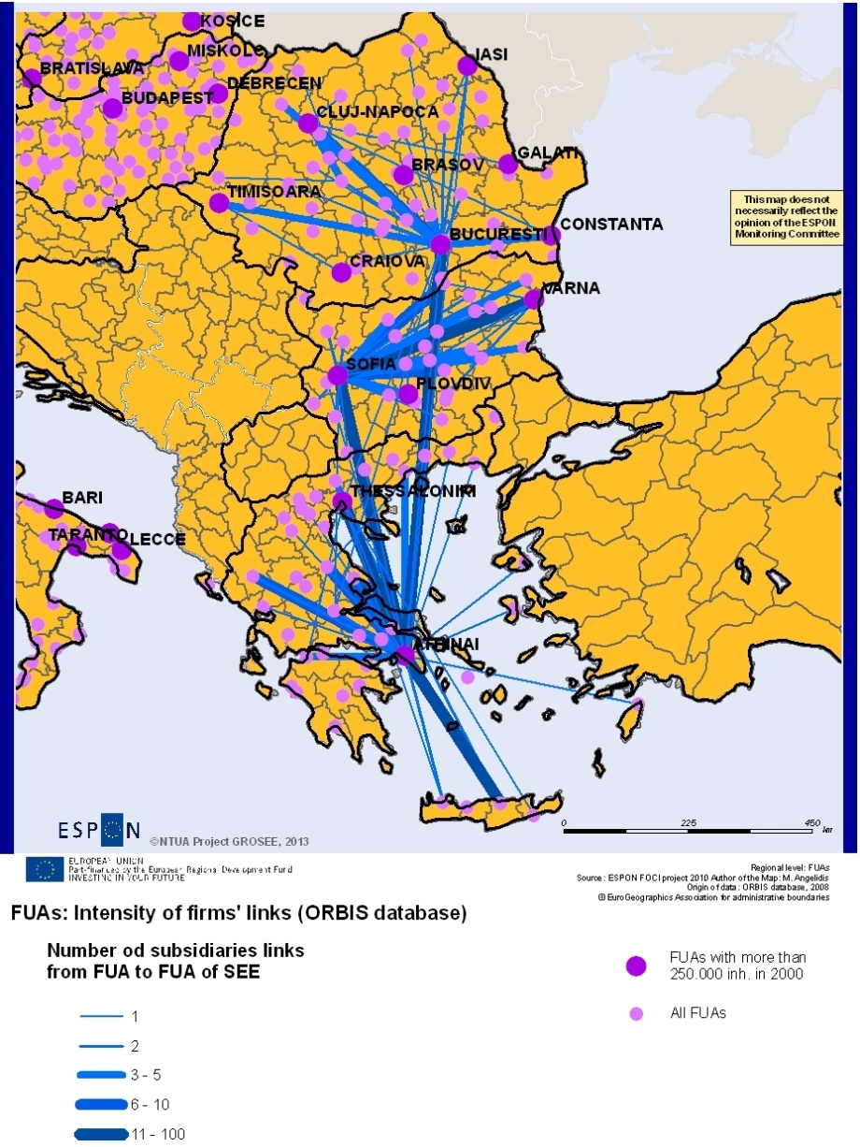
Own elaboration, based on Eurostat data

Looking into the three countries to analyse the networking of cities through firm links provides the following results: Headquarters located in Athens control 113 subsidiaries located in other Greek FUAs and 655 that are located in Athens’ metropolitan area (i.e.85% of the total). The shares for Bucharest and Sofia are slightly smaller. Thessaloniki, Varna and Cluj-Napoca follow.
Linkages among firms as well as linkages among research centres are very meaningful regarding the drivers of competitiveness for the three capitals and countries as well as the entire SEE, because both research centres and the subsidiaries included in the ORBIS database constitute (even at different degrees) comparatively more competitive, internationalised and modernized parts of the economy of the three capitals and countries (the enterprises not included in the ORBIS database are medium sized, small or very small). Although we refer to two aspects of competitiveness which are not of the same nature and our research covers only a part of those linkages, we can draw some interesting conclusions: (a) To the extent that each of the three capitals, the countries and the entire SEE are involved in dynamic clusters of research or economic branches, they participate in clusters in which the leading role is assumed by cities or groups of cities or mega-regions outside the SEE. Networking and even more clustering in the research and the economy inside the SEE is undoubtedly weak. (b) The units of the most competitive branches in the national territories are also strongly dominated by the three capitals. Therefore, it seems that cities situated outside the capitals do not profit enough from the potential positive effects of enterprises clustering (of different groups of branches) at national and regional level. In other words, the three capitals do not redistribute enough innovation and, more generally, they do not reinforce competitiveness to the rest of their countries. This refers more to Athens and less to Bucharest and Sofia.

Accessibility and connectivity inside the three capitals as well as at different territorial levels (countries, SEE, Europe) have different aspects. Regarding the attractiveness of the capitals (as well as SEE) for investments, the level of accessibility from inside the city to its transport gates (airports, ports, major external highways) as well as accessibility to basic services and to industrial and business zones of the city counts. The degree of accessibility for each specific type is in general (see in detail in chapter A5.3 and 5.5) moderate.
Also, the degrees of social cohesion and the state of the environment are important indicators of the citizens’ life quality in the three MRs as well as the attractiveness for investments. From this point of view, they have also a moderate performance in comparison with other EU regions (see in detail in chapter 5.2 and 5.4)
The FMA of Attiki is equivalent to one NUTS2 (GR30), but also to only one NUTS3 level unit (GR300). It includes three basic levels of governance structures: (a) The level of “Decentralized administration” of Attiki (designated by the central government) whose competencies include (among others) regional development and regional planning issues. (b) The level of the “Region” of Attiki (elected) and the municipalities, (elected) that have competencies on the provision of public services, environment and quality of life and are involved in spatial development planning (close to their level). The MR of Bucharest includes two levels of governance structures: the county (judeţ) level which corresponds to NUTS3 and the local level of towns and communes which corresponds to the LAU2 level. In both cases, the authorities are elected. The NUTS2 regional level is a simple delineation for programming purposes. There is also an administrative structure of the capital city. All these governance structures have competencies on the provision of public services, environment and quality of life and are involved in spatial development planning. Sofia capital is administratively organized in 24 city regions, 2 of them have in addition a separate city status. All regions are subjected to the decisions approved by the city council of Sofia municipality and have regional mayors, appointed by the mayor of Sofia. Sofia municipality has competencies on the provision of public services, environment and quality of life and is involved in spatial development planning.

To conclude this sub-chapter, we should emphasize the impact of the recent crisis on the existing and potential drivers of competitiveness of the three capitals and SEE. This is undoubtedly a crisis of the entire EU that had a more intense impact on some countries / regions of “South” and “East” EU, such as Greece / Attiki, Romania / Bucharest and Bulgaria/Sofia. As it has recently (January 2013) been acknowledged by IMF, the crisis exit plan, which was proposed for Greece, caused a recession stronger than it was projected. Regardless of the above, the crisis demonstrated that the types of development realised in the three countries and capitals (independently from the declarations of intentions of the development plans) were not sufficiently resilient to the recent economic crisis. Nowadays, the components of development as well as drivers of competitiveness of the SEE capitals and countries have been considerably modified due to the crisis. We should therefore consider in GROSEE either the pre-crisis period trends or the crisis period ones in order to build different alternative scenarios of future development. In our opinion, this is a difficult and little useful exercise. Instead, we could take thoroughly into account (for policy recommendations) the declared intentions of the interested governments to associate the crisis exit with reforms addressing the weaknesses and enhancing the strengths of the countries’ (and capitals’) drivers of competitiveness.

A summary SWOT analysis regarding the drivers of competitiveness of the three capitals and SEE has been made, that will be further developed for the pre-final report.
- The actual breakdown of different sectors in the three capitals presents specific weaknesses due to the high share of sectors which are not relevant for export, such as constructions, several service branches as well as a high share of industrial enterprises that are not competitive at the world level.
- A second weakness, which is closely interrelated with the first, regards the comparatively low level of R&D due to low investment in R&D in the three capital cities. On the contrary, the existence of a sufficient quantity of human capital with high level skills concerning both, the entire economy and the specific sector of R&D, constitutes undoubtedly an important strength.
- Also, territorial cooperation through the networking of firms and research centres and, even more, through clustering represents the third weak point of the three capitals.
- Concerning internal connectivity to public services as well as business and industry zones, some weaknesses still remain because the recent improvements have not been completed and territorial planning is inefficiently implemented to some extent. Here again there is a challenge for the respective national, metropolitan and local authorities to transform these weaknesses to opportunities by completing the relevant interventions and improving the implementation of the territorial planning using EU as well as national and local funding.
- Therefore, the three capitals have considerable opportunities to develop more industry and dynamic services as well as tourism and culture activities. The main opportunity for the three capitals is to develop R&D activities (with more expenditure and long term investments) in order to spread innovation and High Technology (HT) throughout the entire economy as well as to develop specific branches of HT and Advanced Producer Services (APS).
- Here again, further exploitation of the transport / communication infrastructures that have been at a first level improved using the EU CSF funding is a considerable opportunity for the three capitals and SEE.

Comparison of the three capitals with other European cities as for the drivers of competitiveness
It is useful to compare the competitiveness feature of the three SEE capitals with the respective features of the EU cities. However, it is even more useful in the frame of this project to compare the three capitals with other EU metropolitan regions, the other capitals of EU countries and specific “economic capitals” what are economic capitals?. Thus the results of the comparison would be more useful for the preparation of policy recommendations. Specifically, we compared the SEE capitals:
(a) With the EU Metropolitan regions (MR), as the latter have a development pattern as well as a role in territorial development closer to that of the three SEE capitals. Eurostat and DG Regio (2012) have characterized 253 cities of the EU wider area (EU27, Croatia, Norway and Switzerland) as Metropolitan Regions (MR) according to the population criteria. Starting from the respective Urban Audit LUZs, they have approximated the area of the MR with NUTS3 units. Attiki corresponds to NUTS GR300 (FMA for GROSEE), Sofia to BG411 (CC for GROSEE) and Bucharest to RO321 (CC for GROSEE). We noted at first that, in general lines, EU metropolitan regions develop faster than other EU cities and their countries. Specifically the SEE capitals do the same (Figure 8).
Figure 8 Per capita GDP PPS in % of the EU27 average (=100) in 2009 per capital and country of the EU27
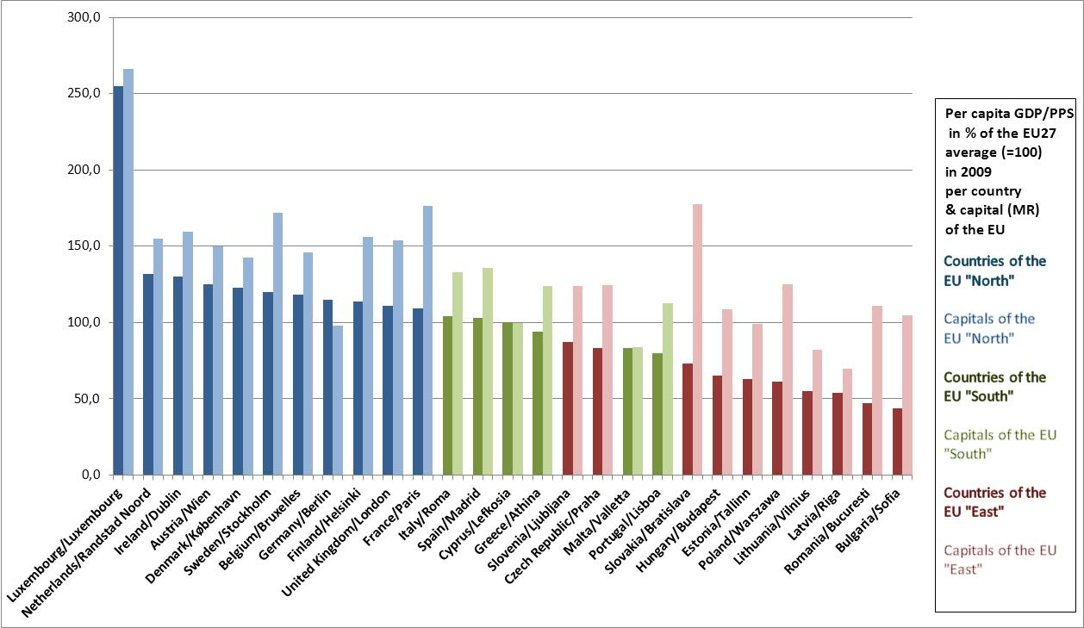
Own elaboration, based on Eurostat data

(b) With the capitals of other EU countries. We have selected from this category a restricted number of case studies: Stockholm, a capital of an EU “north’ country and Rome, capital of an EU “south” country; the population of Rome is comparable to that of Attiki and this one of Stockholm to those of the two other SEE capitals. We have specifically found that the three SEE capitals had in 2009 a GDP in PPS per capita higher than the EU27 average: (124 for Athens, 111 for Bucharest and 105 for Sofia) (Figure 8) and (Annex Map II). The highest values correspond to MR of the Pentagon. Stockholm, capital / case study of the EU “north”, has clearly higher value than the SEE capitals (172), while Rome, capital / case study of the EU “south” has a higher value (133) than Attiki..
(c) With MR having an important role of “economic” capital, situated in other parts of the EU and having comparable population with those of the SEE capitals. In fact, the capitals of the three SEE countries have both a role of administrative capital and a role of an economic capital of a large region (the respective country). From this scope, we selected: Munich and Lyon which are “economic capitals” of large regions of their respective countries; their population are comparable to those of the Bucharest and Sofia. Both belong to the EU “North”
The European MR performed better before the crisis than the respective countries but the difference of the three SEE capitals from their countries was even higher. Sofia and Bucharest performed impressively higher than their countries, like the other “Eastern” capitals.
During 2001-2008 -before the crisis- the three capitals have progressed much better than the majority of the other European MRs. Specifically, their gains as for the GDP in PPS measured in percentage of the EU27 average (=100) were very high – Annex Map II. Bucharest showed the highest value as for the gains in percentage points among all European MRs (61). Sofia and Athens follow at lower places (45 and 20 respectively). During the crisis years 2009-2010, Attiki MR recorded a high loss in % of the EU27 average (from 124 to 115) while the respective index values for Bucharest and Sofia remained roughly stable. Munich and Lyon “lost” (in comparison of the EU average) before the crisis (-16 points for Munich) and “gained” during the crisis. Stockholm improved its position a little before and a little during the crisis.
The results of the comparison of sector breakdowns of the three capitals with the rest of European MR (Eurostat data) corroborate those of analogue analyses presented before. Regarding labour force, according to available data, we came to the conclusions similar to those of chapter 5.1. Performance as for the technological and innovation readiness is the weakest point of the three capitals as well as of the other MRs of SEE. As for the patent applications to the EPO per million of inhabitants for 2008 the differences of the 3 “North” capitals from the SEE ones are extremely large. The respective values are: Munich: 637, Stockholm: 478, Lyon: 284, Rome: 49, Attiki: 13, Bucharest: 8 and Sofia: 8. This analysis is on-going and its final results will be presented in the pre-final report.

However, taking also into account the results of other previous ESPON projects already cited, we can reach some preliminary conclusions (with some reservations which will be addressed for the pre-final report): The SEE capitals presented a considerable growth in terms of GDP before the crisis, much higher in % than their countries, as well as the capitals of the EU “north”. However, as for activities of primary importance for competitiveness, their distance from the EU “north” remains impressively high. We should also note that the respective features for Attiki are closer to the EU “south” development pattern while the features of Sofia and Bucharest are closer to the EU “east” pattern.

It seems that the integration of the SEE capitals in the EU cities’ network has progressed considerably. Starting from the most powerful poles of the EU core, the integration estimated on the basis of the intensity of the economic and transport links, has gradually been extended mostly to the south and central-eastern metropolises and less to the smaller and medium-sized cities. Regarding SEE, the capitals have mostly been integrated.

Drivers of competitiveness of the three capitals in the metropolitan and national contexts
Regarding the three territorial levels/zones of the MRs: CC, FMA and OMR (Outer Metropolitan Ring), it seems that in all three cases the CCs, which had earlier higher competitiveness, have gradually integrated the other areas of the FMAs and transmitted to a large part of them the development dynamics and the competitiveness of the City Cores. In other words, the CC functioned as a strong territorial driver of competitiveness for the large part of their FMAs; this is particularly evident for the eastern area of Attiki and for Ilfov in the case of Bucharest.
Overall, the three capitals do not redistribute enough innovation and technological readiness and, more generally, they do not function as territorial drivers of competitiveness for the rest of the countries.

Drivers of competitiveness of the three capital cities in the context of the SEE and the wider Balkan area
During the decade of the pre-crisis period, the three capitals functioned as major engines of the development of their countries and SEE. On the other hand, on the evidence basis provided above, the economic cooperation / interdependency among them has increased considerably. The most important territorial driver of competiveness in this context was the Direct Investment (DI) from Attiki to Bucharest and Sofia regarding specific branches such as the financial sector (mainly the banks), telecommunications, retail trade (hyper markets) and specific branches of services and, at a lower level, infrastructures construction, housing as well as real estate. DI in industry has been directed less to Sofia and Bucharest and more to the regional capitals and to the smaller cities in the two countries. Territorial cooperation in research had more or less the same territorial feature; it was more centred on the three capitals and much less to the rest of the three countries.
This kind of cooperation has not been limited only to the three capitals and countries, but has also been extended to their neighbouring areas of Western Balkans and Turkey regarding all the three capitals as well as Moldavia regarding Bucharest. Starting from Attiki and Greece, in the same type of cooperation / interdependency which has been described above for the three capitals, Belgrade, Skopje, Tirana and Istanbul have gradually been included.
This interdependency that decelerated during the crisis period constitutes an important driver of competitiveness for the three capitals and SEE because it considerably increased investments in SEE and enabled the turnover increase in a large number of enterprises in relation to their improvement in R&D.

Drivers of competitiveness of the three capital cities in the context of Europe and the world
On the basis also of the evidence provided in sub-chapter 2, economic exchanges among the three capitals and SEE with Europe concern mainly western Europe and are focused on specific branches of industry and services. Western Europe FDI contributes to the raise of the competitiveness of the three capitals and SEE but at the expense of a growing deficit of the SEE economies regarding the balance of their external trade.
Finally, an important territorial driver of competitiveness regarding these multi-level interdependencies is the continuous increase of the accessibility in the three capitals and SEE to the rest of the EU space through the improvement of the transport axes at European level, mainly those included in the TEN-T.

Accessibility and connectivity

Accessibility has become a key term in development policies and strategies at local, regional, national or EU scale. Its overuse or sometimes improper use deprives it from significance or from its instrumental purpose. The level of accessibility “to” or ”of” places may often be a push or a pull factor in their development. Increasing accessibility should be constantly seen as a mean to achieve urban competitiveness and growth and not as a purpose by itself.
Accessibility of urban areas, poles or transport networks has been widely targeted in previous ESPON projects, some of them including also the SEE area in the analysis. Among them, ESPON 1.2.1. Transport Trends, which provides first of all a very solid methodological base that can be used for the analysis of accessibility and connectivity at different spatial levels, but also an overview of the situation of accessibility in Europe (including the SEE area) as it was at the moment this project was completed. Although the ESPON project TRACC (Transport accessibility at regional/local scale and patterns in Europe) does not focus on case studies from SEE, the respective countries are included in the analysis at European level. Greece is the only SEE country for which one can find more detailed background information, especially concerning previous accessibility approaches. The ESPON project 2.4.2 Integrated analysis of transnational and national territories based on ESPON results provided a solid analysis of the situation at that moment in the three countries that GROSEE focuses on, as well as on the connections within the entire European space.
A series of indicators are used in order to measure the connectivity – which is the efficiency of transport networks and the connexity – a minimal measure of the coherence of a transport network. The measurement of the connectivity uses the number of nodes and links. In this case, we must accept that our calculations will reflect the properties of the network and not of the transportation system (the means of transportation or the operating technologies are not considered) which is more versatile. In order to obtain the number of nodes and links, the vector data from JRC Trans Tools gives the possibility, through spatial joint procedures, to calculate the exact number of nodes and links by NUTS0 and NUTS2 that we retain as the most important in our measurements.

Current situation
In order to establish the current state of accessibility and connectivity in South East Europe, we have started with an overview of the existent transport infrastructure, correlating it, in the case of air transport, with statistic data regarding the passenger and freight traffic.

Air transport
The number of commercial airports in every country varies in the SEE area, not only according to the surface (which can explain the greater number of airports in Romania compared to a smaller one in Balkan countries), but also to the morphological characteristics of the territory (the Greek islands provide the greatest part of the airports in the country).The aircraft movements in 2009, as well as the number of passengers in the same year, highlight the dominance of the capitals in all countries (except for Istanbul), but also the relevance of touristic destinations that manage to add balance to the territory. This is especially the case for Greece, through its islands, but also for the Adriatic and the Bulgarian Black Sea coastlines.
For the freight and passengers air transport, the statistical data available on EUROSTAT are for NUTS 2 level. Unfortunately, they do not cover all the existent regions, or the same years. However, the available data for 2009 allow us to observe that for every country the highest quantity of freight is transported in the NUTS 2 region where the capital city is situated, confirming once again the capitals’ dominance and the territory’s uneven servicing. The situation for the passengers‘ air transport is slightly different mainly due to the touristic regions that are attracting a large number of travellers, balancing more the influence of the capitals.
The analysis of the air traffic flows in the area supports the theory of the capitals being the main actors in the territory, not just for international connections, but also for the national ones. It is obvious that they are the main receiver for the international flights and then the connector to the rest of their territory. In the case of Greece and Romania, the influence of Thessaloniki and Timisoara is also noticeable. The flows show a very intense traffic between Athens and Istanbul, Athens-Sofia, Bucharest-Istanbul and Bucharest-Athens. The air traffic between Bucharest and Sofia is lower, due to the short distance, which makes it more suitable for car travelling.
The number of weekly regular flights between capitals shows the very strong influence of Istanbul in the area, as the only city connected to all the capitals, although with differences in terms of flights frequency. A strong connection can be observed between Bucharest- Istanbul, Bucharest – Athens, Athens-Istanbul. Sofia is better connected to Athens than Bucharest and Istanbul. At the same time, it is noticeable that Ljubljana, Belgrade, Sarajevo and Zagreb are much better connected with each other than to the other three capitals. (see also in Annex IV, Map VI, VII and XI)

Rail transport
According to Eurostat data, the countries in the Northern Balkans seem to have more important railway networks. Their tradition is due to their vicinity to the centre of Europe , to morphological aspects that permitted low cost investments and to their inclusion in the industrial machine of the Austrian-Hungarian Empire at the end of the 19th century. Territories in the south-western Balkans (from Bosnia to western Greece) are poorly connected and large areas of the Adriatic coasts are effectively out of the rail network coverage. Considering the rail connection between the three EU countries – Romania Bulgaria and Greece, we have noticed a high level of vulnerability and variability. Thus, the border between these countries is characterized by natural frontiers – the Rhodopes mountains between Greece and Bulgaria (1500-2000m) and the Danube River between Romania and Bulgaria, as well as by few connections: only 2 important connections, out of which only one for each country is used for passenger transportation: Giurgiu - Ruse (RO-BG) and Kulata - Promachon (BG-GR). The railway Bucharest – Giurgiu, leading south, is disconnected since the flooding of 2005 on the river Argeș, that damaged the rail bridge. The variability of the rail network means a lack of regular availability of the trains over the past 23 years. In most cases it derives from the high vulnerability above mentioned, but also from the economic or political decisions taken. For example, the train Sofia – Bucharest – (Moscow) has been interrupted in the past and starting from February 2011, the Greek National Railways have suspended their international non-stop trains from Thessaloniki to Sofia and to Bucharest (see also in Annex IV, Map VIII).
All these create great cuts in the international rail transport as this affects the connection between the city pairs Bucharest – Sofia and Sofia – Thessaloniki. The distance between them (300-350km) is nor big enough to be supported by cost-efficient regular flights and neither short enough to be connected by personal transportation. Improving the axis Bucharest – Sofia – Thessaloniki – Athens with new high-speed railway system seems to be the minimum strategy in order to increase passenger transportation. Good exchanges as well as the diminishing of the network vulnerability to natural risks will create an alternative route, usable by both regular and high-speed trains. The new Calafat-Vidin Bridge (rail and road) which will be fully operational from May 2013 is a great opportunity to connect Bulgaria and Greece to Central Europe although the rail sinuosity of this link (Nădlac HU-RO – Arad – Timișoara – Drobeta- Craiova – Calafat RO-BG Vidin – Sofia – Kulata BG-GR) the operating costs will be high because of the strong meandering of this rail route.

In order to identify the cooperation potential based on distance and time of travelling, which is indispensable to polycentric development, we used the one day trip indicator to establish the degree of contactability among the three capitals and Istanbul and Belgrade, two of the main poles in South East Europe. As used in previous projects, the indicator should take into account the train and air connections, but in this case, since there are no train connections between all capitals and the existent ones do not fit in the time frame set (6.00-22.00, with 6 hours spent at the destination), we could only consider the air connections. As per the 2012-2013 winter schedules of airports, the only pair of capitals that does not allow a day trip is Sofia-Belgrade because there are no direct flights between them and the stopovers would not fit into the set time frame. The rest of the city pairs confirm the existence of favourable connections for one day business or study trips, in some cases with more frequent daily flights (e.g. Athens-Istanbul, Athens-Sofia) providing even more than one possibility to return within the established time frame.

The analysis of the road networks encounters difficulties in the sense of providing comparable data between countries as each country has its own system of standardizing national roads. In order to understand the road networks’ morphology at intra-national level, data on road links and nodes have been appended to NUTS2 regional level. Our analysis on connexity and connectivity through the three indices shows high discrepancies between regions. South Romania and west Bulgaria show high values because of excessive investments in the capital city regions and northern Greece because of an interface role of Thessaloniki area with the rest of Europe. Although Bulgarian national road network which uses a different quality hierarchy, divided into 3 levels does not always reflect high-quality roads, it has a very good overall connectivity comparing to Romania. Some lower values in the Greece regions are due to a very fragmented territory and to the fact that ferry connections to the islands have not been taken into account. However, we may notice very low levels of connection in the Adriatic regions and in northern half of Romania. The higher values in Bulgaria, Greece, Hungary, Slovenia or Austria are also due to a development of the city-outer-rings that diminishes the bottleneck effect and leads to a better connectivity. Romania and the western Balkans need to do improvements in this field (see also in Annex IV, Map X).

Impacts of the "new structure of the European Transport network"
TEN-T Networks have been drawn to insure the north-south or north-west-south-east connectivity (from Central Europe - Vienna and Budapest towards Athens and Istanbul). They reinforce, once more, the central position of the capital cities (Bucharest, Sofia, Budapest, Vienna, Zagreb, Ljubljana) and insure the most important internal needs – Sofia connection to the Black Sea, Bucharest to the Black Sea and to the west, Athens-Thessaloniki or Via Egnatia (east-west). Unfortunately they neither reduce the territorial disparities, nor do they connect poorly connected regions. The national projects for the construction of motorways reflect better this situation. In some cases, pressures have been made to include some projects in TEN-T networks in order to be able to access European funding. It is the case of Iasi -Tîrgu Mureș (RO) motorway project that is aiming to reduce the north-east-north-west disparities and the lack of multiple connections and to create a better east-west corridor between Vienna (AT) – Cluj (RO) – Iasi (RO) – Chisinau (MD) – Odessa (UA). There is also a need for a unified coastal territory in the Black Sea region – a reinforced axis Tulcea – Constanta – Varna – Burgas – Istanbul being able to provide a better access and attractiveness to this touristic area. The Western Balkans also lack coherence in building a strong inter-national road network because of a continuous fragmentation and instability during the past 15 years. EU should plan a future integration in-block of this territory which could provide synergies and solutions for a coherent road network. (see also Annex IV, Map IX)

The Danube became a priority project as water transport is seen by the EU as an efficient alternative to land transport. The Danube’s Strategy initiated by Romania and Austria in June 2011 shows great interest in this sector and will give both parties a key role in managing the projects. The Priority axis no 18 - Rhine/Meuse–Main–Danube inland waterways is supposed to increase navigability and the transfer of freight traffic through multimodal nodes. It will favour the transport of goods mainly west-east, but also east-west if we consider the growing importance of Constanta (RO) harbour in respect to the import of goods from China. The axis 18 is a cleaner and more sustainable alternative to corridor IV as well as to Priority Axis TENT7. The 3 billion Euros estimated overall costs represent great investments that will also favour passenger transport and leisure traffic on the Danube, but on the long-term it must be accompanied by state policies that support cargo traffic on waterways (subsidies, increasing tax for lorry cargo traffic, simplified water-border procedures, and a bigger involvement of the Republic of Serbia in the process etc.) Otherwise, the great risk EU is taking is to invest in inefficient infrastructures that will serve punctual or variable traffic needs.

One of the major preoccupations in road transportation is to create a fluent traffic from NW to SE between Central Europe (with Wien and Budapest as major nodes) on one side and Greece as one of the older EU member States and Turkey as an important commercial partner of EU (and future candidate), along the European corridor no. IV. Other preoccupations envisage a better connection between west and east Balkans. TEN-T Priority Project no. 7 covers these major objectives by trying to link the ports of Patras, Igoumenitsa, Athens, Thessaloniki and Constanta to the heart of the enlarged EU by a continuous motorway. The Greek and Hungarian sectors of this project are more than 90% completed whilst the Romanian and Bulgarian parts are completed to less than 20%.
In order to understand the reduction of the travel time of the TEN-T 7 corridor, we have used the JRC Transtools vector network for simulation inquiries. Travel restrictions have been set in terms of cross-border sections or of ferry-boat passages. There are also restrictions in terms of sinuosity or altitude gain, but the extent of the network and the big amount of data forced us to build or model only in terms of travel speed.
The next comparative table shows travel cost gains between the main city pairs that the TEN-T no 7 Project is likely to influence, in terms of time. The methodology includes setting up travel speeds to each road segment according to TransTools data (revised according to up-to-date modifications) as well as cross-border waiting times (set to 90’ non-Schengen to Schengen/EU countries, 60’ on non-EU to non-EU countries, 20’ for EU to EU countries, 0’ for Schengen to Schengen) or ferryboat across Danube (40’) or across the Egean Sea (35km/h).

Table 4 Travel cost gains between the main city pairs of the TEN-T no 7 Project
Itinerary | Via | Travel time (min)  2013 | Time (min) 2020 (completion of TEN-T no7) | Distance  (km)
Vienna – Istanbul | (RS) Subotica - Belgrade – Kalotina (BG) corridor no 10. | 1010’ |  | 1556
Vienna – Istanbul | (RO) Timisoara – Calafat – Botevgrad – Kulata (BG) TEN-T7 (corridor no 4) | 1080’ | 867’ | 1620
Vienna – Istanbul | Arad – Bucharest (RO) partial TEN-T 7– Stara Zagora (BG) (corridor no 9) | 1074’ | 990’ | 1677
Vienna – Athens | Subotica - Belgrade (RS) – Bogorodica (MK) corridor no 10 | 1045’ |  | 1705
Vienna – Athens | Zagreb (HR) – Belgrade (RS) – Bogorodica (MK) corridor no 10 | 1054’ |  | 1846
Vienna – Athens | (RO) Timisoara – Calafat – Botevgrad – Kulata (BG) TEN-T7 corridor no 4 | 1117’ | 905’ | 1874
Budapest - Constanta | Szeged (HU) – Sibiu – Bucharest (RO) TEN-T7 corridor no 4. | 590’ | 507’ | 1008
Budapest - Constanta | Szeged (HU) – Craiova (RO) partial TEN-T7 corridor no 4 | 624’ | 561’ | 1057
Budapest - Constanta | Debrecen (HU) – Brasov – Ploiesti – Harsova E60 corridor (RO) | 674’ |  | 1074

According to our simulations the completion of the TEN-T no 7 at a motorway level (130 km/h) will bring significant improvements along the European corridor no 4. At the moment, although the passing of the Serbian customs is difficult, Pan-European corridor no 10 (via Belgrade) is the shortest passage from the north to the south of the Balkans in terms of distance as well as in terms of travel time. The completion of the TEN-T no 7 Project at a motorway level will create a time advantage of over 150 minutes (2,5 h) at a regular crossing from Vienna-Budapest towards Istanbul and the rest of Turkey. In the event of Romania and Bulgaria entering the Schengen area, travel time may be reduced by another 60 minutes. The crossing through the other branch of TENT-7 (Arad-Bucharest) and then through a section of the Pan-European corridor no 9 (via Ruse – Stara Zagora) will constitute a good alternative after the improvements of the Romanian branch Timisoara-Constanta.
When considering the passage from central Europe to the Aegean harbours of Greece, the corridor no 10 is still the shortest option (either via Zagreb or Budapest). The TEN-T no 7 Project (corridor no 4) will become the first option after the completion of all sectors. Finally, the completion of the corridor no 4 linking Budapest and the Black Sea at Constanta will bring significant improvements of over 80 minutes either on the Arad-Sibiu branch as well as on the Timisoara – Craiova (southern sector) branch.
The completion of the motorway will actually bring more travel time gains as sinuosity and slopes constitute fewer impediments on motorway sectors but will increase the toll costs which will favour road freight transport over personal transport. There is also a great improvement that via Egnatia brings in term of linking West Balkans (Epirus, Albania and FYROM) to Istanbul and East Balkans in general, but this sector is already completed.
The horizon 2020 for the completion of the TEN-T-7 Project may be not reachable if Romania and Bulgaria do not adjust their national strategies with EU-interest. The recent inclusion (April 2012) of the Romanian planned highway Târgu – Mureș – Iași in TEN-T corridors shows that European interests adjust to national strategies to tackle major internal disparities which represent the national primary interests. At the same time, there has to be greater collaboration between Romanian and Bulgarian governments to meet European interests in the region. As we have shown, the TEN-T 7 Axis will provide major travel time improvements and will (at least for the sector Timișoara – Calafat – Vidin – Sofia) constitute a great opportunity to create a more connected road network, in order to tackle traffic jams, network vulnerability to force majeur, or even to political or social shifts.
Along with the transport networks, another priority of the European policy is to optimise the energy networks (TEN-E), aiming to achieve the targets of the Europe 2020 Agenda (20% reduction of greenhouse gas emissions, 20% increase in energy efficiency and 20% of renewable energy in final energy consumption), ensuring at the same time security of supply and increasing solidarity among states. In order to reach the said targets, in the frame of the Energy Infrastructure Package 12 priority corridors and areas regarding the electricity, gas and oil supplies have been identified and need to be implemented. Among them, the North-South electricity interconnections in Central Eastern and South Eastern Europe, the North-South gas interconnections in Central Eastern and South Eastern Europe, and the Southern Gas Corridor, as well as the Smart Grids for Electricity involve all the 3 countries, enforcing their role in the area, as well as the connection with the western countries. The most important cross-border project in the Southern Gas Corridor, Nabucco, bringing the gas from the Caspian Sea to European market, will cross Turkey, Bulgaria, Romania, Hungary and will end in Austria. Apart from it, other cross-border projects (e.g. Nis-Dimitrovgrad-Sofia gas pipeline) are meant to ensure a better access to resources and increase the cooperation between states, contributing thus to the territorial cohesion improvement.

Conclusions
The accessibility and connectivity analysis shows that in terms of numbers and spatial distribution, the airports are relatively evenly distributed in the SEE territory. It is also obvious that the influence they exert is different. The three capitals and Istanbul are clearly the dominant poles in the area in respect to air transport and they are well connected with each other, but the connectivity inside the SEE area needs to be improved in order to facilitate a better cooperation among all the cities and a more balanced access to the services they provide. The rail infrastructure and connections do not currently support a proper level of accessibility neither inside the SEE area, nor with the rest of the European territory. The road network presents also discrepancies and dysfunctions in terms of connectivity. The main impact of the TEN-T corridors crossing the area will be therefore to provide major travel time improvements and better connections within the area under analysis, as well as with central Europe and Turkey, supporting and emphasizing the role of the three capitals as growth poles.

8 Existing planning and cooperation of the three capitals (preliminary findings)

Existing territorial policy and plans for the capitals and metropolitan areas
The master plans and other urban planning related documents aim at identifying present and future needs and direction for developing the system’s facilities, contributing by default to a better organisation of the capitals and their metropolitan areas. Each of the three capitals has a master plan both for the city itself and for its surrounding area. In some cases (Bucharest, for example), the two plans are relatively disjunctive, because there is no integrative plan. At lower territorial levels, the Bucharest surrounding area is analysed and development policies are formulated in spatial development plans or studies such as the Ilfov County Territorial Plan (2004) or the Strategic Concept For Bucharest 2035 (2011-2012). The first one proposes the development of a satellite system of 13 localities in the immediate proximity of the capital where secondary and tertiary activities should be developed preferentially. The strategic concept presents the major directions and areas for the spatial development of the capital, underlining the importance of the north-south axis and the natural diagonal one of the Dâmboviţa river valley.
The territorial development in the FMA of Attiki is regulated:
(1) By the Regional Operational Programs (ROP) of Attiki. The ROP of Attiki 2007-2013 specifies the directions of the Greek National Spatial Reference Framework (NSRF) 2007-2013. The strategic territorial objective of ROP, as expressed in the NSRF, is the «Enhancement of the international role of the Region of Attica as a European Metropolis in the area of south-eastern Europe and the Mediterranean Sea». In 2012, the Region of Attiki published a report of “preliminary positions” in the frame of the current debate regarding the National Development Strategy for the Programme Period 2014-2010”. The report sets a strategic territorial objective very similar to that of the period 2007-2013 (see before) and proposes the following objectives to achieve this target: (a) Improving the attractiveness of the region as International Business Centre (b) Improving competitiveness of the economy through support of innovation, entrepreneurship, research and development as well as spread and exploitation of new information technologies (c) Improving quality of life and protection of the environment (d) Creating more and better jobs.
(2) By specific Master Plans (“Rythmistika Sxedia”) or Strategic Plans. The most recent development on this matter is the introduction in 2011 of a new proposal of “Strategic Plan for Athens” (SPA) 2021, which is actually under discussion by the interested national, metropolitan and local authorities and bodies. SPA 2021 promotes the following principles of territorial development: polycentricity, complementarity, networking, competitiveness, environmental sustainability, balanced development, social cohesion. Specifically, it supports development of the metropolitan centre of Attiki, constituted by the twin poles of Athens and Piraeus, as well as a number of development poles and axes in the different areas of Attiki, in the frame of a polycentric development objective. It also specifies objectives for the infrastructures, the preservation areas etc.
Finally, in the relatively recent Greek Spatial Plans and Programmes for Tourism, Industry, Renewable Sources of Energy and Transport infrastructure, the role of Athens is crucial, mainly as node of redistribution and diffusion of the development at national and transnational level. Specifically, these plans give emphasis to the links of the national networks of transport and energy with the respective TENs through the SE Europe area.
Existing transport policy and planning in both Bucharest and Attiki set as primary objective to upgrade and expand the transport infrastructure with priority to the public transport means. They focus on the integrated use of the multiple transport modes at the level of the metropolitan areas with emphasis on the improvement of multimodal transport. Bucharest planning gives also priority to the increase of the traffic capacity of the arteries and their connection with the motorway while Attiki plans preview construction of a limited number of new highways and upgrade of selected regional road axes. Planning for both capitals emphasizes on improving their connection with SEE and the rest of the EU space.

Sofia capital is governed in line with the main strategic document on municipal level – the Plan for Development of Sofia Municipality (PDSM), which corresponds to the National Strategy Framework and the Master Plan of Sofia. Both documents point out the key positioning of Sofia as a crossroad of three Pan-European corridors and the potential of the city to further develop as a major communication centre. In regard to this the construction of the Kalotina Motorway that will connect Sofia - Nish and Belgrade along the Pan-European corridor No 10 branch C (already opened for tender) is of great importance, as well the rail connection along the 8th Pan-European transport corridor between Bulgaria and FYROM. At municipal level 4 linear objects of major importance for the development of the city have been identified – three boulevards (East tangent, West Tangent, bul. Todor Kableshkov) and the third metro diameter, which is to be constructed. The construction of the third metro line is also definitive for the future reorganisation of the public transport. In 2012 Sofia municipality presented a new integrated urban transport plan, aiming to address major problems as regulation of traffic and avoiding congestion; reconstruction and completion of the city transport network; development of underground parking lots; modernization of street lighting; construction and repair of bridges and multi-level junctions; completion of the metro-lines, etc. In addition a new integrated plan for urban development is being developed as part of the cohesion policy of EU for 2014-2020. The plan envisages 6 urban impact zones – 2 zones with predominating social functions in northwest and west direction of the city, 2 zones with potential for economic development – to the east and to the north of the city, 2 zones with public functions of great significance – the centre of the city and Studentsky grad, where the campuses of most universities are located.
Table 5 Number of projects where one of the three countries acts as LP
 |  | Number of projects where the three countries act as LP
 |  | RO | BG | GR
Acting as Project Partner | RO |  | 1 | 5
Acting as Project Partner | BG | 0 |  | 6
Acting as Project Partner | GR | 0 | 0
Source: UB - CICADIT, Processed data after: http://www.interreg4c.eu/
Revealed Cooperation by INTERREG Program
Concerning the cooperation between the three metropolitan areas, the most important source to obtain relevant information consists of qualitative and quantitative data offered by the INTERREG programme IV and the South East Europe Transnational Cooperation Programme.
Regarding lead partners of INTERREG projects, there is a clear dominance for the countries in western Europe, Italy leading in a detached way (33 projects), followed by France, the Netherlands, Spain, Germany and Great Britain (all having 67% of these projects). In total they gather a share of 13% of all participations. Of these countries, Greece has most of the collaborations in projects that have as leader Italy (20), the Netherlands (11), France (11), but also countries such as Finland, Germany, Spain and Great Britain (4 to 7 projects).
At the partnership level between the three countries – Greece, Romania, Bulgaria – practically most of the projects are led by Greece as can be seen in table 6. The explanation for this discrepancy is Greece’s high experience in the INTERREG programme in relation to the other two countries. It can be stated that the collaboration level between the three countries under INTERREG IV C is still low.
By analysing the domains and the regions participating in INTERREG IVC projects, important differences might be remarked: Attiki participates in 19 projects, Bucuresti-Ilfov in 19, while Yugozapaden in 37. Concerning the common areas of interest, it can be noted: Energy and sustainable transport (2 projects for Attiki, 3 for Bucuresti-Ilfov and 9 for Yugozapaden) and Entrepreneurship and SMEs (6 projects for Attiki, 4 for Bucuresti-Ilfov and 5 for Yugozapaden). Projects focusing on these two main domains show the real possibilities for foreseeing future cooperation (see also Annex IV, Figure II).
A zoom at the three metropolises level show Sofia’s detachment (37 projects INTERREG IV C) that appears „hypertrophic” in comparison to the others (Bucharest and Athens, each one with 19 projects). The common interest area for these capitals is Entrepreneurship and SMEs (5 projects for Sofia, 6 for Athens and 4 for Bucharest).
The cross-regional analysis underlines that Attiki and Yugozapaden Region have most of the participations in the INTERREG IVC projects (namely 17% of the total national participation for Attiki, and 51% for Yugozapaden Region). In the case of Romania, the highest share is held by the North-Western Region (21%), followed by Bucharest-Ilfov Region (20%). Therefore there is an enormous discrepancy in Bulgaria, between Sofia and the rest of the country, while in the case of Romania and Greece, the report is more balanced (see also Figure 9).

Figure 9: INTERREG IVC: Number of contracted projects by regions
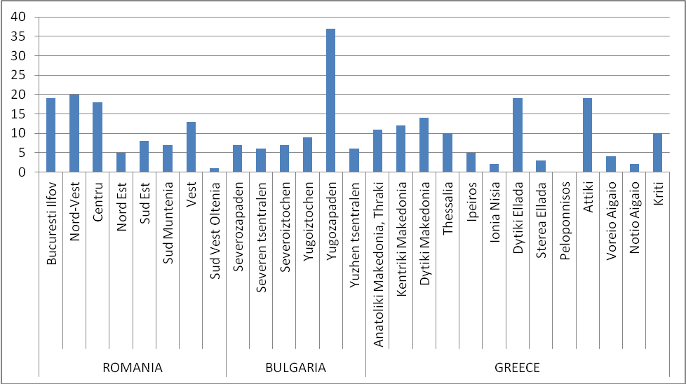
UB - CICADIT, Processed data after: http://www.interreg4c.eu/

Between the three capitals there are 12 partnerships in this type of projects (Yugozapen Region has six partnerships with Attiki Region and 4 with Bucharest-Ilfov, while Bucharest- Ilfov has two common projects with Attiki Region).
The partnership between the border regions in Greece and Bulgaria seems closer in comparison to the one between Bulgaria and Romania. Yugozapaden region has 4 projects in progress, in partnership with Kentriki Makedonia Region and two with Anatoliki, Makedonia, Thraki. The great number of projects involving Greece and Bulgaria neighbouring regions might have an explanation in the fact that they have participated in the INTERREG III programme.
This relatively low number of partnerships between the border regions of the three countries is due to the existence of another INTERREG IV programme that relates exclusively to the transborder cooperation. These projects are more numerous than those aiming at interregional cooperation. From Bulgaria the most efficient unity concerning the submitted projects, as well as the contracts is Ruse. Among the counties that didn’t succeed in contracting any project, we can count Dambovita in Romania and Razgrad in Bulgaria. The INTEREG IVA border cooperation project between Greece and Bulgaria took place between the years 2000-2006. There are currently 89 projects in implementation between Bulgaria and Greece.
The GROSSE project doesn’t aim at analysing the impact of the INTERREG programme; this has already been done in “The Intermediate evaluation of the Interregional Cooperation Programme INTERREG IVC”. Repeating the conclusions highlighted in the respective study does not bring added value and therefore some amendments can be added by analysing the projects implemented by the three capital regions under the transnational cooperation programme South East Europe.
The two main priorities of the INTERREG IVC operational programme are well constructed, covering all the key aspects regarding “growth, jobs and sustainable development” (Interregional Cooperation Programme INTERREG IVC, 2007), but the future programming period should take into consideration the Europe 2020 Strategy. The 10 sub-themes of the INTERREG IVC programme are all included under the three pillars of the strategy and the seven flagship initiatives: “the thematic focus of the current INTERREG IVC programme is already sufficiently broad for ensuring that inter-regional co-operation is able to contribute to the “EU headline targets” and the seven “flagship initiatives” as promoted by the Europe 2020 Strategy” (The Intermediate evaluation of the Interregional Cooperation Programme INTERREG IVC, p. 125), but nevertheless the future sub-themes have to be correlated and referenced to the Europe 2020 Strategy targets. The Europe 2020 Strategy is not without its shortcomings and the careful suggestions made by the ESPON SIESTA project also should be taken into consideration (some regions cannot reach the Europe 2020 targets which are guidelines and not compulsory).
Cooperation between local and regional authorities and economical and social actors (the universities perceived as trainers for the human capital and enterprises in general) in exchanging their experiences and good practices is primordial and this should continue. The EU acknowledges this fact, but more should be done in order to capitalize the results of INTERREG projects. In this respect, future policies elaborated at EU, national, regional or local level should be substantiated upon INTERREG results as well as other operational programmes’ results. Even though the main focus of the INTERREG programme is to support cooperation between local and regional authorities, we cannot overlook the scarce participation of the universities. In this respect universities should be encouraged to involve more actively in project partnerships.
Greek partners from Athens are more present in INTERREG IV C projects in comparison to partners from Bucharest or Sofia and their metropolitan regions. Also, there is a low level of contracting projects as lead partners (in the case of Romania and Bulgaria, especially Bucuresti-Ilfov and Yugozapaden Regions) in the case of the SEE Transnational Cooperation Programme, especially on the priority “Development of transnational synergies for sustainable growth area”. The last two capital cities have to surpass their short term as EU members and focus harder on caching up with Athens. Nevertheless, it should be stated that all the three countries and regions are involved in many projects having as priority the “Protection and the Improvement of the Environment”.
The challenges that the capital cities and their metropolitan regions have to face are severe. The basic infrastructure lacks in most of the rural area from the metropolitan regions of Bucharest and Sofia. The capital cities struggle with infrastructure designed for needs from more than 20 years ago. Rural areas suffer of strong depopulation, lack of working places and lack of basic utilities. Meanwhile in Sofia and Bucharest, the economic development from the last years lead to overcrowding of the road transport system, decrease of environmental conditions and the social housing couldn’t keep up with the increasing number of young people coming to work in the capital city. These are only a few of the most severe challenges that have to be dealt with. Although INTERRREG IV C offers “soft” solutions, local and regional authorities need solutions more to their hard problems. At least Sofia and Bucharest are in a phase were they can learn from the mistakes made by the more developed countries, but still soft solutions are sometimes useless in cases of hard issues. For example the B3Regions project aims to develop broadband services in remote rural areas, but remote rural areas in Romania barely have electricity, not to say a personal computer. There are other financial instruments for the “hard” issues, but these severe challenges have to be taken into account in order to have a proper background for the first ones.
In conclusion, besides the excellent suggestions made in “The Intermediate evaluation of the Interregional Cooperation Programme INTERREG IVC” especially for the SEE, we would emphasize the need:
  - For European, national, regional and local policies to be substantiated upon results from INTERREG projects as well as other operational programmes (SEE Transnational Cooperation Programme);
  - To involve more strongly the universities and the research centers;
  - To better link the future programming period with the Europe 2020 Strategy;
  - To prioritize and implement the most tangible measures and effects that networking, know-how transfer and good practices exchange have to offer in these strongly challenged territories.

9 Synthesis: from the local capacities of the three capitals to their global role (preliminary findings)

As we have already seen, Greece’s GDP per capita in PPS is much higher than that of Bulgaria and Romania. Therefore, in 2009 almost all the NUTS3 regions of Greece had higher GDP than all the respective regions of Bulgaria and Romania (see also Annex IV, Map XII). In Greece, the higher GDP values are observed in Attiki and in its neighbouring NUTS3 units, as well as in the touristic area of Cyclades, followed by the areas of the axis Athens - Thessaloniki and the rest of the touristic island areas. In Bulgaria, the regions of FMA of Sofia and the other big cities: Varna, Burgas and Stara Zagora clearly distinguish from the rest of the country. The same applies to Romania for the regions of FMA of Bucharest and some other big cities: Timisoara, Cluj-Napoca, Brasov and Constanta.

During 2000-2009, the higher % changes of GDP per capita are observed in the Romanian regions with the highest GDP rates corresponding to Bucharest and its closer cities and Timisoara. In Bulgaria the highest change rates are observed in Sofia and its neighbouring regions, as well as in the centre and the west of the country. In Greece relatively higher increases correspond to some island regions and Attiki.
Overall, the three capitals have much higher GDP per capita than their respective countries, but also present higher GDP growth rates than the other regions in their countries.
The dispersion of the regional GDP per inhabitant is a good tool to measure regional development inequalities in a country. In all three countries, regional inequalities (regarding this index at NUTS2 level) rose impressively from 1995 to 2009. However, they increased much more in Bulgaria and Romania, which undergo since 1989 the transition to the market economy and then, in 2007 entered the EU. The "dispersion" analysis in 2009 at NUTS3 level reveals that regional inequalities in all three countries were even more considerable at this territorial level. A very important increase of the index occurred in Greece from 1999, year of entrance in the Euro-zone, until 2009. Similarly significant are the raises for Bulgaria and Romania from 2007, year of entrance of these two countries in the EU, as well as during the pre-accession period (2000-2006).

The three capitals in the respective national urban systems
The ESPON 2006 project 1.1.1 (2005) constructed a typology of Functional Urban Areas / FUAs, which is based on the average scores of seven features and functions of the FUAs: population, transport, tourism, industry, knowledge, decision-making and administration. Subsequent ESPON projects have enriched the definition of FUAs. See in Annex IV, Map XII the FUAs of Greece, Bulgaria and Romania. The ESPON concept of Metropolitan European Growth Areas / MEGAs is even more important for our analysis, as MEGAs of SEE may be seen as the core nodes of a potential “Global Integration Zone” in SEE functioning as a “counterweight” to the “Pentagon”, the most “integrated” area of the EU space. See, among others, for the features and advantages of spatial integration, the ESPON 1.1.1 (2005) and ESPON FOCI (2010) projects.
SEE includes four MEGAs: Athens, Sofia, Bucharest and Thessaloniki. We should notice here that the three capitals play vital, though different roles, in their respective national urban systems. The majority of the other regional urban networks are rather monocentric, as the primary city has a very prominent role. There are few cases of morphologically and functionally polycentric urban systems, which include mostly small and medium sized cities. In Bulgaria and Romania, Sofia and Bucharest constitute strong centres of urban networks at supra-regional and regional levels (with a less powerful role compared to Attiki). The majority of the other regional urban networks are rather polycentric, as the respective primary city has a medium prominent role.
Big cities in their regional role might be seen as diffusion channels of the competitiveness elements, representing the higly specialised services in the territory. At least in the case of Romania and Bulgaria, the decentralization process has just begun and its effects still do not capture the quality of new relationships with the capital. The enlargement of the three capitals’ role in the Western Balkans is very low (perhaps limited to Albania and FYROM), as most of the former republics of Yugoslavia have much stronger and direct connections with Vienna and Budapest.

The SEE in the World and Europe

The integration of SEE in the world
The role and specialization of the countries and of the groups of countries in the world trade are key components of their integration in the world space (see in detail in ESPON TIGER 2012). Bulgaria and Romania are specialised in the export of more labour intensive industries while northern and north-western Europe still focus on the export of manufacturing technological products. While Greece belongs to the Mediterranean countries which occupy intermediate positions regarding exports (between the manufactured and technological goods, on the one hand and the labour intensive goods, on the other), it is still very specialized in no manufactured goods.
Also, the degree of exports’ specialisation in services highlights contrasting roles of the different EU countries in the international division of labour. Greece belongs to a range of countries in which the services trade represents more than half of their goods trade while the respective ratio is around 30% for the entire EU27. Bulgaria and Romania, similarly to the rest of eastern as well as central European countries, have a low share in export of services.
According to the typology developed by the ESPON TIGER project (2012) for the geography of trade at regional and country level:
(a) Bulgaria and Romania belong to Type 1 which includes countries with trade very oriented to Europe, both to central-eastern EU and the eastern neighbourhood of EU.
(b) Greece belongs to Type 4 which is similar to the EU average, but with a trade more oriented toward eastern European regions, China and Japan.

The integration of SEE in the European space
SEE includes Greece, which was integrated in the EU relatively early (1981), and Bulgaria and Romania, which entered the EU much later (2007). The three countries are included not only in the specific spatial pattern of SEE but also in more general spatial patterns that include the 27 EU member states. The following two general typologies are often used in the EU territorial analysis:
(1) The EU 27 countries can be divided in three major types according to their economic performance, measured by their Gross Domestic Product (GDP) per capita: highly developed, moderately developed and less developed countries. See for instance the use of this division in the 5th Cohesion Report (2010) and a detailed discussion of this typology in ESPON INTERCO (2012). We should note that Bulgaria and Romania are included in “less developed” countries, while Greece in “moderately developed” countries.
(2) More interesting is a "territorial" typology that distinguishes the 27 member states of the EU (plus Norway and Switzerland) in three groups according to their geographical location, as follows (see in Figure 10): (a) "Northern countries" - EU "North”: LU, NO, CH, DK, IE, NL, SE, FI, AT, BE, DE, FR and UK (b) “Southern countries” - EU "South": IT, ES, CY, GR, PT and MT (c) “Eastern countries” - EU “East”: SI, CZ, EE, SK, HU, LV, LT, PL, RO and BG. These three "territorial" groups correspond largely to the previous three groups of countries: the "Northern" to the “highly developed” countries, the “Southern” to the “moderately developed” and the “Eastern” to the “less developed” countries (Note: we have used in Figure 10 data for 2008 because this is the year of turning to the crisis, during which successive changes in the relative index values have occurred for some of the EU countries). Obviously, this "territorial" division does not fully follow the ranking of the above ratio of GDP. For example Slovenia, which is part of the "East", has a higher index value than Portugal and Malta, which belong to the "South".

The same figure presents the Candidate and Potential Candidate Countries for EU membership (CC / PCC) - the Western Balkans, which represent the "rest part" of the historical and geographical unit of the Balkans, the “entire” South-East Europe (both in the EU and not). Turkey is also a Potential Candidate country. Because the Western Balkan countries constitute the "neighbourhood" of the SEE, it is worth noticing that a future economic integration of the "entire" SEE will be difficult, as the Western Balkans countries present a significantly lower per capita GDP than the "poorer" countries of EU, with the exception of Croatia, where the GDP per capita in 2008 was higher than that of Romania and Bulgaria.

It should be stressed that during the crisis, the distance between the EU North and the EU South widened considerably (Figure 11).

Figure 10: Per capita GDP in PPS (Purchasing Power Standard) in % of the EU27 average (=100) in 2008, per country, in EU27, Norway and Switzerland –divided in North, South and East- and Western Balkans and Turkey
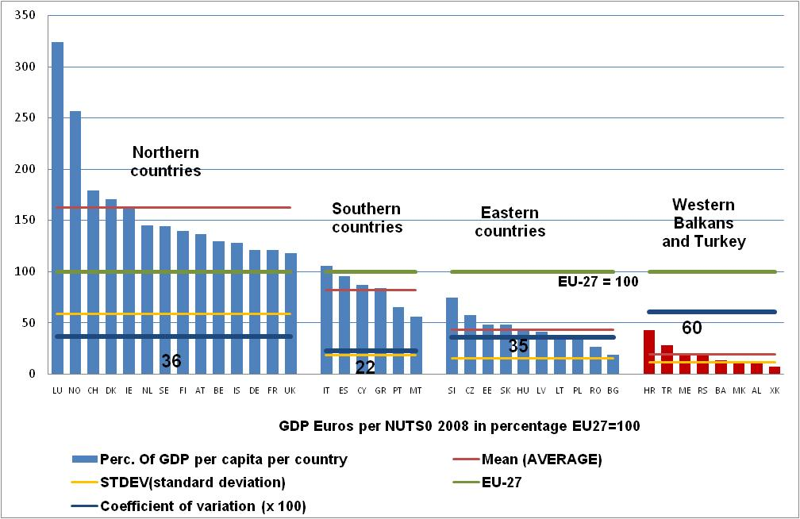
*the figures 36, 32, 35 and 60 represent the average to the EU-27
Own elaboration, based on Eurostat data

Figure 11: Per capita GDP in PPS in % of the EU27 average (=100) during the crisis period 2008-2011, in Euro-zone, SEE countries, Italy, Portugal and Spain
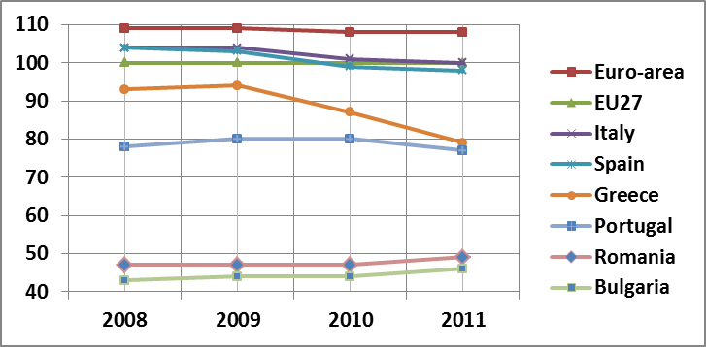
Own elaboration, based on Eurostat data

The SEE countries’ development features and interdependencies
During the ’90s, a reconversion process was undertaken in Bulgaria and Romania similar to that for the rest of the Eastern European (EE) countries: transition to the market economy, continuous integration into the global economy, shrinking of agriculture and industry, raise of the service sector, important economic development difficulties accompanied with a decrease of the population. In Bulgaria and Romania, as in most cases of the EE countries, capital cities attracted population and activities at the expense of the smaller cities and the countryside. Greece followed to a significant extent the South-European economic development pattern: shrinking of agriculture and industry, growth of the service sector and tourism, which is related to some extent to the over-development of the construction sector.
GDP in PPS per capita in most regions of Bulgaria and Romania was less than half of the EU-27 average in both 2008 and 2012, while per capita GDP in Greece was clearly higher.
Before the crisis, from 2000 to 2008, all SEE countries experienced high annual growth rates. The starting year of the crisis (2008) marked a particular strong reversal of the previous tendency in SEE. It is worth noticing that a reversal of similar intensity is also observed in the case of the Western Balkans, which are the SEE "neighbourhood” (EC / DG Economic and Financial Affairs (2012), Backé and Gardó, (2012), Bartlett and Prica, (2012)).
Greece was much more affected by the crisis, while Romania and Bulgaria followed with a comparatively lower per capita GDP decrease. The high level of debt and the following implementation of a not successful model of budgetary adjustment led to greater difficulties in the case of Greece. The way out of the crisis, mainly for Greece (and less for Romania and Bulgaria) depends on the EU response to the more general economic crisis of the entire EU27, primarily of the Eurozone. The three countries try to improve extroversion and competitiveness of their economies, as well as to substitute a part of their imports with domestic production in combination with structural reforms. The improvement of the cooperation and policy coordination among the three SEE countries and capitals could contribute to the successful implementation of the national development strategies.
Concerning the evaluation of the spatial economic interdependences within the SEE but also from / to the rest of the EU, the amount and the spatial orientation of Foreign Direct Investments (FDI) is an important indicator, which is very closely related to competitiveness. The higher share of FDI in all three countries comes from the more developed EU countries. Specifically, FDI towards Romania come above all from Austria, while FDI from Greece to both Romania and Bulgaria hold one of the first places in the respective ranking. They mainly concern financial services and communications (investments by big companies) as well as trade, services, industry, construction and real estate, where investments come from big as well as smaller companies (Iammarino and Pitelis, (2000), Bozhilova, (2010)). Generally, Greek DI in Bulgaria and Romania during the last twenty years had an important impact on the raising of competitiveness through territorial integration in SEE.
In addition, other forms of interdependence among the three countries have gradually been growing, almost continuously, during the last twenty years such as commercial exchanges, tourist flows (from Greece to Bulgaria and Romania at a first stage but also from Bulgaria and Romania to Greece later on) and immigration.
More specifically, immigration from Bulgaria and Romania to Greece (mainly towards Attiki and northern Greece and less to other Greek regions) was much more important than the opposite and concerned mainly the service sector, but also construction, industry and agriculture. It should be stressed that a shift of labour force towards Greece due to higher wages there, matched quickly with a shift of intense labour force industries, mainly small and medium sized, towards Bulgaria and Romania. A shift of significant interest for territorial development regards the relocation of industries of northern Greece to Bulgaria, particularly in the south, in search of lower paid workforce. In general, Greek DI were at first concentrated on Bucharest and Sofia and secondly on the other big cities of Bulgaria and Romania (see in ESPON FOCI 2010 and Angelidis et al., 2011).

In conclusion for the two last sections, Greece followed during the last two decades several particular features of the “South” EU development pattern, while Bulgaria and Romania followed those of “East” EU. In all three countries, the economic crisis has interrupted the high growth rates of the period 2000-2008 and had a greater impact on Greece. The interdependencies among the SEE countries have been developed very significantly over the last twenty years in issues related to competitiveness, such as FDI, trade and tourism, but also shift of labour force especially from Bulgaria and Romania to Greece. However, the dependency links of the three countries on the economies of stronger EU countries in key sectors of competitiveness, such as FDI, have also been significantly deepened. The unequal nature of trade exchanges between SEE and the EU "north” -SEE import from the "north" high technology goods and export to the latter low technology goods - was maintained, if not increased.

10 Policy recommendations and measures and possible projects (preliminary findings)

By analysing the three metropolitan areas in accordance to the plan of the activities provided in the project, some specific recommendations can be drawn; recommendations that take into account the particularities for each metropolitan area, their geo-strategic position at multi-territorial levels, their existent and potential role in the SEE region as well as at national and regional levels, the potential for cooperation and networking among them within a larger political and economic context.
One important element of the evaluation is the complementarities of potential and resources of the three capital regions, which could be better valorised by enhanced cooperation. In this respect the analysis shows that during the last decades cooperation in different fields has increased but there is still room for increasing it in all sectors. The role of the three countries and mainly of their capital regions as major leaders of development and networking is ever more important at geo-strategic level as they represent an important EU anchor in this part of the European continent in terms of relationships with the Asian area.
It should be pointed out that Athens and Attiki play important roles in relation to the eastern Mediterranean basin and Middle East, whereas Sofia is important because of its close relationship with the countries building the former Yugoslavia and Bucharest has a key position for connections to central and north eastern Europe as well as with the Danube and the Black Sea.
Major complementarities can be found in relation to economic patterns as Athens has a strong tertiary sector, whereas Sofia and Bucharest are in a process of economic conversion. All capitals have a developed educational and health sector as well as strong cultural environments. Tourism development can be related to seaside, mountain or business with specific attractiveness for each of the three metropolitan regions.
In transports, Athens is a major SEE harbour, whereas Sofia and Bucharest are important road and railway nodes and all three are significant airlines connectors.
The main policy recommendations resulting from the study so far could be summarised:

- Taking into consideration the economic structure of Athens, but particularly that of Sofia and Bucharest and their metropolitan regions, strong efforts should be made in order to diversify their local and regional economies. In this regard emphasis should be put on manufacturing industries and agriculture and not only on the service sector.
- The rise of the capital cities and their metropolitan areas took place at the expenses of their surrounding towns and regions, and influence territories especially in the rural territories. On the basis of the first and second priority of TA2020, it is recommended for all three metropolises to develop common spatial and socio-economic strategies with their adjacent towns and communes to achieve a more balanced and a better diffusion of development.
- The weak or insufficient cooperation of the three capitals in terms of research and development projects as well as in the economic sector and entrepreneurial activities (especially the direct relation Bucharest / Sofia) was largely recognised as one important shortcoming for the promotion and growth of the whole area. So taking into consideration Europe 2020S and especially the forth priority of TA2020, it is recommended to enhance cooperation in all sectors by setting up cooperation networks in R&D, among entrepreneurial associations, professional organisations as a way to enhance and support an integrative process of the SEE countries in general.
- The strong polarisation and concentration of activities and FDI in the capital cities of Bulgaria and Romania has positive effects at national level but affects a sound and sustainable growth at regional level. To promote the capitals of both countries to a higher ranking in the MEGA hierarchy (ESPON 1.1.1, 2006) it is recommended to establish a special legal and institutional framework for metropolitan regions able to support integrated development projects and strategies and thus develop their metropolitan regions.
- The structural economic convergence of Sofia and Bucharest is still lagging behind according to statistics, which shows that the general restructuring processes are still ongoing. In this respect, both capitals have a tertiary sector that is still less developed as compared to the case of Athens. By increasing the attractiveness for specialised services such as banks and insurance companies, information and communication should be a strategic target for both cities.
- The statistical figures show unfavourable trends for Athens and Attiki regarding the occupation and unemployment, with worrying figures for the young population. It is recommended to improve labour and human resource development policies in parallel to social ones in order to avoid social exclusion and improve access to the labour market. Although unemployment is low and the employment rates are above EU average in both Sofia and Bucharest NUTS2 regions, this is accompanied by a quite low productivity (related to the structure of economic activities too), which must be dealt with. Active policies are necessary aiming to increase the labour productivity by encouraging development of new technologies.
- There is a significant gap between the quality of human resources in terms of knowledge and higher education and the use of this potential in all the three capitals. It is recommended to develop policies, which will support more the R&D sector, by higher financial allocations in the creative and innovative sectors.
- The access to Internet broadband at household level is still lower than EU average. The improvement and expansion of general infrastructure, especially in the metropolitan areas of the three cities are necessary actions for improving communication, access to information (the fifth TA2020 priority), which will support a fast forward social and economic development.
- The superior level of higher education infrastructure in all three capitals represents a valuable potential for the area that could be enhanced and strengthened by developing active cooperation networks among universities and faculties in both educational and research programmes. Organising regional conferences, regional joint educational and research centres or integrated educational master programmes could become important driving factors with synergetic effects, for a recognition of the whole area as an emerging EU region and a pole of competitiveness.
- In order to further increase the competitiveness of the three capitals and their regions it is recommended to better valorise the high cultural and touristic potential by improving infrastructure, services and promotion of the area within common programmes. The social structure of both Sofia and Bucharest metropolitan regions show a certain level of risk for social exclusion, for increase of poverty and social groups with poverty risks, which need active measures and policies aiming to reduce this type of vulnerability, especially affecting the Roma communities and isolated and rapidly ageing rural areas. Furthermore it is recommended to improve social services and the assistance of elderly people and of disadvantaged groups.
- In spite of remarkable progresses done during the last decades, the accessibility of the whole SEE area is still low in comparison to the situation in central and western Europe. It is recommended to consider improvement of accessibility at multilevel scale and by combined and integrated sectorial approaches. Accessibility has still to be improved in relation to the core areas of the EU but also within the Balkan region. (Fig. 12) In this respect it is necessary to expand the pan-European corridors to Athens and to improve the direct road and rail connections of the three capitals. A proposal for a "Balkan corridor" must be envisaged, aiming to better connect the Danube corridor to the Aegean and Mediterranean seas. Relationship to the Black Sea and further to the east of Europe and to the northern Baltic Region should be considered as part of a larger strategy for the eastern half of the continent, in which the role of the three countries and their capitals could be essential.

Figure 12: South-East European polycentric network in regional context

Axis Bucharest – Sofia – Athens – the Balkan connector / corridor

Istanbul and Western Asia

Budapest – Wien and Central Europe
Towards Eastern and North-eastern Europe
Western Balkans and Adriatic Sea
Middle East and Southern Asia
Mediterranean Sea and Northern Africa

- The traffic and communication represent a problem at regional, metropolitan and core cities levels too. Alternative measures for reducing traffic are needed in all the three capitals: improving public transport is especially needed in Athens and Attiki, whereas improving and developing transport infrastructure are still needed in both Bucharest and Sofia. The development of a metro system expanded at metropolitan levels combined with the improvement of the parking systems in the core city areas, bicycle paths and more pedestrian areas should be major objectives in relation to transport for all three capitals. According to TA2020 recommendations mobility plans should be developed for the metropolitan areas and for the regional levels too.
- It is also recommended, as an indirect measure, to reduce traffic problems and improve communication in the metropolitan areas to better control and reduce the sprawl tendencies by a sounder spatial planning and spatial management and control/support the aim to achieve the idea of a "Compact City"
- Important measures and active policies are required in the field of environmental protection and increased resilience to climate change and natural hazards. Most important recommendations relate to improve the waste management in general and increase recycling in particular, as well as to reduce air pollution generated by traffic, while water consumption management should be improved in the case of Sofia where there is an increasing consumption trend. Particular action should be taken by Bucharest to finish the water treatment plant as it is the only EU capital city, which is massively polluting the watercourses.
- To improve the microclimatic conditions and reduce the heating islands in all three capitals specific measures are needed. A general recommendation is the increase of the woodlands green areas around the big cities accompanied by an increased surface of green areas inside the cities too. For Bucharest city it has been already proposed within the spatial plan for the metropolitan area and for the Ilfov county (NUTS3) to set up a green-yellow belt where building development areas will be restricted in favour of green lands.
- Figures show a bad use of the agricultural land around the three big metropolitan areas due to excessive fragmentation and lack of interest. It is recommended to promote urban agriculture, a current trend at international level specific for great metropolises, which improves the urban environment and makes an efficient and rationale land use.
- All three capitals and capital regions are in different ways subject to natural hazards and risks. It is recommended to increase their resilience to earth quakes, landslides or flooding by improved systems of survey and disaster management.
- Improved territorial cooperation is needed by the networking of companies and of research centres, by clustered and improved communication in general.
- A better use of strategic and action planning is needed as well as a more efficient implementation of spatial planning provisions. In spite of numerous planning documents, the spatial development is chaotic and inefficient, creating traffic and environmental problems. An improved and enforced management of spatial planning is needed in all three cases in order to achieve the principles of the more recent EU documents such as the Leipzig Charter, the Toledo Declaration or the Green Paper for Territorial Cohesion. It is also recommended to highly improve through sound and sustainable planning measures, the relationship between the core cities and their metropolitan areas and surrounding regions in order to play the role of a leverage factor at territorial level.
- Upgrade port facilities in order to enhance intermodal transport through cooperation of rail and maritime transport (for freight and passengers).
- To enhance the strategic planning for the SEE it is recommended to set up a regional research centre similar to the NORDREGIO in the Baltic Area.

11. Further proceedings towards the Draft Final Report

Activities
In the next period the TPG will focus on three main activities
- Finalization of Activity A5 concerning existing planning and cooperation among the three capital cities and
- Elaboration of the Activity A6 – Synthesis: from local capacities of the three capitals to their global role
- Elaboration of the Activity A7 – Policy recommendations, policy measures and possible projects

Interviews and questionnaires with local authorities
The TPG intends to organize interviews and questionnaires with local authorities for a better evaluation of the cooperation at local, regional, national and supranational level.

Workshops
Three workshops, in Sofia, Athens and Bucharest will be organized, aiming to present the project and receive a constructive feedback from a wide range of interested parties.

Dissemination
The Lead Partner (University of Bucharest – Interdisciplinary Centre for Advanced Researches in Territorial Dynamics) participated till now in 3 International Conferences and Seminars with 6 Power Point presentations showing preliminary findings of the project and making widely known our scientific aims. At the same time a paper was sent for publication in the Actual Problems of Economics ISSN 1993-6788 . In the next period the TPG is interested in further dissemination activities, the main focus being put on publishing scientific papers dealing with the three case studies and the Balkans.

Project visibility
The GROSEE – Website was launched beginning of March and can be accessed under http://www.grosee.unibuc.eu/. A newsletter is available on the Romanian ESPON Contact Point http://www.esponromania.ro/newsletter/id4/c1/ (last data accessed 25.04.2013).


The ESPON 2013 Programme is part-financed by the European Regional Development Fund, the EU Member States and the Partner States Iceland, Liechtenstein, Norway and Switzerland. It shall support policy development in relation to the aim of territorial cohesion and a harmonious development of the European territory.
ISBN

Since 2007, Eurostat has calculated a new, derived indicator which records the differences between regional per-inhabitant GDP PPS and the national average, and makes them comparable between countries. This dispersion indicator is calculated at NUTS 2 and at NUTS 3 levels. For a given country, the dispersion ‘D’ of the regional GDP of the level 2 (or 3) regions is defined as the sum of the absolute differences between regional and national GDP per inhabitant, weighted on the basis of the regional share of population and expressed in percentage of the national GDP per inhabitant

