Atlantic Area

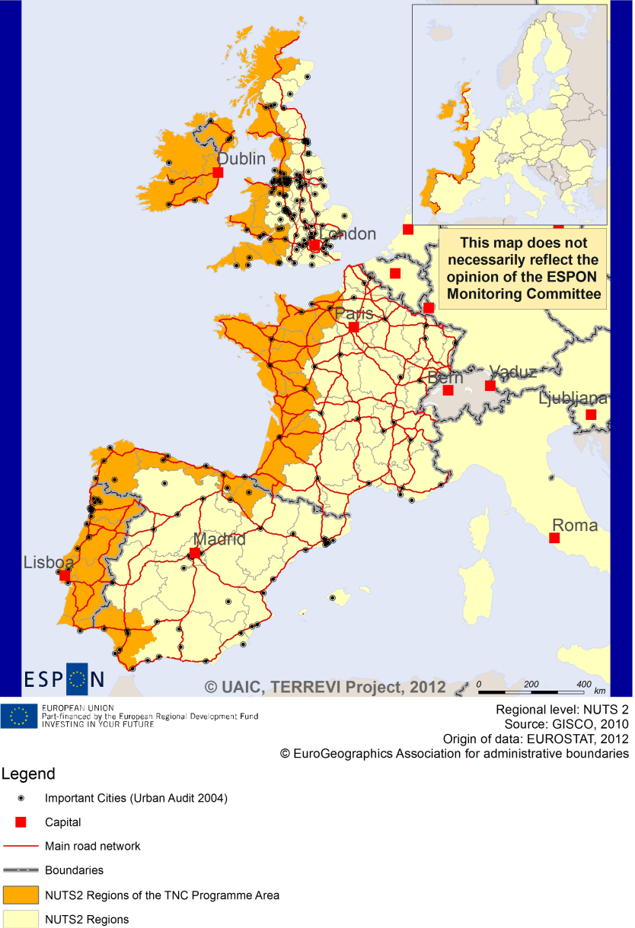

ESPON Project TERREVI

November 2012

# Introduction

ESPON supports policy development in relation to the aim of territorial cohesion and a harmonious development of the European territory. It provides comparable information, evidence, analysis, and scenarios on territorial dynamics, which reveal territorial capitals and development potentials of regions and larger territories. Considering the programme area in its European context adds an important new perspective that can help shaping the programming and the places of implementing projects.

The ESPON TERREVI project focuses on producing evidence for Structural Funds programmes with the aim to support the development of the programmes to be carried out in the 2014-2020 period.

One milestone of this work consists in presenting selected ESPON research pieces in easy-to-understand factsheets for all territorial cooperation programme areas. The aim is to provide the reader with preliminary insight on types of territorial evidence ESPON holds at hand with regard to the possible investment priorities of future programmes. The factsheets certainly only give a first glimpse rather than fully present the work of the large number of ESPON projects that are currently underway. Likewise, each programme area includes diverse development potentials and challenges, which needs targeted information search. However, hopefully this factsheet will contain information, benchmarking the programme area in its larger, territorial context, that is of interest and help to better understand the programme area and to navigate within the richness of ESPON material available.

In addition to the programme factsheets there will be a number of specific programme case studies illustrating how ESPON material can be used to support the development of future programmes e.g. by giving a comparative European dimension to the envisaged SWOTs. These case studies will be carried out in early 2013

This factsheet is structured in three main parts. The first part presents a selection of indicators that help comparing the situation of the programme area in question with the European average, the average for all programme areas as well as the situation in the countries involved. The second part briefly presents the territorial factors of interest for the programme area. The final part offers guidance on the further use of ESPON results and tools. This is intended as an electronic publication so map quality is generally high to allow users to zoom into specific territories.

This factsheet does not necessarily reflect the opinion of the ESPON Monitoring Committee.

# Europe 2020

Europe, with its member states and their regions, is more exposed to global shocks and international competition than at any time before. As the world becomes more interdependent this trend will continue and shape policy thinking across sectors, borders and geographical scales. At the same time, Europe is characterised by a large territorial diversity meaning that global developments can imply rather different development possibilities and challenges for different European regions and cities.

The differences are partly defined by major geographical structures such as urban systems, access and connectivity, the geographical specificity or population density. At the same time, the differences are also spelled out in the larger development trends that affect an area and the way and degree to which it is affected.

The data, indicators and territorial evidence provided by ESPON provides insight on both the main structures and larger territorial trends. The fine art is to identify what can actually be influenced by policy-making and, in particular, by place-based policy and territorial cooperation related to your programme area.

This chapter provides a selection of ESPON data related to Europe 2020 objectives of smart, sustainable and inclusive growth, giving also hints as regards the main thematic objectives envisaged in the draft regulations for the next period of EU Cohesion Policy. The Europe 2020 Strategy aims to enhance smart, sustainable and inclusive growth. This strategy has clear territorial dimensions. However, achieving these goals is challenging in the crisis-driven times. Furthermore, the economic disparities are growing as economic trends and the crisis have various impacts on different parts of Europe.

In the following the traffic light for each indicator represents how your programme territory compares to wider European medians where green = your programme area performs better for that indicator, yellow = similar, and red = worse.

The traffic lights below were created in order to graphically represent the situation of each analysed TNC Area compared to the one of the EU-27+4 space. The median value, calculated depending on the values registered for every NUTS 2/NUTS 3 region composing the programme area was used as the central value indicator. The median of the programme area was compared to the one computed for EU-27+4 territory.

EU 27+4 in traffic lights means the EU Member States as well as Iceland, Liechtenstein, Norway and Switzerland – the ESPON space.

### Smart, Sustainable and Inclusive growth

Smart growth refers to developing an economy based on knowledge and innovation. In the framework of the Europe 2020 Strategy it means improving the EU's performance in education, research/innovation and digital society.

Sustainable growth refers to promoting a more resource efficient, greener and more competitive economy. Within the Europe 2020 Strategy it means e.g. building a more competitive low-carbon economy that makes efficient, sustainable use of resources, protecting the environment, reducing emissions and preventing biodiversity loss, capitalising on Europe's leadership in developing new green technologies and production methods, and introducing efficient smart electricity grids. In the framework of the Europe 2020 Strategy it means focus on competitiveness, resource efficiency, climate change and biodiversity.

Inclusive growth refers to fostering a high-employment economy delivering social and territorial cohesion. Within the Europe 2020 Strategy it means raising Europe’s employment rate, helping people of all ages anticipate and manage change through investment in skills & training, modernising labour markets and welfare systems, and ensuring the benefits of growth reach all parts of the EU. In short the key factors are employment and avoiding risk of poverty and social exclusion.

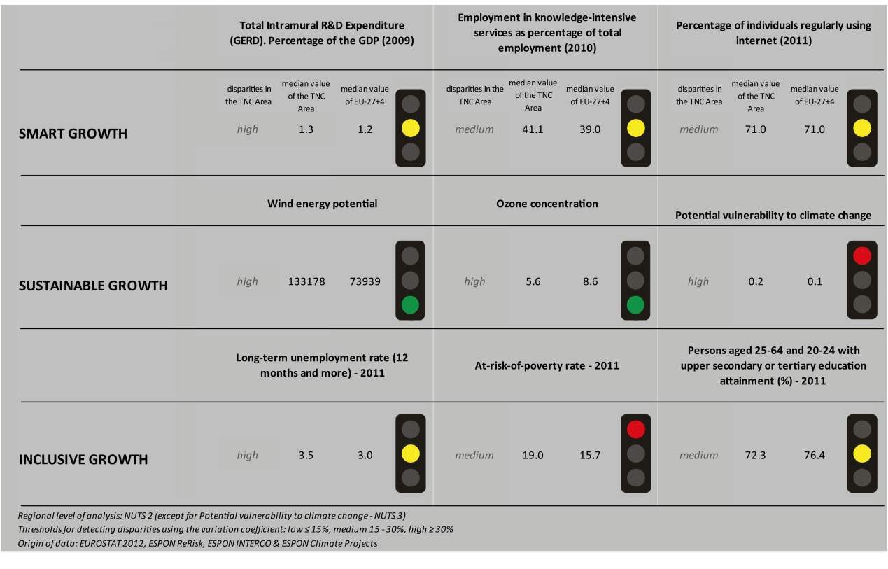

The **Smart Growth** indicators show three yellow traffic lights for the Atlantic Area TNC, meaning that the area’s values of R&D expenditure, employment in knowledge-intensive services and the rate of individuals using the internet on a regular basis are similar to the median value of the EU27+4. Using the taxonomy of the KIT project, Map 1 shows that most parts in the area are mainly ‘smart and creative diversification areas’. However, the areas located in Great Britain and Ireland are mainly ‘smart technological application areas’ but some are even qualified as ‘applied science areas’.

The Atlantic Area’s values for the **sustainable growth** indicators ‘wind energy potential’ and ‘ozone concentration’ are better than for the EU27+4. One must add, however, that the disparities within the area are high for both indicators. Map 2 shows that the area’s fossil fuel consumption is, in general, not affected by the Directive on the promotion of clean and energy-efficient road transport vehicles.

In contrast, the traffic light system shows that the Atlantic Area is more vulnerable to climate change than the EU27+4. Map 3 shows a rather scattered picture on the area’s capacity to adapt to climate change. While Portugal and the Spanish part of the TNC area have a rather low capacity to adapt to climate change, the areas in France, the UK and Ireland show more positive values.

With regards to **inclusive growth**, the Atlantic Area TNC has a higher at-risk-of-poverty rate than the EU27+4. With regards to the rate of persons aged 25-64 and 20-24 with upper secondary or tertiary education attainment, the level of the TNC area is similar to the EU27+4.Also, the long-term-unemployment rate in the TNC area is similar to the EU27+4 level; however, there are high disparities within the area.

Map 5 shows that the employment rate in the area is in fact rather high to very high, but there are disparities between the regions. In fact, the UK has the highest rates of employment in the area with a rate of over 75% in most regions. The values for the regions in France and Ireland range between 65% and 75%. The value is only slightly lower in the north of Spain and Portugal.

In all four DEMIFER scenarios, the predictions about the change in labour force are quite similar. In fact, in all scenarios, the change in labour force is more negative in the north of the UK and the north-east of Portugal and the north of Spain, and positive in the rest of the TNC area.

**MAP 1 – Territorial Patterns of Innovation (ESPON KIT project) for the TNC Atlantic Area**

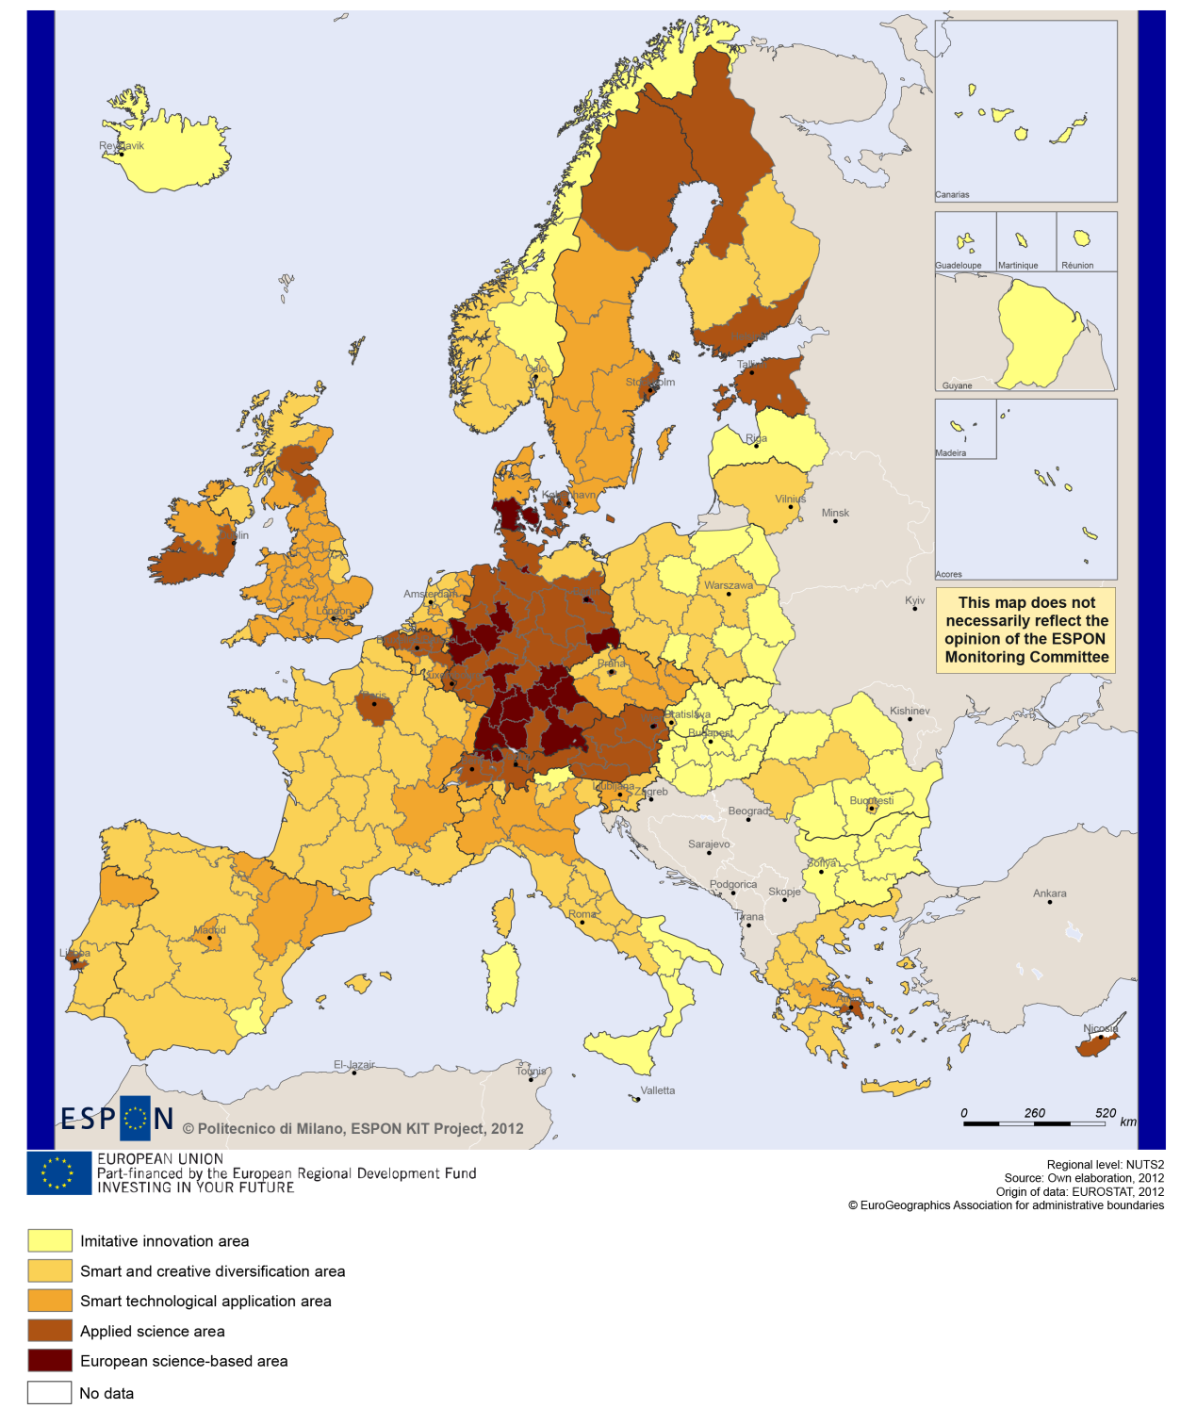

**MAP 2 – Territorial impact on fossil fuel consumption of Directive on the promotion of clean and energy-efficient road transport vehicles (ESPON ARTS project) TNC Atlantic Area**

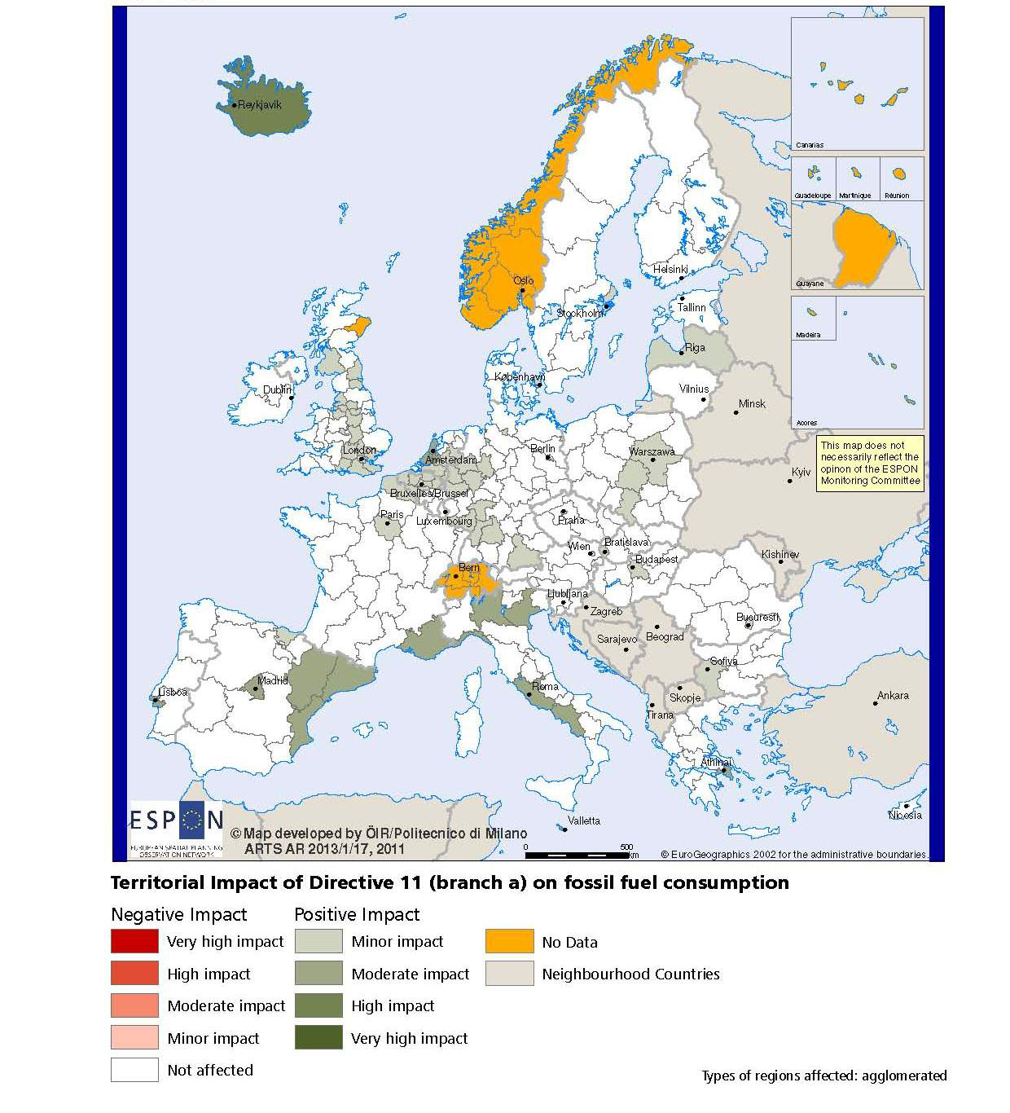

**MAP 3 – Combined adaptive capacity to climate change (ESPON CLIMATE project) for the TNC Atlantic Area**

*“Adaptive capacity (adaptability)” to climate change indicates the ability or potential of a system to respond successfully to climate change and variability, and includes adjustments in behaviour, resources and technologies.*

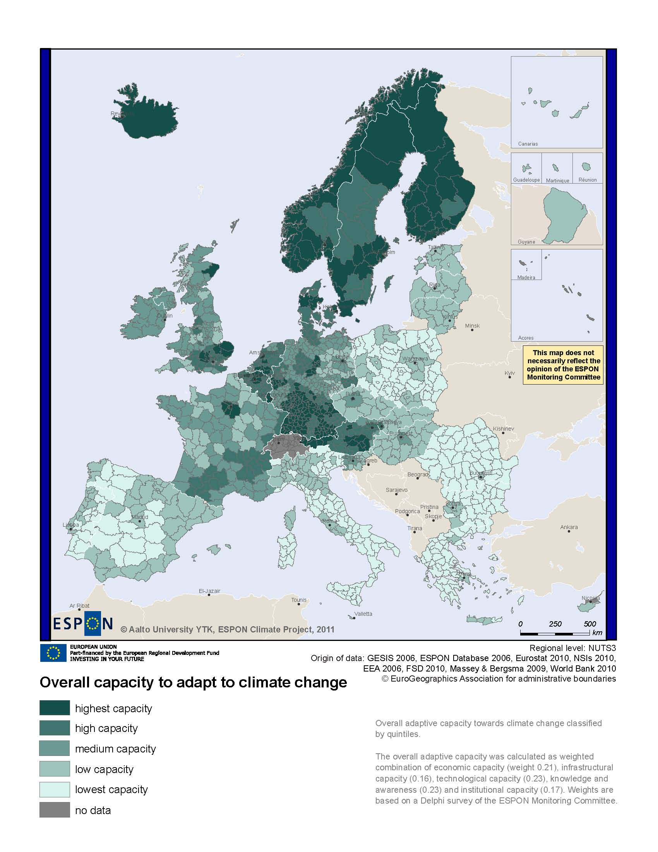

**MAP 4 – Change in Labour Force 2005-2050 (ESPON DEMIFER project) for the TNC Atlantic Area**

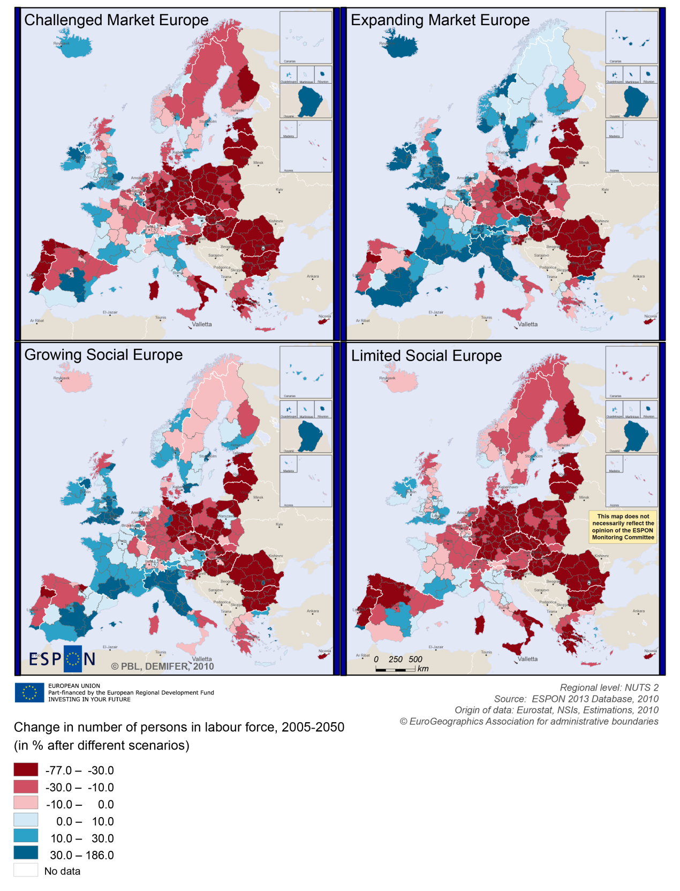

**MAP 5 – Employment rate 2010 within the TNC Atlantic Area**

C:\Dokumente und Einstellungen\pucher\Lokale Einstellungen\Temporary Internet Files\Content.Word\disclaimer.jpg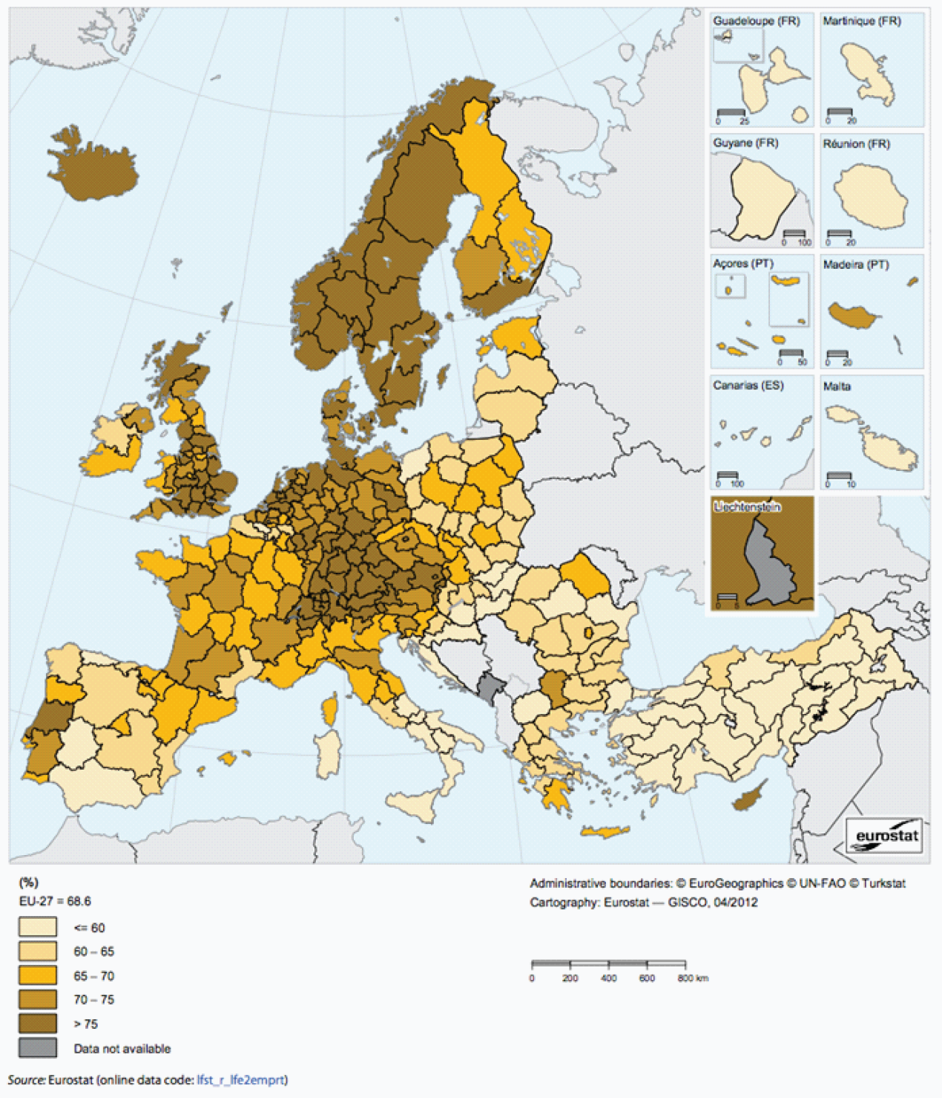

# Territorial factors of interest for the programme area

Territorial cooperation programmes can make a difference for the future development of cross-border and transnational territories in Europe. Some of the factors can be analysed by European wide data sets and using some studies having specific maps, figures and tables concerning the areas of the cooperation region.

Besides a wide range of standard indicators frequently used in the context of European regional policies, ESPON has established various indicators which focus more on the territorial dimension. These indicators provide among others information on the development preconditions of an area. Two standard indicators in this field are rural-urban settings and accessibility.

The Atlantic Area programme area comprises a number of the metropolitan areas such as e.g. Dublin, Edinburgh, Liverpool, Manchester, Bilbao, Porto or Lisbon. Furthermore, some of the main global agglomerations in Europe are located in rather close proximity outside the programme area, i.e. London, Paris or Madrid. The map confirms the presence of both metropolitan areas and a number of smaller growth poles in the programme area. However, it illustrates also territorial differences within the programme area.

Urban areas are a minor part of the programme area, which is in a European perspective rather dominated by intermediate and rural areas and areas in close proximity to a city. Furthermore, there are a number of remote regions. To the remote areas belong some regions on Ireland, large parts of Scotland, the Faroe Islands and the regions along the Portuguese-Spanish border.

Whereas the programme area comprises a number of larger international ports, multimodal accessibility measured by rail, road and air remains in many parts of the programme area around or even below European average values. Indeed, above average accessibility values are mainly to be found for the metropolitan areas. Large parts of the programme area and in particular remote regions have considerably less favourable accessibility values. Also the possibilities for one-day business trips within the European urban network are limited to the urban centres and even there possibilities are often limited.

With regard to geographic specificities, the programme areas is clearly characterised by coastal areas and islands, but it comprises also a large share of mountain areas in particular in the UK, Spain and Portugal and some sparsely populated areas.

In particular the coastal character comes with advantages and challenges. Although it does not come with a specific economic structure, it appears that a significant proportion of areas have high residential attractiveness. In the areas where natural zones dominate – Scotland, most of the Irish coast, northern England, Wales, Aquitaine and a large part of the Spanish coastline – global urban pressure remains moderate. Furthermore, many coastal areas are also characterised by relatively high levels of biodiversity and protected areas. Furthermore, coastal ecosystems provide not only food but habitats for diverse economic-valuable and other species.

Last but not least, it has to be noted that coastal areas and islands are often particularly vulnerable to climate change.

**MAP 6 – Urban-rural typology of NUTS3 regions including remoteness (DG Regio) for the TNC Atlantic Area**

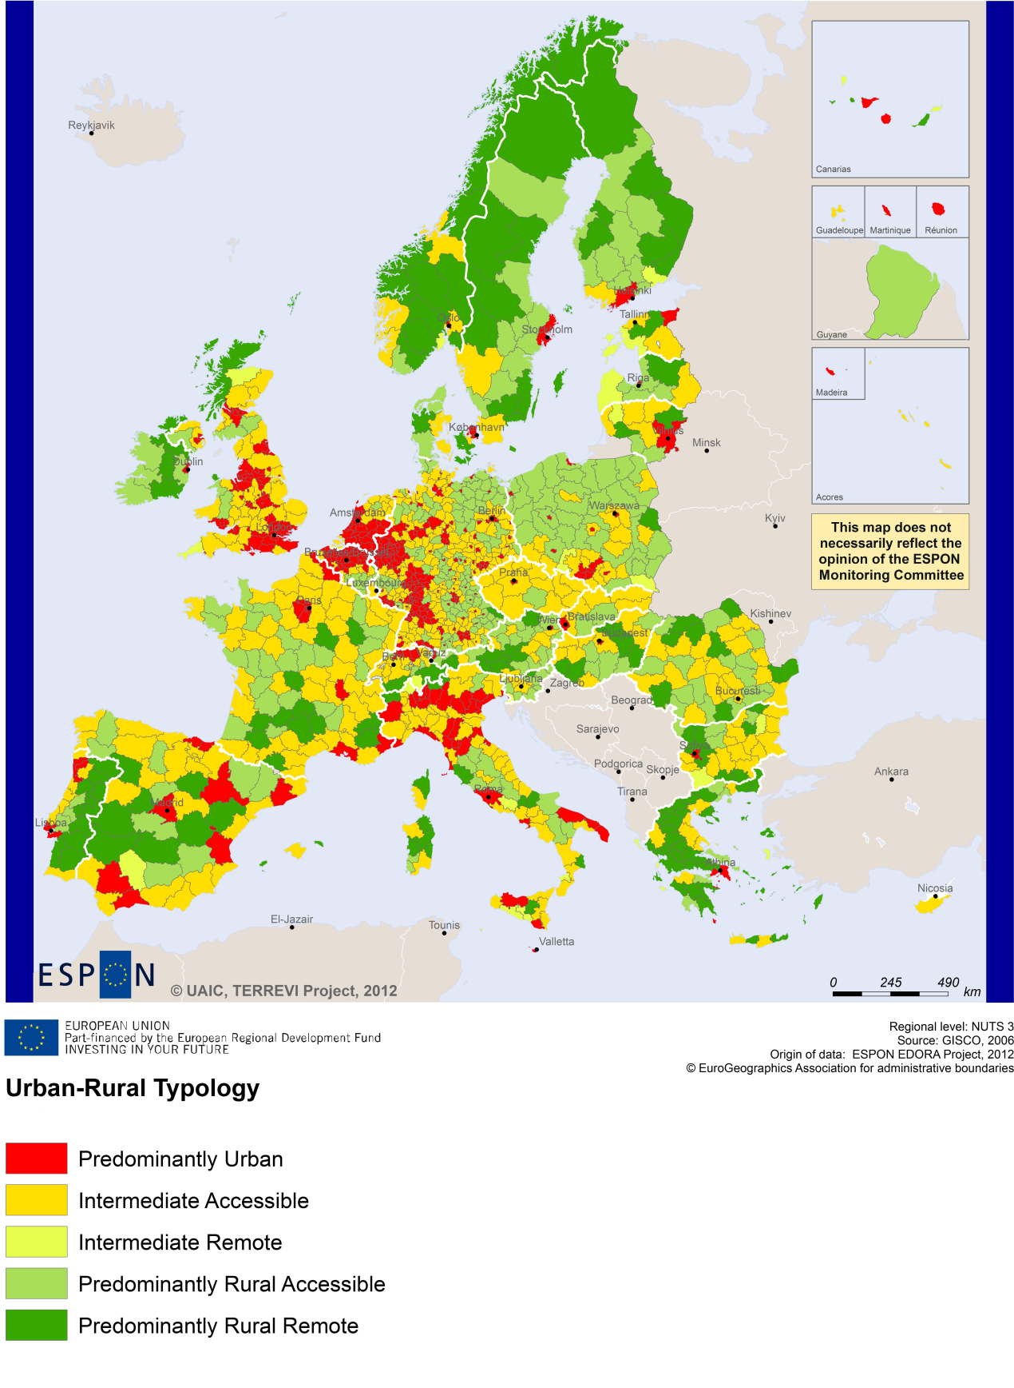

**MAP 7 – Multimodal accessibilty (ESPON Accessibility Update) for the TNC Atlantic Area**

*“Potential Accessibility Multimodal” scores accessibility of NUTS 3 regions by road, rail and air relative to the European average in an Accessibility Index.*

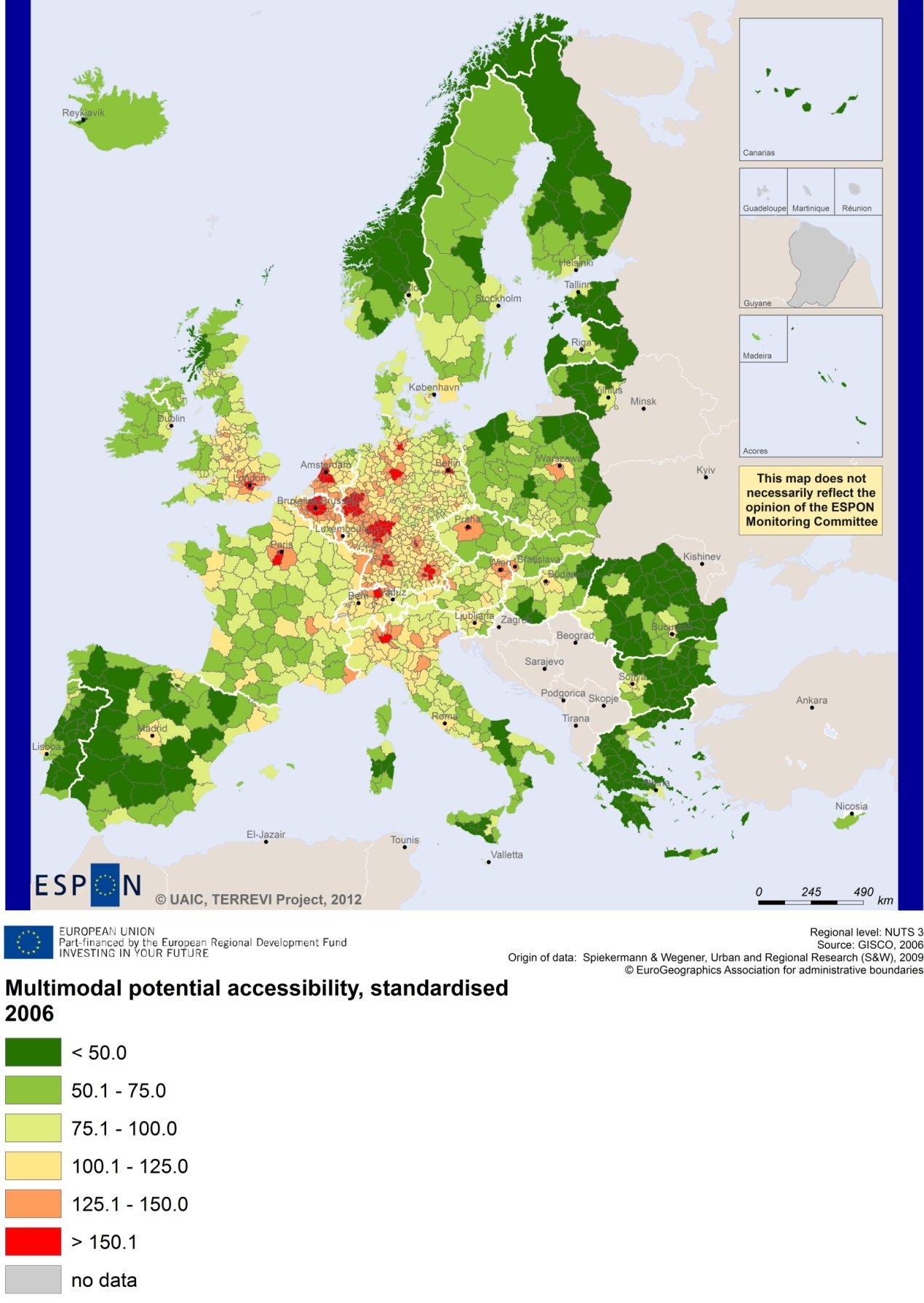

# Recommended ESPON reading

ESPON provides an essential underpinning for translating into practice the calls for integrated and place-based approaches to economic development, when analysing a programme area or deciding about future programme priorities. ESPON has published a wide range of exciting reports providing valuable territorial evidence for future territorial cooperation initiatives.

The table below shows examples of relevant projects for the Cooperation Region. However, you have to study other ESPON reports as well in order to capitalise fully on the European information available for the transnational programming.

|  |  |  |
| --- | --- | --- |
| **ESPON study** | **Topic** | **Content** |
| CAEE | Agglomeration economies | It aims at a better understanding of the economic costs and benefits of large urban agglomerations (see e.g. figure 1). The case studies include Dublin and Manchester (Annexes 2 & 3). |
| TRANSMEC | European cooperation | It develops general tools to support territorial cooperation programmes in capitalisation and considerations on future strategic project development (see map 27 and from map 36 to 39 on potential accessibility indicators). The method is applied for the Northwest-Europe cooperation area. It covers also two projects of Interreg IVB Atlantic Area, i.e. SHAREBIOTECH and ATLANTOX. |
| SGPTD | Growth poles | It provides evidence on European secondary cities, their performance and functional roles in different parts of Europe, and the potential policy intervention affecting their performance (see from figure 2 to 2.12). The case studies include among others Cork (annex of the Scientific Report). |
| ATTREG | Attractiveness | It provides a better understanding of the contribution of European regions’ and cities’ attractiveness to economic performance. The case studies comprise among others Cornwall and the Isles of Scilly, in the United Kingdom (Annex 4/3) and the Algarve, in Portugal (Annex 4/1). |
| GEOSPECS | Specific types of territories | It provides evidence on the strength, weaknesses and development opportunities of specific types of territories and regions (e.g. border areas, highly or sparsely populated areas). The case studies include Highland Council area in Scotland (Annex 24) and the Irish Sea (Annex 31). |
| EATIA | Territorial impact assessment | It tests the practical use of existing methods and tools for Territorial Impact Assessment. A particular focus is on Portugal (Annex 3) and the UK (Annex 1). |
| ReRisk | Energy | It focuses on opportunities to support competitive and clean energy supplies for regions in Europe and to generate and strengthen sustainable energy sources. The case studies include Navarra, in particular in the case of Wind Energy. |
| PURR | Rural regions | It creates and tests new ways to explore the territorial potentials of some rural areas and small and medium-sized towns in peripheral parts of Europe around the North Sea, the Irish Sea and the Baltic Sea. The project analyses the Cambrian Mountains, in Wales, as a case study region. |
| TPM | Territorial performance | It establishes knowledge on how territorial impacts of these macro challenges translate at the regional level and how to deal with these challenges. Two regional highlights concern Navarra and the Greater Dublin Area. |
| KIT | Innovation | It describes patterns and potentials of regions in terms of knowledge and innovation economy and explores development opportunities (see from map 3.1.1 to 4.4.1). It provides some case studies on Cambridge, Oxford, Cardiff and West Wales (see Draft Final Scientific Report, Vol. 2, 3). |

Furthermore, some of overall ESPON products of particular interest for territorial cooperation are:

* **ESPON Synthesis report** “new evidence on smart, sustainable and inclusive territories” provides an easy to read overview on ESPON results available.
* **ESPON Territorial Observations** is a publication series, which on a few pages presents policy relevant findings deriving from latest ESPON research.
* **ESPON 2013 Database** provides regional information provided by [ESPON projects](http://www.espon.eu/main/Menu_Projects/) and [EUROSTAT](http://epp.eurostat.ec.europa.eu/portal/page/portal/eurostat/home).
* **ESPON Hyperaltas** allows comparing and analysing a region’s relative position at European, national and local scale for a wide range of criteria.
* **ESPON MapFinder** provides access to the most relevant ESPON maps resulting from ESPON projects and reports.
* **ESPON Typologies** provides nine regional typologies for additional analysis of regional data to be considered in the European context.

All ESPON reports and tools are freely available at  
[**www.espon.eu**](http://www.espon.eu)



The ESPON 2013 Programme is part-financed by the European Regional Development Fund, the EU Member States and the Partner States Iceland, Liechtenstein, Norway and Switzerland. It shall support policy development in relation to the aim of territorial cohesion and a harmonious development of the European territory.