ESPON 2013 Programme/Map of the Month
European Regions 2010: Economic Welfare and Unemployment
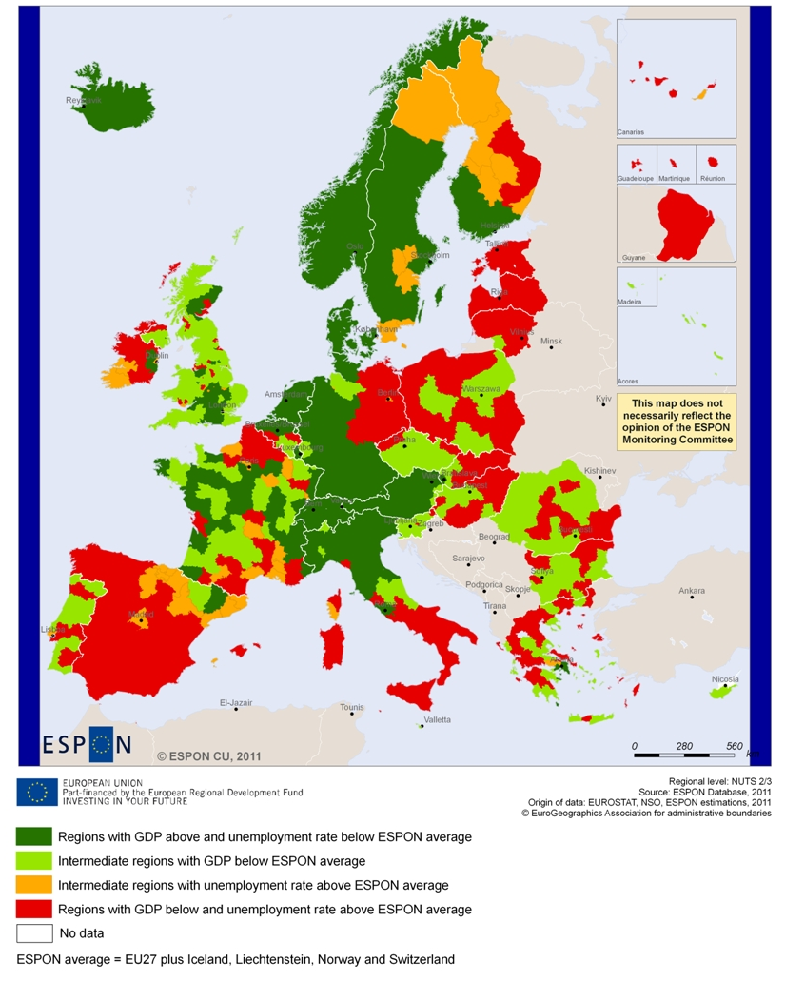
The global financial crisis from 2008 onwards resulted in a significant economic downturn as well as new and intensified social challenges in many European countries and regions. This impact hit European regions asymmetrically leaving some countries and regions with substantial challenges in their economic recovery, but not all.
The European Commission states in its Fifth Report on Economic, Social and Territorial Cohesion that Cohesion policy should continue to play a critical role in these difficult times, in order to deliver smart, sustainable and inclusive growth, while promoting harmonious development of the Union and its regions.
The socio-economic situation of Europe and its regions in the global and historical context is addressed in the First ESPON 2013 Synthesis Report when looking at exports, unemployment change and locations of multinational corporations and their subsidies.
This month ESPON presents a map of European regions in 2010 in relation to a main European challenge: jobs creation and economic growth. The map combines GDP per capita and unemployment rates using the latest available data (2010), including some estimations made by ESPON.
The map shows the socio-economic situation of European regions in 2010 by benchmarking each region at the European level. In doing so, ESPON provides regions with new, evidence based and comparable information, which can support policy makers to understand the position of their region from a European perspective and in drawing up sustainable and efficient integrated policy responses which in turn can help overcoming the impact of the economic crisis in their territories.
For sure, the map presents a snap-shot of the situation in 2010. The recent world-wide financial development indicates that the situation in countries and their regions is volatile and that fluctuations in particular related to the employment situation may happen in short time.
Observations
The socio-economic situation in Europe is rather diverse with large regional disparities in GDP per capita and unemployment rate across Europe. Northern and Central regions in Europe are in 2010 generally in a better position than Eastern and Southern parts.
The most favourable regional situations, both in terms of a GDP per capita and unemployment rate (in dark green), are mainly found in Belgium, Denmark, the Netherlands, Switzerland, Austria and Norway as well as the countries Luxembourg and Iceland. In addition, some regions scattered in France, Northern Italy, Sweden, the UK and Finland stand out in a positive way in relation to the European average.
On the contrary, Estonia, Latvia, Lithuania and several regions in Spain (except Catalonia, Basque country and Madrid) are in the less favourable position seen in the European context, both in social and economic terms (in red). The large majority of the regions in these countries have unemployment rates above and GDP per capita below European average. In addition, Ireland, Eastern part of Germany, Southern Italy and some regions in Poland, Romania and Greece also face particular challenges in 2010 with a need to find ways increasing the socio-economic attractiveness and competitiveness of these regions.
Finally, when looking at patterns within national borders, countries in Southern Europe, mainly Spain, Italy, France, as well as Ireland show a considerable regional diversity. These countries include regions scoring high and low in terms of GDP as well as in terms of unemployment in relation to the European average, which show the presence of particular national challenges in terms of balancing economic development and disparities between regions.
Conclusions
- The regions that have been affected the least by or been more resilient towards the economic crisis (ie. double positive in terms of unemployment and economic welfare) are concentrated in the Central and Northern Europe. In 2010 particular the large majority of regions in the Netherlands, Austria, Denmark, Switzerland and Norway as well as the countries Luxembourg and Iceland are in a favourable position.
- Many regions located in Southern and Eastern Europe seem to be hit more severely by the economic downturn as they in 2010 experience a double negative situation (GDP per capita below and unemployment rate above ESPON average). This situation is particularly visible in the Baltic States, Spain, Ireland, Eastern Germany and some regions in Poland, Romania, Bulgaria and France, indicating a particular need for targeted policy measures to recover from this situation.
- Capital regions across Europe are generally in a more favourable situation than surrounding regions, having a driving effect for the economy. However, in many countries with regions with a double negative situation (i.e. unemployment rate above and GDP per capita below ESPON average), the capital regions share the same situation as the rest of the nation.
- Finally, considering that high unemployment is often considered one of the main causes for out migration affecting the attractiveness of a region, special attention seems adequate to regions in Northern Finland and Sweden as well as to capital regions in peripheral countries such as Lisbon, Madrid and Dublin that are hit more severely by the economic recession having high unemployment compared to other capital regions in Europe. In 2010, the Greek capital region of Athens displayed levels of GDP and Unemployment above, however close to the average.
Concept / method / measurement
The map shows the combination of unemployment rate with GDP-PPS per capita using the latest data available (2010) including some ESPON estimations.
As indicator for the level of economic welfare the GDP-PPS per capita is used. GDP-PPS is the gross domestic product (GDP) per power purchasing standard (PPS) where PPS takes into account the relative cost of living and inflation rates. This makes it possible to compare the indicator between countries. This indicator is then divided by the total population in the region (NUTS 3).
The unemployment rate is a harmonized indicator from EUROSTAT that reflects the attractiveness of a region and represents unemployed persons as a percentage of the labour force. The labour force is the total number of people employed and unemployed aged 15 to 74.
In order to cross GDP-PPS per capita with unemployment and to present a European level benchmarking of the regions, both indicators are divided into two classes: above and below ESPON average⁽⁵⁾.
The map shows regions in dark green with a double positive situation (GDP per capita above and unemployment rate below average). The red coloured regions clearly represent the less favourable situation, i.e. regions with GDP below and unemployment rate above ESPON average.
In orange and light green are intermediate regions that score below average in one of the two indicators used and above average in the other. In this group we can identify in light green the regions with a GDP below average and in orange the regions with unemployment rate above average.
More information
ESPON Database
First ESPON 2013 Synthesis Report
Expert at the ESPON Coordination Unit: Sandra DI BIAGGIO, e-mail: sandra.di.biaggio@espon.eu

Interested in ESPON?
The ESPON 2013 Programme is part-financed by the European Regional Development Fund, the EU Member States and the Partner States Iceland, Liechtenstein, Norway and Switzerland.
It shall support policy development in relation to the aim of territorial cohesion and a harmonious development of the European territory. ESPON shall support Cohesion Policy development with European wide, comparable information, evidence, analyses and scenarios on framework conditions for the development of regions, cities and larger territories. In doing so, it shall facilitate the mobilisation of territorial capital and development opportunities, contributing to improving European competitiveness, to the widening and deepening of European territorial cooperation and to a sustainable and balanced development.
The Managing Authority responsible for the ESPON 2013 Programme is the Ministry of Sustainable Development and Infrastructures, Department of Spatial Planning and Development of Luxembourg. More information: www.espon.eu
Press Contact: pierina.petruzzi@espon.eu, phone +352 54 55 80 707

Where unemployment has growing considerable in the period 2007-2010. See http://ec.europa.eu/regional_policy/images/map/unemployment/unemployment_short_note.pdf.
This average relates to the 31 countries participating in the ESPON 2013 Programme (EU 27, Iceland, Lichtenstein, Norway and Switzerland).
Unemployment rate, 2010=98.21 (UNEMP_ESPON=100); GDP per capita, 2010=111.29 (GDP_CAP_ESPON=100)
The unemployment rate is based on data available at NUTs 0, which require some caution when looking at this indicator. In any case, a recent publication from DG Regio, analyzing the development of unemployment rate in Europe at NUTS 2 level, gives the perception that this ESPON estimations are close to the picture presented. Information on this issue can be found here: http://ec.europa.eu/regional_policy/images/map/unemployment/unemployment_short_note.pdf
In order to compare GDP-PPS per capita with unemployment and to present a European level benchmarking of the regions, a typology of regions is presented. This regional typology allows comparing each region to the ESPON average for both indicators in 2010 . GDP per capita, 2010, ESPON space=25.232€; unemployment rate, 2010, ESPON space=9.6%.

